Exploring the possibility of memory-enhancing effects in wistar rats by employing extracts from the synonneums of Chenopodialum album leaves

Mr. Tinku kumar¹, Mr.Girendar kumar gutam ², Mr. Amal kumar³ ,Mr.Rohit malik⁴
Shri ram college of pharmacy^{1,2}, Baba college of pharmacy³, shri ram group of college( pharmacy)

ABSTRACT
The frequent causes of dementia include Alzheimer’s disease (50%). Cognition deficits produced by cholinergic antagonism mimic the cognitive symptomology of Alzheimer’s disease. Scopolamine, a muscarinic receptor antagonist, is reported to impair long term potentiation (LTP), and frequently used as amnesic agent for evaluation of antiamnesic effect of new drugs. Considering the adverse effects of synthetic drugs, there is search for natural remedies which are safe and effective. The World Health Organization (WHO) estimates that 80% of the world’s population presently uses herbal medicine for some aspects of primary health care, Therefore, natural products may provide a new source of beneficial neuropsychotropic drugs provided they are adequately tested and their mechanisms are properly deciphered.
Various plants are being used in complementary and alternative medicines for Nootropic activity. Attention is being focused on the investigation of the efficacy of plant-based drugs used in the traditional medicinal system because they are cheap, have little side effects and according to WHO, about 80% of the world population still rely mainly on herbal remedies.
The present work was under taken to evaluate the Nootropic activity of Chenopodium album leaves extracts in Scopolamine induce Alzheimer type Dementia in rats.
For the purpose ethanolic & aqueous extract of Chenopodium album leaves were prepared and screened for phytochemical constituents and Nootropic activity.
For pharmacological activity Wistar rats weighing 150-200 g were randomly divided in to seven groups (n=6/group). Group І served as normal control & received vehicle; Group ІІ served as Scopolamine control & received vehicle; Group ІІІ standard drug piracetam (150 mg/kg, i. p); Groups ІV & V were administered with ethanolic extract of Chenopodium album leaves (250 & 500

mg/kg respectively, p.o) and Groups VІ & VІІ received aqueous extract of Chenopodium album leaves (250 & 500 mg/kg respectively, p.o). All treatments were given orally & intraperitoneal started after 14 days inject Scopolamine (except normal control group) and continued for 14 days along with Scopolamine.

Introduction

A person's thoughts, knowledge, interpretation, understanding, and beliefs are all included in their internal and exterior mental processes, which are collectively referred to as cognition. Severe cognitive problems may result from damage to these areas. Globally, degenerative neurological disorders are a major contributor to memory loss and other cognitive problems. It does not differentiate between the sexes, yet it disproportionately affects the elderly. Epilepsy patients often struggle with cognitive impairment due to either the disease itself or the medications used to treat it. Evidence suggests that nootropics may help with a variety of memory and focus issues. While piracetam (PIM) research has focused mostly on its cognitive benefits, it has also been demonstrated to have anti-myoclonus and anti-amnesic qualities in a variety of experimental conditions. The anticonvulsant phenytoin has been shown to impair learning and memory.[3]To avoid cognitive decline, it may be helpful to mix antiepileptic medication with nootropics. The majority of people with epilepsy will need lifelong treatment with antiepileptic medication. Because of this, it's possible that the nootropic drugs need thorough testing and long-term use.

Memory

Specifically "the mental representation and subsequent retrieval of perceptual experiences, mental representations, and other forms of information and experience". In psychology, memory refers to a person's recollection of previously learned material. Although early research on memory was undertaken in the philosophical realms, by the late nineteenth and early twentieth century, cognitive psychology paradigms were used to the study of memory. As the growing discipline that represents the marriage of cognitive psychology and neuroscience, it has become one of the cornerstones of cognitive neuroscience in recent decades. The Formation of Associations and Recollections

Classification based on time span
In cognitive psychology, we often talk about three types of memory: sensory, working, and permanent. Data exchange across these databases is often known as
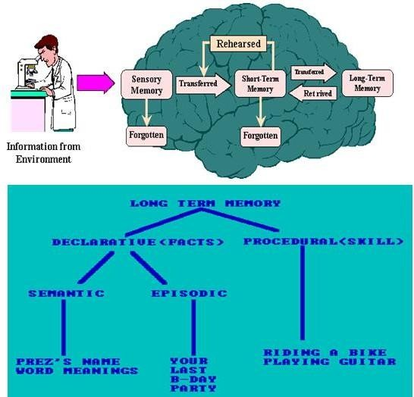

FIGURE 1.4 Schematic diagram of MPP+ intracellular pathway
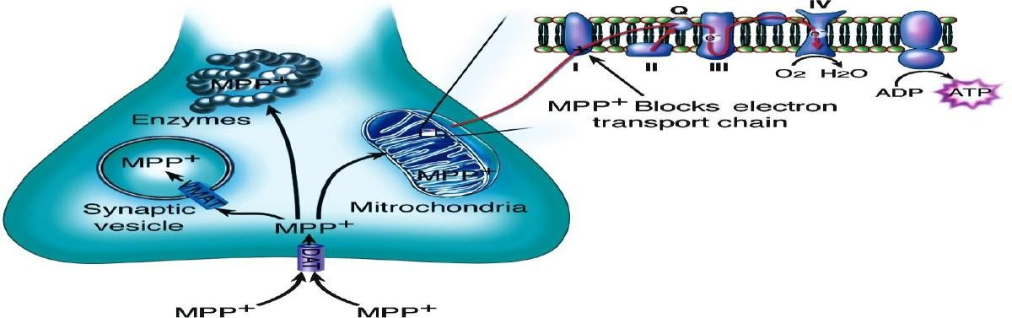

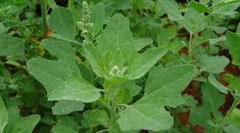
PLANT PROFILE

Figure 1.17- Leaves Of Chenopodium album herb Botanical Classification
Kingdom : Plantae Subkingdom : Tracheobionta Superdivision : Spermatophyta Division : Magnoliophyta
Class : Magnoliopsida
Subclass : Caryophyllidae
Order : Caryophyllales

Family :Amaranthaceae Sub Family : Chenopodiaceae Genus : Chenopodium
Species : Chenopodium album [23]

Habitat:-

Chenopodium album may be found almost everywhere, with notable concentrations in areas with high levels of nitrogen in the soil (such as those in Africa [24], Australia [25], North America [26], and Oceania [27]).

MATERIALS & METHODS

2.1 CHEMICALS & REAGENTS
All the substances like chemicals, drugs & reagents that are used in the study were of analytical grade & procured from various manufacturers.

Table 2.1: List of chemicals and reagents
Chemical/ Reagent | Company Name
Ethanol | S D fine Chemicals Limited, India
Sodium hydroxide | SD Fine Chemicals Limited,  India
Phenolphthalein indicator | Qualigens Fine Chemicals, Pvt.  Ltd.
Topfer’s Reagent | Qualigens Fine Chemicals,  Pvt. Ltd.
Petroleum Ether | RFCL Limited, India
Di ethyl Ether | RFCL Pvt. Ltd.
Glycerine | RFCL Limited, India

Sodium chloride | SD fine Chemicals Limited,  India
Piracetam | Nootropil,USB India, Pvt.  Ltd,Vapi,Gujarat.

2 Insoluble Acid Ash Value

After adding the collected plant material's entire ash content to 25ml of heated H2O and letting it steep for 15 minutes, they added 25% v/v HCl to a 100ml beaker and let it freeze. Finally, they filtered the mixture using Whattman filter paper No.- 44 (without ash) and rinsed the residue twice with hot water. The filter paper with the insoluble ash on it was burned in a sintered crucible at 1000 degrees Celsius. Finally, the acid unsolvable ash content was determined by weighing the crucible and the leftovers using the following formula: -
The percentage of acid insoluble ash is equal to (a/y) multiplied by 100.

When a= the weight of the leftovers or residual and y= the measured amount of powder in grammes.

Value of water soluble ash.

Two grammes of the powdered (air-dried) material was used to negotiate the whole ash value. After 5 minutes of boiling, the ash was completely dissolved. Unsolvable material was congested on ashless or ash-free filter paper, washed with hot distilled water, and burned for 15 minutes with 25 ml of distilled H2O. below 4500 degrees Celsius. Ash that could be dissolved in water was calculated by subtracting the mass of the insoluble material from the total mass of the ash. The percentage of water-soluble ash was determined relative to an air-dried plant specimen using the following formula: -
Ash value (percent) in water = (a/y) 100

Water-soluble ash = total ash minus water-insoluble ash.

Where a= the weight of the leftovers or residual and y= the measured amount of powder in grammes.
CHENOPODIUM ALBUM LEAVES CHEMICAL TESTS
The following findings were obtained from micro-chemical testing on powdered
Chenopodium album leaves: [103].

Cellulose Detection Test with Iodine
Under the microscope, powdered leaves put on glass slides and treated with iodine solution were studied.

Test with Sulfuric Acid

Under the microscope, powdered leaves put on glass slides and treated with iodine solution and sulphuric acid were studied.

Chitin Detection Test with Iodine
To examine the powdered leaves, a solution of iodine was applied to a glass slide where they were placed.

Iodine and Sulfuric Acid Dissolved in Water Test

The leaves were powdered, put on a glass slide, treated with a solution of iodine and sulphuric acid, and then examined using a microscope.

The Phloroglucinol Concentration Test + HCl

The leaf powder was placed on the glass slide. Phloroglucinol and concentrated ph. It was then cooked with a 1:1 solution of HCl and examined under a microscope.

Check for Safranin

A glass slide was affixed with powdered leaves. Safranin was introduced, and its effects were studied under a microscope.

2.5.3 Fat and Fixed Oil Detection.

The Chloroform Procedure.

A microscope was used to examine leaf powder that had been put on a glass slide and had a few drops of chloroform applied to it.

2.5.4 Suberin and Cutin Detection, Version Test with Iodine

A glass slide with some powdered leaves on it was placed in some iodine solution and examined under a microscope.

Test with Sulfuric Acid

The powdered leaves were placed on a glass slide and examined under a microscope after being treated with a solution of iodine and sulphuric acid.

Test for Red in Sudan

To examine the powdered leaves, a solution of Sudan Red III was applied to a glass slide and then examined under a microscope.

2.5.5.Tannin Detection Examine with ferric chloride.
The sample drug's powdered leaves are placed on a glass slide, and a few drops of ferric chloride solution are added before being examined under a microscope.

2.5.6 Starch detection Test with Iodine
Leaves were ground into a powder, placed on a glass slide, and then examined under a
microscope after being treated with a drop of iodine solution.

ANIMALS USED IN TESTS

Male wistar rats weighing between 150 and 200 g were used for the nootropic activity study after receiving approval from the Institutional Animal Care and Use Committee. These rats were kept in the animal house at department of pharmaceutical sciences kumaun university nainital for this purpose. Every animal will be given 7 days to acclimatise under standard husbandry circumstances, with an average temperature of. at a constant 25°C (77°F), relative humidity of 45–55 percent, and a light/dark cycle of 12*12 hours (or ambient temperature). Each useful group or team will form its own animal team and ensure that no animals in it are simultaneously applying for jobs in other departments. The animals will spend 48 hours becoming used to the laboratory environment. before the standard operating procedure for skeletonizing if someone is under duress of any kind. All animal care techniques complied with CPCSEA regulations as out by the Government of India's Ministry of Forest and Environment.

Group1: Normal Control

Normal Rats were maintained on standard chow diet and water ad libitum.

Group 2: Scopolamine Control/Negative Control

Scopolamine (3 mg/kg; i.p.) for 14 days to impair learning and memory. (Alzheimer diseases)

Group 3: Standard/Positive Control (+ Scopolamine)

Piracetam (Standard drug) (150 mg/kg; i.p.) was administered once daily for 14 days along with Scopolamine.
Group 4: Test Group I (Scopolamine + CaEe 250 mg/kg; p.o.) once daily for 14 days along with Scopolamine.
Group 5: Test Group II (Scopolamine + CaEe 500 mg/kg; p.o.) once daily for 14 days along with Scopolamine.
Group 6: Test Group III (Scopolamine + CaAe 250 mg/kg; p.o.) once daily for 14 days along with Scopolamine.
Group7: Test Group IV (Scopolamine + CaAe 500 mg/kg; p.o.) once daily for 14 days along with Scopolamine.

RESULTS AND DISCUSSION

PLANT AUTHENTICATION
A coupon specimen of Chenopodium album leaves obtained in Haldaur, Uttar Pradesh, was identified and the drugs was authenticated from the National Ayurveda Dietetics Research Institute, Bangalore.

3.2 MACROSCOPICAL CHARACTERS
The following macroscopical characters of Chenopodium album leaves were observed:

Table 3.1: Observations of macroscopical characters
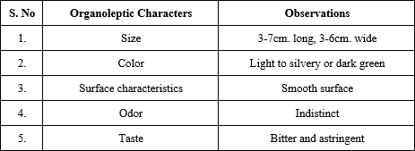

3.3 CHEMICAL CONSTITUENTS PRESENT IN CHENOPODIUM ALBUM LEAVES
Leaves powdered from Chenopodium album were subjected to a battery of micro-chemical analyses, the results of which revealed the presence of cellulose, chitin, fixed oils and fats, suberin, sudan red cutin, tannins, starch, mucilage, proteins, calcium oxalate crystals, cellulose cell wall, and calcium carbonate..
Table 3.2: Micro-chemical constituents of Chenopodium album leaves

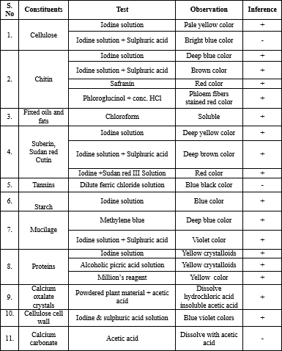

PHYSICOCHEMICAL CHARACTERS
Total Ash contents of Chenopodium album leaves.
By deducting the full crucible's weight from the empty crucible's weight, the plant's entire ash value could be determined. Chenopodium album has a total ash value of 12 mg/g.

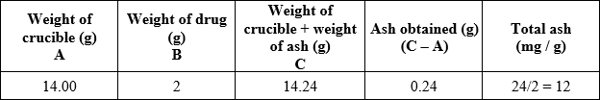
Table 3.3: Total ash value
Note: Results are the means of three observations of drug sample.
3.4.2 Value of Acid Insoluble Ash of Chenopodium album leaves.
The acid unsolvable ash of the leaves was calculated as subtracting total ash from wt. of crucible and weigh of unsolvable acid ash. The Chenopodium album leaves acid unsolvable ash was find out that is 8.5 mg/g.

Table 3.4: Acid-insoluble ash
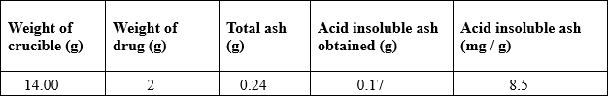
Note: Results were the means of three observations of drug sample.
3.4.3 Water Soluble Ash Content of Chenopodium album leaves
The water soluble ash of the plant was calculated by subtracting total ash from wt. of crucible & weigh of soluble ash in water. The Chenopodium album leaves ash which is soluble in water found to be 4 mg/g.

Table 3.5: Water soluble ash
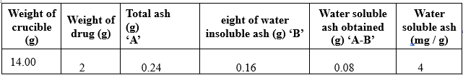
Note: Results were the means of three observations of drug sample.

% Body Weight Gain

150
a
b
b
b
b
b

100
% Body Weight Gain

50

0
Normal
Scopolamine
Piracetam
CaAe (250mg/kg)
CaAe (500mg/kg)
CaEe (250mg/kg)
CaEe (500mg/kg)

Figure 3.4 - Effect of ethanol and aqueous extacts of Chenopodium album leaves extracts and Piracetam on spontaneous locomotor activity in Scopolamine treated rats

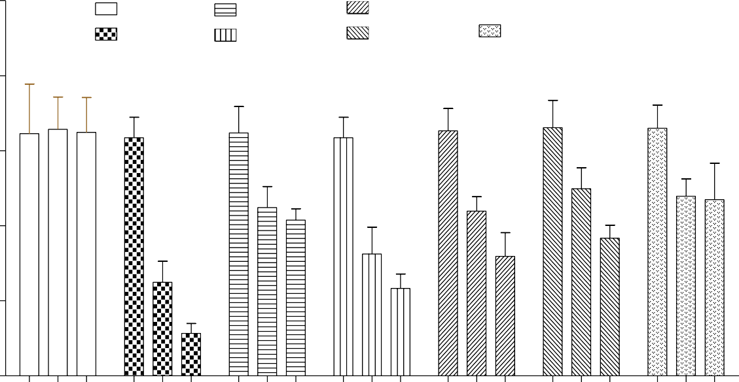
250
e
Normal
Scopolamin
Piracetam
CaAe 250
CaAe 500
CaEe 250
CaEe 500
b
b
b
b
b
a

200

150
Counts/5 min

100

50

0
1
12
18
1
12
18
1
12
18
1
12
18
1
12
18
1
12
18
1
12
18

Days

Data are presented as mean SD (n = 6), with a and b denoting significant differences between the Normal and Scopolamine groups, respectively.

Reference

- Lanni C, Lenzken SC, Pascale A, et al. (March 2008). "Cognition enhancers between treating and doping the mind". Pharmacol. Res. Vol. 57, issue (3): pg. 196–213.
- Gazzaniga, Michael S. (2006). The Ethical Brain: The Science of Our Moral Dilemmas (P.S.). New York, N.Y: Harper Perennial. pg. 184.
- Giurgea C (1972). "[Pharmacology of integrative activity of the brain. Attempt at nootropic concept in psychopharmacology] ("Vers une pharmacologie de l'active integrative du cerveau: Tentative du concept nootrope en psychopharmacologie")". Actual Pharmacol (Paris) (in French).vol. 25: pg.115–56.
- Lauralee Sherwood (2015). Human Physiology: From Cells to Systems. Cenga Learning,pg. 157-162
- Eysenck, M. W. (2012). Fundamentals of cognition. New York: Psychology Press.

- Baddely, A. (2007). Working memory, thought, and action. Oxford, UK: Oxford University Press
- LaBar K.S.; Cabeza R. (2006). "Cognitive neuroscience of emotional memory". Nature Reviews Neuroscience. vol. 7, issue (1): pg.54–64.
- Adolphs R.; Cahill L.; Schul R.; Babinsky R. (1997). "Impaired declarative memory for emotional material following bilateral amygdala damage in humans". Learning & Memory.vol. 4: pg.291–300.
- Cahill L.; Babinsky R.; Markowitsch H.J.; McGaugh J.L. (1995)."The amygdala and emotional memory". Nature.vol. 377,issue.(6547): pg.295–296.
- Kalat, J. W. (2001). Biological psychology (7th ed.). Belmont, CA: Wadsworth Publishing.

- Papassotiropoulos, Andreas; Wollmer, M. Axel; Aguzzi, Adriano; Hock, Christoph; Nitsch, Roger M.; de Quervain, Dominique J.-F.(2005). "The prion gene is associated with human long-term memory". Human Molecular Genetics. Oxford Journals.vol. 14, issue. (15): pg.2241-2246.
- Dudai, Y. (2007) Memory: It's all about representations. In: Roediger, H. L., Dudai, Y. and Fitzpatrick S. M., eds. Science of Memory: Concepts. New York: Oxford University Press, pg. 13–16.
- Semon, R. (1904). Die Mneme. Leipzig: Wilhelm Engelmann.

- Moscovitch, M. (2007) Memory: Why the engram is elusive? In: Roediger, H. L., Dudai, Y. and Fitzpatrick S. M., eds. Science of Memory: Concepts. New York: Oxford University Press, pg. 17–21.
- Byrne, J. H. (2007) Plasticity: new concepts, new challenges. In: Roediger, H. L., Dudai,Y. and Fitzpatrick S. M., eds. Science of Memory: Concepts. New York: Oxford University Press, pg. 77–82.
- Ofengenden Tzofit (2014). "Memory formation and belief" (PDF). Dialogues in Philosophy, Mental and Neuro Sciences.vol. 7, issue (2):pg. 34–44.
- Jensen O.; Lisman J.E. (2005). "Hippocampal sequence-encoding driven by a cortical multi- item working memory buffer".Trends in Neurosciences.vol. 28 issue (2): pg.67–72.
- C.Rananath et al. (2007) The medical Temporal lobe and Recognition memory vol.32, pg.123-152.
- Suzuki, W. A. (2007). "Working memory: Signals in the brain". In: Roediger, H. L., Dudai,
Y. and Fitzpatrick S. M., eds.Science of Memory: Concepts. New York: Oxford University Press, pg. 147–150.
- LeDoux J.E. (2007) Consolidation: Challenging the traditional view. In: Roediger, H. L., Dudai, Y. and Fitzpatrick S. M., eds. Science of Memory: Concepts. New York: Oxford University Press, pg. 171–175.

