“Effectiveness of ICT in Teaching Analytical Geometry in Relation to Critical Thinking among 11th Standard Students in

Tiruvannamalai District-Tamil Nadu, India”

R.CLARA RUVIN, M.Sc, M.Ed., Dr. S. POONGUZHALI, Ph.D.,
Ph.D. Research Scholar, School of Education, Research Supervisor
(VISTAS) VELS University, Chennai, Assistant Professor in Education email – claramount24@gmail.com School of Education,
Mobile: 9092256984 Vels (VISTAS) University, Chennai

Abstract

This study examines the effectiveness of Information and Communication Technology (ICT) in teaching Analytical Geometry in relation to the development of critical thinking among 11th standard students in Tiruvannamalai District, Tamil Nadu. A pre-test–post-test control group experimental design was adopted to compare traditional teaching methods with ICT-based instructional strategies. The pre-test results revealed no significant difference between the experimental and control groups, indicating initial equivalence. After the intervention, students exposed to ICT-supported instruction showed significantly higher achievement in Analytical Geometry and notable improvement in critical thinking skills. The experimental group demonstrated better mean scores, deeper conceptual understanding, and enhanced analytical and reasoning abilities compared to the control group. The findings clearly indicate that ICT-integrated teaching is highly effective in improving mathematics achievement and fostering critical thinking among higher secondary students in Tiruvannamalai District.
Keywords: ICT, Analytical Geometry, Critical Thinking, Experimental Method,
11th Standard Students, Mathematics Achievement.

Introduction

Information and Communication Technology (ICT) plays an important role in modern education, particularly in the teaching of mathematics, where many students find abstract ideas difficult to understand. Analytical Geometry involves concepts such as coordinates, graphs, slopes, and equations, which are often challenging when taught using conventional classroom methods alone. The use of ICT tools like graphing software, interactive visuals, and digital demonstrations helps students clearly visualize these concepts and relate them to real situations.

ICT-based teaching also encourages students to think independently by allowing them to analyze problems, test solutions, and observe results instantly. Such learning experiences support the development of critical thinking skills, as students are actively involved in reasoning, problem solving, and decision making. Considering the need to improve mathematics achievement at the higher secondary level in Tiruvannamalai District, the present study focuses on examining the effectiveness of ICT in teaching Analytical Geometry and its influence on the critical thinking ability of 11th standard students.

1.1 Statement of the Problem

The study is titled “Effectiveness of ICT in Teaching Analytical Geometry in Relation to Critical Thinking among 11th Standard Students.” The research aims to assess whether the use of digital educational resources improves students’ academic performance in Mathematics and contributes to the development of their critical thinking skills.

1.2 Need for the Study

Mathematics teachers commonly encounter difficulties while teaching concepts related to coordinates, slopes, distances, and geometric representations. A major challenge faced by students is the inability to visualize geometric relationships on the Cartesian plane using traditional teaching methods. The integration of ICT in mathematics instruction offers dynamic visualization and interactive tools that help students observe, analyze, and understand these concepts more effectively, making learning more engaging and meaningful.

Educational researchers have highlighted the value of multimedia learning in improving students’ understanding of complex concepts. Mayer (2016) pointed out that learning becomes more effective when visual and verbal information are presented together in a meaningful manner. In a similar view, Jonassen (2008) emphasized that digital learning environments encourage learners to actively explore concepts and construct their own understanding.

With the growing importance given to ICT in the education system, it is essential to investigate its actual effectiveness in higher secondary mathematics classrooms, particularly in enhancing students’ critical thinking skills.

1.3 Scope of the Study

• The study is confined to examining the effectiveness of ICT in teaching selected topics of Analytical Geometry to 11th standard students.

• It also investigates the relationship between ICT-supported instructional methods and the development of students’ critical thinking skills.

• The research is limited to higher secondary school students studying under the State Board syllabus.
• The subject content includes only the prescribed units of Analytical Geometry for Class XI.

1.4 Hypotheses

H₀₁: There is no significant difference in the post-test achievement scores in Analytical Geometry between boys of the control group and boys of the experimental group.

H₀₂: There is no significant difference in the post-test achievement scores in Analytical Geometry between girls of the control group and girls of the experimental group.

H₀₃: There is no significant difference in the post-test critical thinking scores between rural students of the control group and the experimental group.

H₀₄: There is no significant difference in the post-test critical thinking scores between urban students of the control group and the experimental group.

1.5 Limitations of the Study

• The study is limited to 11th standard students studying in a single higher secondary school.

• The sample consists of 60 students, with 30 students in the control group and 30 students in the experimental group.

• The assessment is restricted to selected units of Analytical Geometry and specific components of critical thinking.

• The duration of the study is confined to a four-week period of instruction.

2. Research Methodology

The research methodology followed the exact experimental structure described below.

2.1 Method Adopted

The Experimental Method was used to compare the effectiveness of ICT-based instruction with traditional teaching in Analytical Geometry.

2.2 Design of the Study

A Pre-Test–Post-Test Control Group Design was adopted.

The experimental group was taught through ICT tools such as graphing software, interactive geometry applications, and digital animations.

The control group received traditional classroom teaching.

A validated achievement test and a critical thinking test were administered to both groups before and after the intervention.

2.3 Sample of the Study

The sample comprised 60 students from 11th standard in a government higher secondary school.

30 students were assigned to the experimental group and 30 to the control group.

The sample included both boys and girls from rural and urban backgrounds.

According to Best & Kahn (2010), this sample size is adequate for conducting meaningful statistical analysis in a quasi-experimental study.

2.4 Ethical Clearance Statement

Ethical permission was obtained from the school administration. Informed consent was taken from students and parents. Confidentiality of student data was ensured throughout the study.

2.5 Variables of the Study

Independent Variable: ICT-based instruction in Analytical Geometry

Dependent Variables:

Achievement in Analytical Geometry

Critical Thinking Scores

Demographic Variables: Gender (boys/girls) and locality (rural/urban)

2.6 Procedure of the Study

Phase 1 – Pre-Test: Both groups took an Analytical Geometry achievement test and a critical thinking test.

Phase 2 – Intervention:

Experimental group: ICT-based lessons for 4 weeks

Control group : Traditional teaching Phase 3 – Post-Test: Both groups completed the same tests to measure improvement.

The entire study was completed within 8 weeks.

Phase 3 – Post-Test: Both groups completed the same tests to measure improvement.

The entire study was completed within 8 weeks.

2.7 Statistical Techniques Used

Descriptive Statistics: Mean, median, mode, standard deviation.

Inferential Statistics:

t-test for comparing post-test scores

Significance tested at p < 0.01

3. Data Analysis and Interpretation

The statistical analysis showed significant improvement in the experimental group in both Analytical Geometry achievement and critical reasoning.

Each hypothesis was tested using the t-test and interpreted accordingly.

3.1. Testing of Hypothesis

Hypothesis-I

There is no significant difference between control group and experimental group boys in Post Test

Table-1

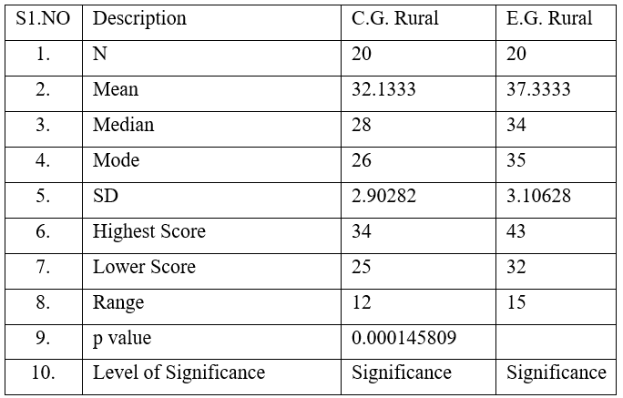
Table-1 presents the Level of Significance between Control Group and Experiment Group Boys in Post Test in Achievement in Analytical Geometry

The mean post-test score of the Experimental Group Boys (37.333) is higher than that of the Control Group Boys (32.133).

The standard deviation is relatively similar, suggesting comparable variance in both groups.

The p-value = 0.000145809 is statistically significant at p < 0.01 level, indicating a very strong difference between groups.

Conclusion: “Null Hypothesis-I is rejected.” E-content had a significant positive effect on boys’ achievement in Mathematics.

Graph-1

Graph-1 present the Level of Significance between Experiment Group and Control Group Boys in Post Test in the Achievement in Analytical Geometry
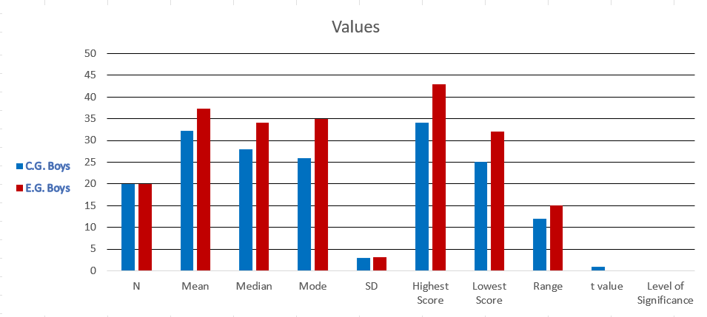

Hypothesis-II

There is no significant difference between control group and experimental group girls in Post Test

Table-2

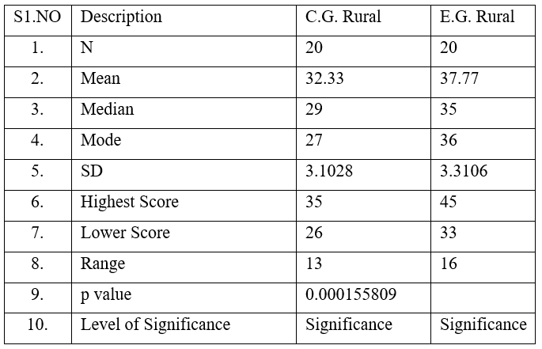

Table-2 presents the Level of Significance between Control Group and Experiment Group Girls in Post Test in Achievement in Analytical Geometry

Graph-2

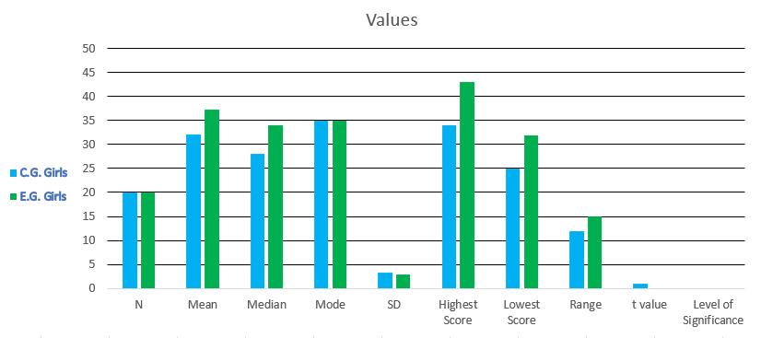
Graph-2 presents the Level of Significance between Control Group and Experiment Group Girls in Post Test in Achievement in Analytical Geometry

Hypothesis-III

There is no significant difference between Control group and Experiment group Rural students and their Post Test Scores.

Table-3

Table-3 presents the Level of difference between the Experiment Group and Control Group Rural Students in Post Test in the Achievement in Analytical Geometry
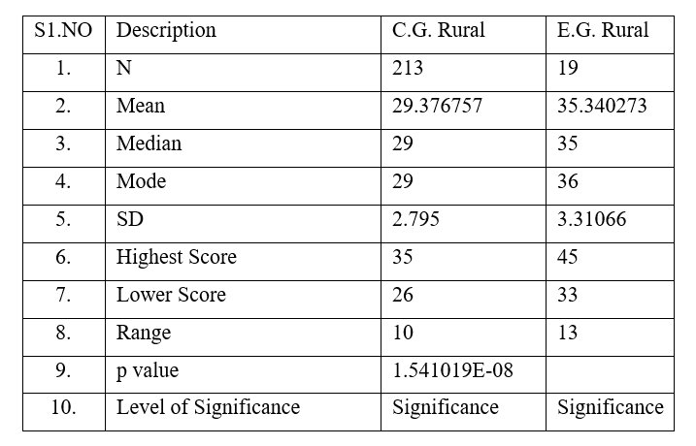

- Rural students in the Experimental Group scored significantly higher (Mean = 35.24) than those in the Control Group (Mean = 29.37).

- The p-value = 0.00000015 is extremely significant (p < 0.01), indicating a highly reliable difference.

- Conclusion: “Null Hypothesis-III is rejected.” E-content is highly effective in improving rural students’ academic achievement in Analytical Geometry

Graph-3

Graph-3 Shows the Level of difference between the Experiment Group and Control Group Rural Students in Post Test in the Achievement in Analytical Geometry
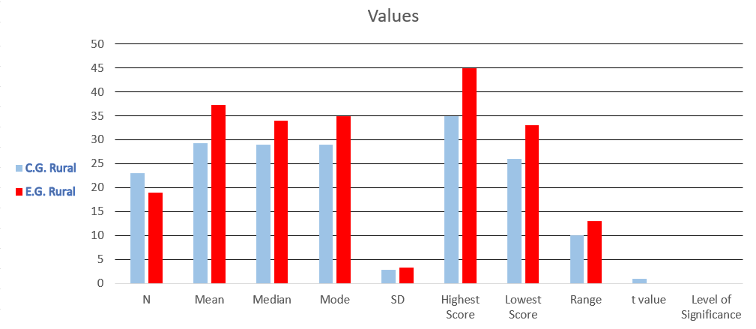

Hypothesis – IV

- There is no significant difference between Control group and Experiment group Urban students and their Post Test Scores

Table-4

Table-4 presents the level of Significance between the Experiment Group and Control Group Urban Students and their Post Test in the Achievement of Analytical Geometry

S1.No | Description | C.G. Urban | E.G. Urban
1. | N | 9 | 11
2. | Mean | 27.893145 | 34.346371
3. | Median | 22 | 29
4. | Mode | 25 | 32
5. | SD | 3.5 | 1.89793
6. | Highest Score | 32 | 35
7. | Lower Score | 23 | 29
8. | Range | 9 | 6
9. | p value | 0.000967246
10. | Level of Significance | Significance | Significance

- Urban students in the Experimental Group scored higher (Mean = 34.34) than the Control Group (Mean = 27.89).
- The SD is lower in the experimental group, indicating greater consistency in scores.
- The p-value = 0.000967 is statistically significant (p < 0.01).
Conclusion: “Null Hypothesis-IV is rejected.” E-content significantly enhanced the achievement of urban students in Analytical Geometry

Graph-4
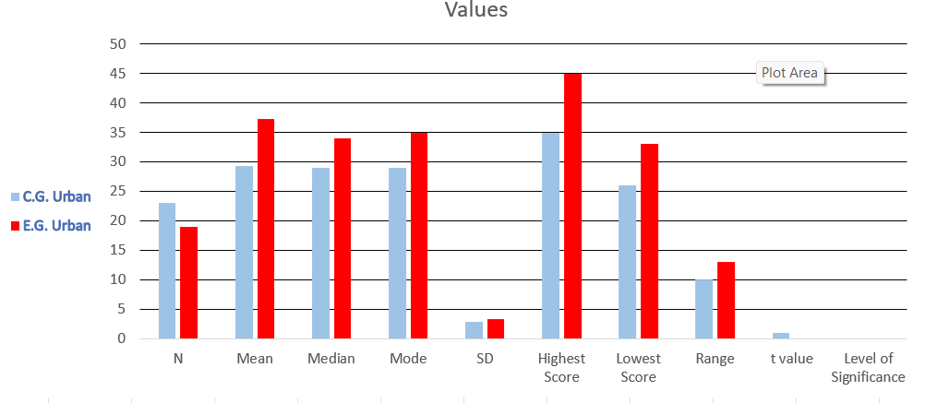
Graph-4 Shows the Significance between the Experiment Group and Control Group Urban Students and their Post Test in the Achievement of Analytical Geometry

The obtained p-value is statistically significant, the “Null hypothesis-IV is rejected.” There is a significant difference between the Experiment Group and Control Group Urban Students and their Post Test.

- The boys in the experimental group who were taught Analytical Geometry using ICT showed better performance than the boys in the control group who followed the traditional method. The higher post-test scores and the significant p-value clearly indicate that ICT-based instruction was effective in improving achievement and critical thinking.

- The girls in the experimental group performed better than the girls in the control group in the post-test. Improvements were observed in average scores as well as overall performance. The statistically significant difference suggests that the improvement was due to the ICT intervention rather than chance factors.

- Rural students exposed to ICT-supported teaching demonstrated noticeable improvement when compared to rural students in the control group. The results show that ICT helped rural learners understand Analytical Geometry concepts more clearly and apply critical reasoning more effectively.

- Urban students in the experimental group also achieved higher post-test scores than urban students in the control group. The consistency in performance and significant difference between the groups confirm the usefulness of ICT-based teaching in strengthening mathematical understanding.

- In general, the findings of the study reveal that ICT-integrated instruction had a positive effect on students’ achievement in Analytical Geometry and their critical thinking ability, irrespective of gender or locality.

5.Discussion

The findings of the present study indicate that ICT-based instruction significantly improved students’ achievement in Analytical Geometry and enhanced their critical thinking thinking abilities across gender and locality. Students in the experimental group consistently performed better than those in the control group, demonstrating the effectiveness of technology-supported teaching in mathematics learning.

The noticeable improvement among rural students suggests that ICT can reduce learning difficulties by providing visual clarity and interactive exploration, making abstract geometric concepts easier to understand. The relatively lower variation in scores within the experimental group further reflects more consistent learning outcomes when ICT tools are used.

However, certain limitations must be acknowledged. The study was conducted with a limited sample size of 60 students, over a short instructional period, and within a single school setting, which may restrict the generalization of the findings. Future research may extend this work by involving larger and more diverse samples and by examining the long-term influence of ICT on mathematical achievement and critical reasoning.

6. Conclusion

This study confirms that ICT-based instruction significantly improves academic achievement in Analytical Geometry and strengthens critical thinking among 11th standard students. Learners who received technology-supported instruction performed better than those taught through traditional methods, regardless of gender or locality. The findings highlight ICT as an effective instructional approach in mathematics education and support its inclusion in higher secondary classrooms to promote conceptual understanding, critical reasoning, and balanced learning outcomes.

References:
- Aggarwal, J. C. (2010). Principles, methods and techniques of teaching (pp. 142–165). Vikas Publishing House.
- Anderson, T. (Ed.). (2008). The theory and practice of online learning (2nd ed., pp. 120–138). Athabasca University Press.
- Best, J. W., & Kahn, J. V. (2010). Research in education (10th ed., pp. 210–235). Pearson Education.
- Clark, R. C., & Mayer, R. E. (2016). E-learning and the science of instruction: Proven guidelines for multimedia learning (4th ed., pp. 90–112). Wiley.
- Garrett, H. E. (2008). Statistics in psychology and education (pp. 255–278). Paragon International Publishers.
- Jonassen, D. H. (2008). Meaningful learning with technology (3rd ed., pp. 75–98). Pearson Education.
- Mangal, S. K. (2012). Statistics in psychology and education (pp. 134–156). PHI Learning Pvt. Ltd.
- Mayer, R. E. (2009). Multimedia learning (2nd ed., pp. 65–88). Cambridge University Press.
- Polya, G. (2004). How to solve it: A new aspect of mathematical method (pp. 45–67). Princeton University Press.
- Tall, D. (2013). Advanced mathematical thinking (pp. 101–123). Springer.

