The use of Al in Today's Technology Devices

Mr. Surendra Pratap Singh*
Assistant Professor
Advanced Institute of Education, Palwal

Abstract

Artificial Intelligence (AI) software is used to build and develop an intelligent application from scratch with the help of Machine learning and Deep Feep learning capabilities. Deep Feed, is a powerful social media management platform leveraging the latest in AI technology that automates and optimize social media efforts. Artificial intelligence (AI) is a wide-ranging branch of computer science concerned with building smart machines capable of performing tasks that typically require human intelligence. Artificial intelligence allows computerized machines to model, or even improve upon, the capabilities of the human mind. It works by combining large amounts of data with fast, iterative processing and intelligent algorithms, allowing the software to learn automatically from patterns or features in the data. AI is machine- displayed intelligence that simulates human behaviour or thinking and can be trained to solve specific problems.
A list of the top applications of AI (Artificial Intelligence): Application of AI in e- Commerce: Personalized Shopping, AI-Powered Assistants, Fraud Prevention, Applications of Artificial Intelligence (ΑΙ) in Education, Applications of AI in intelligent manufacturing, Applications of AI techniques to combating cyber crimes, Applications of AI in medical field, such as , dermatology, cardiology, fighting against COVID-19, Emerging applications of AI in neuro-oncology, Applications for protein 3-D structures. Applications for AI tool with sensitivity of 99.1% for abnormal radiographs, AI with enhancing sensitivity rates for diagnosing major thoracic findings on chest X- rays, AI has increased the odds of identifying metastatic breast cancer in whole slide images of lymph node biopsy. AI applications for military fields and for disaster management. Applications of AI in bioinformatics and other advanced scientific areas where data have accumulated for many decades.
According to prominent scientists and experts Artificial intelligence (AI) might be the most important technology we ever develop in the last century. It is argued that AI must remain safe and used beneficially for human society in order to safeguard its long-term future. AI it is already incredibly powerful. Also, AI, is a research tool for many amazing and innovative applications. Recently, Alpha Fold made a amazing leap toward solving problems in protein 3-D folding, a problem in which scientists have been working on for decades. Despite AI’s impressive accomplishments there are always questions of safety and beneficial aspects for human civilization. Ensuring AI is used to benefit everyone is already a challenge. As AI becomes more powerful, so does its scope for affecting modern economy, politics, and culture. AI is being used in so many impressive, creative and beneficial ways across pretty much every sector out there. In March 2023 GPT-4, a chatbot prototype based on the impressively large language model was launched. It uses AI technology to produce human-like text, and represents Open AI’s most advanced AI system. GPT-4 is a huge step forward in the generative AI race, but experts say it has dangerous potential. Experts believe it may have unleashed a whole new wave of cybercrime.

Introduction: Artificial intelligence (AI) and how it works
Artificial intelligence (AI) is a wide-ranging branch of computer science concerned with building smart machines capable of performing tasks that typically require human intelligence. Artificial Intelligence is an interdisciplinary science with multiple approaches, advancements in machine learning and deep learning, in particular, are creating a paradigm shift in virtually every sector of the technological development of industry and implementing AI into business environments. AI cuts down on time spent on repetitive tasks, improves employee productivity, and enhances the overall customer experience.
Artificial intelligence (AI) allows machines to model, or even improve upon, the capabilities of the human mind. Artificial Intelligence works by combining large amounts of data with fast, iterative processing and intelligent algorithms, allowing the software to learn automatically from patterns or features in the data. An AI algorithm is an extended subset of machine learning that tells the computer how to learn to operate on its own. In turn, the device continues to gain knowledge to improve processes and run tasks more efficiently than human intelligent thinking.
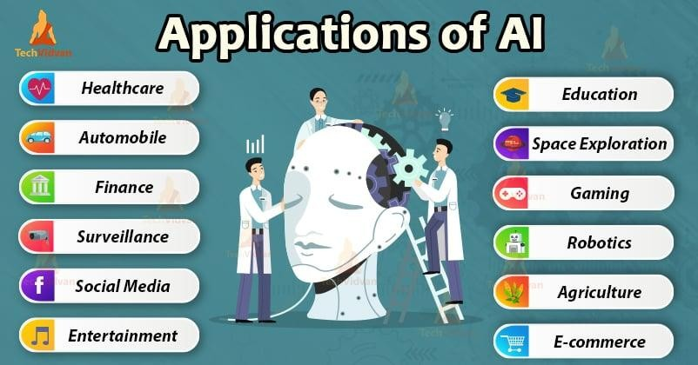
Artificial Intelligence (AI) is a dynamic tool used across industries for better decision making, increasing efficiency and eliminating repetitive work.

As the world of work continues to evolve in the 21st century and digital technology advances, the rise of artificial intelligence in the workplace has become a topic of much debate. While some see AI as a valuable tool that can enhance productivity and improve the employee experience, others are concerned that it could lead to widespread job loss, erode workers' rights and introduce ethical problems. For example, chatbots and virtual assistants are often used to automate routine tasks that were previously performed by human workers, which could result in job cuts. And, as AI becomes more sophisticated, it could even replace human workers in higher-skilled roles, such as data analysis or customer service.

Artificial Intelligence is a broad field of study that includes many theories, methods and technologies, as well as the following major subfields:
- Machine learning automates analytical model building. It uses methods from neural networks, statistics, operations research and physics to find hidden insights in data.
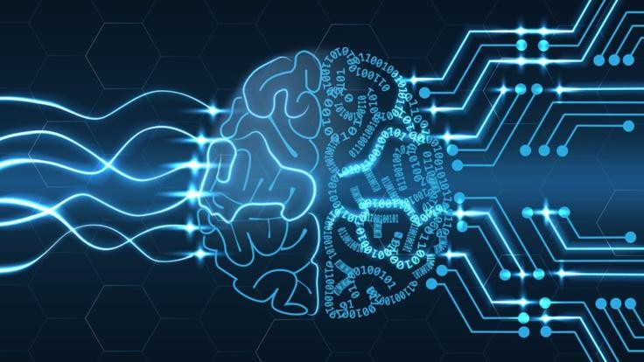
- A neural network is a type of machine learning that is made up of interconnected units (like neurons) that processes information by responding to external inputs, relaying information between each unit. Neural networks are mathematical models whose structure is loosely inspired by that of the brain. Each neuron within a neural network is a mathematical function that takes in data via an input, transforms that data into a more amenable form, and then spits it out via an output.

Figure 2. Machine learning is the process of teaching a computer to carry out a task, rather than programming it how to carry that task out step by step. At the end of training, a machine-learning system will be able to make accurate predictions when given data.

- Deep learning uses huge neural networks with many layers of processing units, taking advantage of advances in computing power and improved training techniques to learn complex patterns in large amounts of data. Common applications include image and speech recognition.
- Computer vision relies on pattern recognition and deep learning to recognize what’s in a picture or video. When machines can process, analyze and understand images, they can capture images or videos in real time and interpret their surroundings. CV helps systems understand and interpret the visual world in a way that can elicit appropriate action. It trains computers to interpret and understand the visual world.
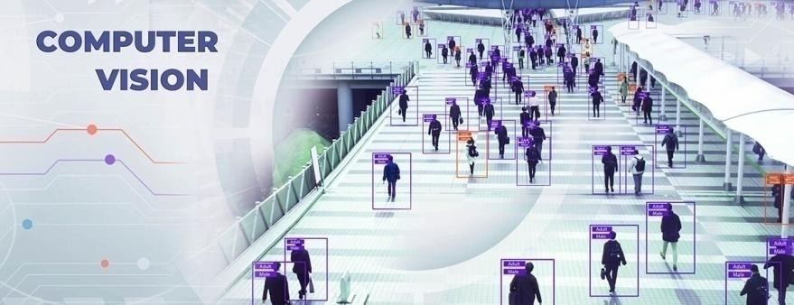
- Natural language processing (NLP) is the ability of computers to analyze, understand and generate human language. NLP is natural language interaction, allowing humans to communicate with computers using normal, everyday language. Advantages and benefits of AI, strengthening democracy?

The USA, China, Japan, United Kingdom, South Korea and the European Union (EU), and other OECD countries, are already very strong contenders in digital industry, artificial intelligence (AI) and business-to- business applications. With a high-quality digital infrastructure and a regulatory framework that protects privacy and freedom of speech. EU countries are already strong in digital industry and business-to-business applications. The majority of scientists think that AI could help people with improved health care, safer cars and other transport systems, tailored, cheaper and longer-lasting products and services. It can also facilitate access to information, education and training. The need for distance learning became more important because of the Covid-19 pandemic. Artificial intelligence can

also make workplace safer as robots can be used for dangerous parts of jobs and open new job positions as AI-driven industries grow and change.
It is obvious for many applications that AI can enable the development of a new generation of products and services, including in sectors where USA, China and European companies already have strong positions. AI can support a more sustainable, green and circular economy, improve machinery, farming, healthcare, fashion and greener tourism. AI can boost sales, improve machine maintenance, increase production output and quality, improve customer service, as well as save energy.
Also, digital experts believe that democracy could be made stronger by using data-based scrutiny, preventing disinformation and cyber attacks and ensuring access to quality information. AI could also support diversity and openness, for example by mitigating the possibility of prejudice in hiring decisions and using analytical data instead. AI is predicted to be used more in crime prevention and support a more ethical criminal justice system. AI is already used by online platforms to detect and react to unlawful and inappropriate online behaviour.
But it is already evident that increasing reliance on AI systems also poses potential risks for the human society. Underuse of AI is considered as a major threat. For example, missed opportunities for developed and developing countries from poor implementation of major programmes, such as the EU (Green deal, losing competitive advantage towards other parts of the world, economic stagnation and poorer possibilities for people). Underuse of AI could derive from public and business' mistrust in AI, poor infrastructure, lack of initiative, low investments, or, since AI's machine learning is dependent on data, from fragmented digital markets. Overuse of AI can also be problematic. AI could severely affect the right to privacy and data protection. Use of AI in the workplace is expected to result in the elimination of a large number of jobs. But, AI is also expected to create better jobs, education and training that will ensure a skilled workforce in the long term.

How Artificial Intelligence (AI) is being used

At present there is a high demand for AI capabilities from a great variety of industries and systems that can be used for automation, learning, legal assistance, risk notification and research. Specific uses of AI in industry include:
- Health Care. There are many AI applications in health institutions that can provide various routine tasks. For example AI machines can ―read‖ personalized medicine data and X-ray readings of patients for various diseases (e.g. breast mammograms, data obtained by radiomics and biopsy slides, and lung cancer low-dose computed tomography scans ). Also, AI can act as a personal health care assistants. For example. AI can act as life coach (e.g. reminding patients to take their pills), remind people to take exercise and for how long, or to propose to eat healthy food for reducing obesity.
- Retail industry. Artificial Intelligence computers can provide virtual
shopping capabilities that offer personalized recommendations and discuss purchase options with the consumer. Companies with stock management and organizational problems (clothes, tools, equipment, etc) and site layout technologies will also can be improved with the help of AI.
- Manufacturing. AI can analyze factory Internet of Things (IoT) data. The Internet of Things (IoT) is growing exponentially, but security for IoT projects and deployments remains an obstacle for many organizations. One fundamental IoT security component is making sure devices and services have trusted identities that can interact within secure ecosystems.
- Life sciences. From ensuring drug safety to getting new therapies to
market faster, AI technologies can unleash the full potential of data to solve the greatest health challenges facing humanity today and in the future.
- Banking. Artificial Intelligence enhances the speed, precision and effectiveness of human efforts in financial institutions. AI techniques can be used to identify which banking transactions are likely to be fraudulent.
- Public sector. Artificial Intelligence can make smart cities smarter. It can support national defense with mission readiness and predictive maintenance. Europe has spent up to €700 million on robotics and public–private partnerships in the context of AI. Consequently, many AI-based applications

for the public sector are emerging, promising great value with regard to workforce and productivity.¹


The 5 biggest technological giants of information technology

The 5 Big Technological companies, also known as the Tech Giants, refers to the most dominant companies in the information technology industry, notably the five largest American technology companies:

Alphabet (Google), Microsoft, Amazon, Apple, and Meta (Facebook).
Over the last few decades, the technological sector has grown exponentially. Internet penetration has increased, enterprises have gotten bigger, and millions more people have now personal computers and smartphones. As a result, the leading companies that offer internet or enterprise services or sell computers or smartphones have seen substantial increases in revenue. The number of internet users has increased from 16 million internet user (1995) to 5.473 billion internet users in July 2022.
These 5 biggest technological companies are dedicating large scientific resources and invest billions for breakthroughs in artificial intelligence having also a huge Market capitalization in 2023:
Among the big technological companies, Apple takes the lead in terms of the number of acquisitions, with a record of 29 AI startup acquisitions since 2010, followed by Google with 15 acquisitions. Microsoft and Face book follow closely with 13 and 12 acquisitions, respectively. Major technology companies like Intel, Sales force, Twitter, and IBM are also among the top acquirers.
Also, we must present the Chinese company Tencent which is another world-leading internet and technology company that develops innovative products and services. Founded in 1998 with its headquarters in Shenzhen, China, Tencent's communication and social services connect more than one billion people around the world. Also it offers a range of services such as cloud computing, advertising, FinTech, and other enterprise services. As of March 2023 Tencent has a market capitalization of $471.66 Billion..
The biggest technological computer operated companies have the resources and expertise to both acquire startups and also to invest heavily in AI research and development. But another advantage is the access to large amounts of data, which is crucial for training AI models and the ability to scale and commercialize their AI products and services.
With significant advancements in machine learning, natural language processing, and computer vision, Artificial intelligence has finally emerged as a key technology in the 5th industrial revolution. These advancements have led to the development of AI systems that can perform tasks that were previously thought to be the exclusive domain of humans, such as image and speech recognition, language translation, and decision-making.
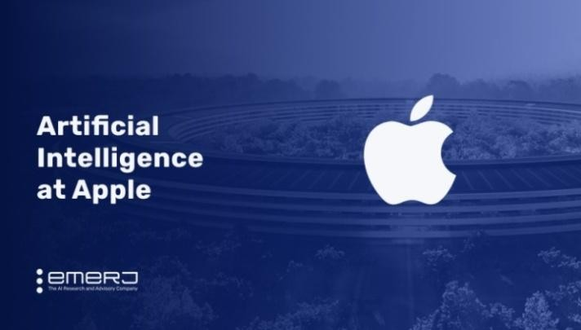
Apple was founded by Steve Jobs, Ronald Wayne, and Steve Wozniak in 1976. Apple is a global technology corporation specializing in consumer devices, software, and online services. In March 2023 Apple had a market capitalization of $2.6 Trillion, making Apple the world's most valuable company.

In the period 2015-2019, the number of businesses utilizing AI services increased by 270%, and this number is still growing. Businesses understand the capabilities of AI and exploit it in order to stay ahead of the competition. AI

systems would eventually evolve into stand alone systems, like robots or expert systems, was prevalent thirty years ago. But the majority of AI applications today combine different technologies making it more possible to be applied across several sectors.


Siri is Apple’s AI-enabled assistant that is available across Apple devices and aims to help users with daily tasks. Siri, the first virtual personal assistant, was the result of decades of artificial intelligence research in collaboration with EPFL, the Swiss Institute of Technology. Siri is an easy way to make calls, send texts, use apps, and get things done with just your voice.
In the period 2014-2021, there has been a consistent rise in the amount of money invested annually in new businesses that are operating in the artificial intelligence (AI) market. Approximately 36 billion dollars in investment went toward AI startups in 2020. This amount was surpassed and rose to 38 billion US dollars in just the first half of 2021.
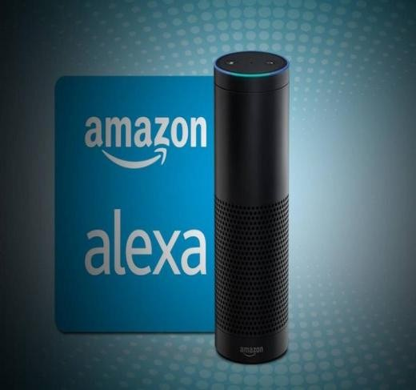
Amazon Alexa and Echo speakers. Alexa is a virtual personal assistant. Amazon now wants to offer users better compatibility with even more smart home products. Alexa and Siri, Amazon and Apple's digital voice assistants, are much more than a convenient tool—they are very real applications of artificial intelligence.

Artificially intelligent systems can perform tasks commonly associated with human cognitive functions. AI systems can work as interpreting speech, playing games and identifying patterns. They typically learn how to do so by processing massive amounts of data, looking for patterns to model in their own decision-making. In many cases, humans will supervise an AI’s learning process, reinforcing good decisions and discouraging bad ones.
Artificial Intelligence (AI) market and popularity is soaring
In the last decade the function and popularity of Artificial Intelligence (AI) are soaring. AI applications have significantly evolved over the past few years and have found their applications in almost every business and scientific sector.²

Artificial Intelligence (AI) Practical Applications

AI applications in E-Commerce
Artificial Intelligence (AI) has been deployed in the e-commerce and financial industries, to achieve better customer experience, efficient supply chain management, improved operational efficiency, with the main goal of designing standard, reliable product quality control methods and the search for new ways of reaching and serving customers while maintaining low cost. Machine learning and deep learning are two of the most often used AI approaches.^{4,5}
Personalized shopping. Artificial Intelligence technology is used to create recommendation engines through which you can engage better with your customers. These recommendations are made in accordance with their browsing history, preference, and interests. It helps in improving your relationship with your customers and their loyalty towards your brand.
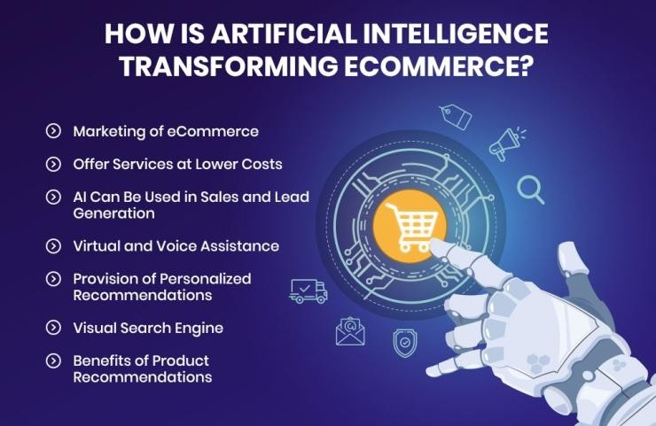

AI-powered assistants. Virtual shopping assistants and chatbots can help improve the user experience while shopping online.
AI-Fraud prevention. Credit card frauds and fake reviews are two of the most
significant issues that E-Commerce companies deal with. Artificial Intelligence can help reduce the possibility of credit card fraud taking place.

Applications of AI in Education
According to UNESCO (United Nations Education, Scientific and Cultural Organization), Artificial Intelligence (AI) has the potential to address some of the biggest challenges in education today, innovate teaching and learning practices, and accelerate progress towards SDG 4 (Sustainable Global Goals 4, equitable quality education and lifelong learning opportunities for all). This goal ensures that all girls and boys complete free primarInclusive Education for All). But educational experts suggest that rapid technological developments inevitably bring multiple risks and challenges, which have so far outpaced policy debates and regulatory frameworks. UNESCO is committed to supporting Member States to harness the potential of AI technologies for achieving the Education 2030 Agenda, while ensuring that its application in educational contexts is guided by the core principles of inclusion and equity.
Artificial Intelligence’ s role is to address current inequalities in education, regarding access to knowledge, research and the diversity of cultural expressions and to ensure AI does not widen the technological divide.
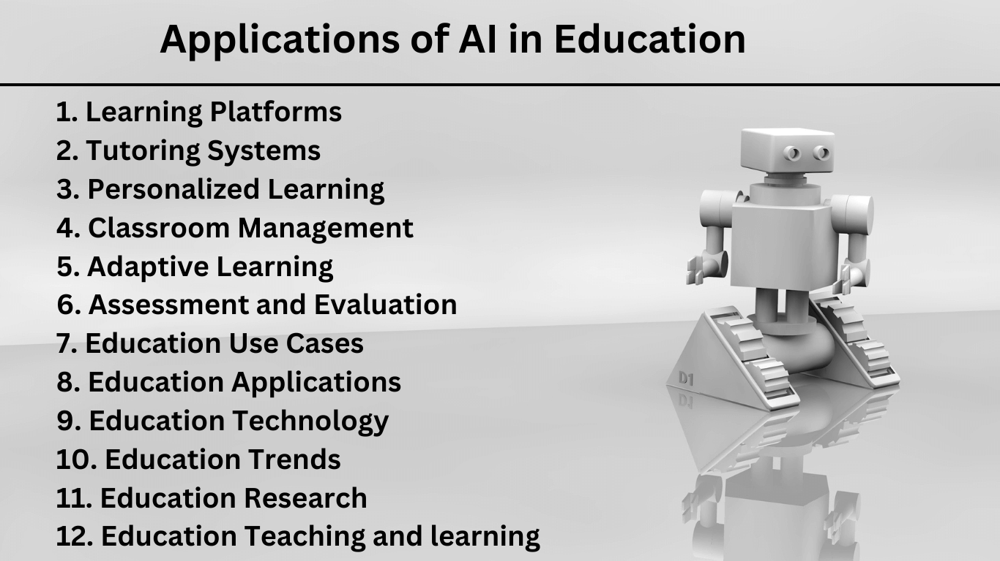
Figure 6. Although the education sector is the one most influenced by humans, Artificial Intelligence (AI) technologies have slowly begun to intrude into the education sector in various areas of teaching in the last decade.

The slow transition of applications of AI in the education sector has helped increase productivity among faculties and helped them concentrate more on students than office or administration work. Personalized learning, plagiarism detection (on essays in various subjects which are obligatory to pass certain lesson in universities) and 24/7 tutoring access are just a few
The applications of AI in education has created new opportunities for designing productive learning activities and developing better technology- enhanced learning applications. However, it remains a challenge for most researchers and practitioners from the fields of both computers and education to implement relevant activities or systems. The challenges of developing intelligent tutoring systems and adaptive learning systems are not only computer programming skills, but also techniques of simulating the intelligence of human experts. The latter include the knowledge and experience of human tutors for making judgments and decisions based on the best available evidence to help solve individual learners’ problems and help them learn better.⁸

AI application in administrative tasks automated to aid educators
Artificial Intelligence can help educators with non-educational tasks like task-related duties like facilitating and automating personalized messages to students, back-office tasks like grading paperwork, arranging and facilitating parent and guardian interactions, routine issue feedback facilitating, managing enrollment, courses, and other topics.

AI-Creating smart educational content for lessons
Digitization of content like video lectures, conferences, and textbook guides can be made using Artificial Intelligence. Educators can apply different interfaces like animations and learning content through customization for students from different grades. Artificial Intelligence helps create a rich learning experience by generating and providing audio and video summaries and integral lesson plans.

Applications of AI in Robotics

Robotics is another field where Artificial Intelligence (AI) applications are commonly used for a long time. Robots powered by AI use real-time

updates to sense obstacles in its path and pre-plan its journey instantly and perform various tasks.

Artificial Intelligence and automotive industry
Robots have been used in automotive assembly lines for over 50 years. Automakers are using robotics in a great variety of manufacturing processes. Why robots? They are efficient and dependable in production lines in industry. They also bring supply chain automation to the automotive industry and make it one of the largest users of robots.
Artificial Intelligence (AI) has redefining the automotive industry. Organizations in the automotive industry are realizing the need to leverage advanced algorithms and computational structures, innovative testing and validation platforms, integrated cockpit solutions, and 5G network adoption and application deployment for building their next generation mobility services. As a result, mergers and acquisitions focused on acquiring AI capabilities is on the rise in the auto manufacturing sector.
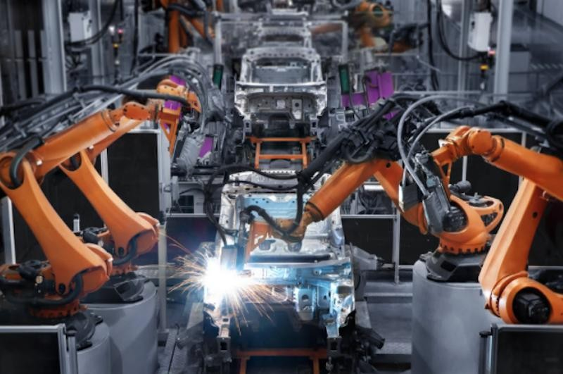
Figure 8. The automakers use robots for the last 50 years Automakers are using robotics in a great variety of manufacturing processes with the help of computer programmes and AI involvement.
Human society needs robots for dangerous, repetitive and high- precision work. Robots perform tasks in hostile environments that are impossible for humans, while also carrying out repetitious tasks with speed and accuracy. Without robots, our modern industrialized world would not be possible. The world needs robots for hazardous jobs and automated manufacturing. Robots are employed in roles ranging from cleaning up dangerous waste and chemical spills to disarming bombs and protecting

soldiers in the field. Robots also provide a level of precision that is unmatched by the human hand, and one which is repeatable over indefinite time frames. These characteristics make them ideal for precision cutting, welding and assembly processes. Robots are also revolutionizing medical procedures, allowing many types of surgery to be performed with non-invasive, out-patient procedures, as opposed to traditional procedures requiring longer recovery times. Medical robots are now so advanced that they are being employed in brain, heart and eye surgeries, allowing doctors to treat conditions that were previously only possible through treatments.
AI programmed Robots were already introduced to carry goods in hospitals, factories, and warehouses. Domestic robots, also known as personal service robots or companion robots, are designed to help with household tasks. They perform a variety of tasks, such as cleaning, laundry, and providing care for elderly or disabled people. One example of a domestic robot is the Roomba vacuum cleaner robot. It is a small, autonomous cleaning robot that can be programmed to clean floors, carpets, and rugs. Roombas have been used in homes around the world since 2002. Today there are several different models available from iRobot and other companies.
The Wakamaru robot (Mitsubishi), was designed to provide companionship for elderly people who live alone or who have difficulty getting around.
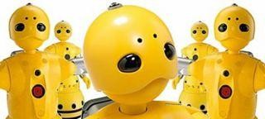
Wakamaru can perform Face recognition, Basic manual tasks, Good listener (voice recognition capabilities), Good verbal skills with customers (vocabulary of 10,000 words), Sings cheerful songs, Escort visitors to different destinations within your office building.

Applications of AI in Human Resources

Recruiting of personnel in a company with the help of Artificial Intelligence is a process that it is used extensively. AI helps with blind hiring. Using machine learning software, you can examine applications based on specific parameters. AI drive systems can scan job candidates' profiles, and resumes to provide recruiters an understanding of the talent pool they must choose from. Recruiting has always been a time-consuming, repetitive process. For example, many companies have used AI to quickly process large amounts of data to improve efficiency, accuracy, and productivity. In its simplest terms, AI is really just automation that allows us to solve big, complex, repeatable problems with quality results. AI is there to better illuminate the path to get there. Automation capabilities and benefits can be applied to recruiting processes, especially for repetitive, high-volume functions such as screening, sourcing and scheduling. AI-powered technology is meant to speed up time-consuming manual processes so recruiters can focus on more valuable initiatives during the hiring process.
A study found that 46% of companies struggle with finding and attracting the right candidates for their open positions. AI programmes can search online resumes and social profiles to find the best candidates for each job based on specific traits. They can also relay personalized messages to promising candidates and do it in scale. AI is being taught to overcome human biases during sourcing and screening. The key is teaching the program on data that presents as gender-neutral and training it to ignore other identifying information that might trigger biased decisions. Once your AI program sources and contacts candidates, AI in hiring process can lead them through the recruiting funnel quickly and efficiently, ensuring the candidate experience goes smoothly. Recruiter chatbots can provide real-time answers to candidate questions, offer quick feedback and suggest next steps. They can provide links to promising job descriptions, clarify company hours and location, and schedule interviews.

Applications of AI in Healthcare

Artificial Intelligence finds diverse applications in the healthcare sector. From chronic diseases, like cancer, to radiology, AI is being leveraged to deploy efficient and precise inventions that will help take care of patients suffering from the diseases.
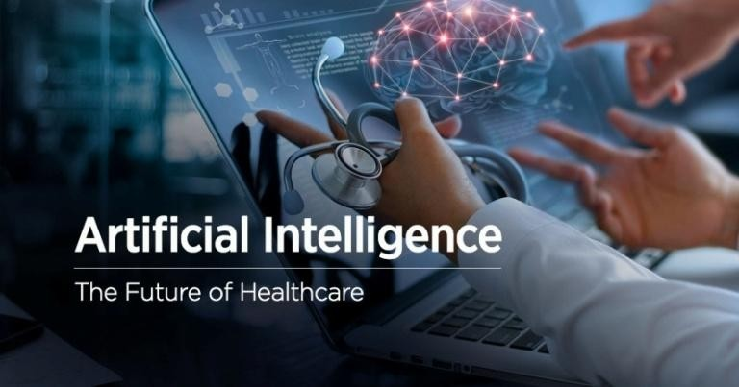
Figure 10. Artificial intelligence (AI) is instrumental as one of the most effective solutions in modern-day healthcare technology. In 2021, the global market size of this innovation in the medical field was valued at $10.4 billion. Within which clinical trial applications and robot assisted surgery accounted for the largest revenue shares.

AI provides several advantages over traditional methods of analytics and making clinical decisions. AI algorithms make the systems more precise as they get the opportunity to understand training data, which furthers helps humans get unprecedented insights into treatment variability, care processes, diagnostics, and patient results. More applications of Artificial Intelligence (AI) are used in the last decade in healthcare to build sophisticated machines that can detect diseases and identify cancer cells.
AI can help analyze chronic conditions with laboratory and other medical data to ensure early diagnosis. AI uses the combination of historical data and medical intelligence for the discovery of new drugs. Also, healthcare organizations deal with myriads of medical data. From patient medical history to insurance documents, there’s no shortage of information that needs to be taken into account when running a medical facility. AI can make things easier by going through large volumes of data at the fraction of the speed that humans usually require, simplifying various operational tasks and boosting overall workflow efficiencies. AI in healthcare contributes in the improvement of patient care. And, by developing a comprehensive, AI-enabled digital.
Some of the most pressing challenges in healthcare AI include data privacy and security, patient safety and accuracy, training algorithms to recognize patterns in medical data, integrating AI with existing IT systems, gaining physician acceptance and trust, and ensuring compliance with federal regulations.¹³

Applications of AI in self-driving vehicles
Self-driving vehicles use AI and combined sensors and software to control, navigate, and drive the vehicle automatically. While design details vary, most self-driving systems create and maintain an internal map of their surroundings, based on a wide array of sensors, like radar. Various self- driving technologies have been developed by Google, Uber, Tesla, Nissan, and other major automakers, researchers, and technology companies.
Artificial Intelligence is used to build self-driving vehicles. AI can be used along with the vehicle’s camera, radar, cloud services, GPS, and control signals to operate the vehicle. AI can improve the in-vehicle experience and provide additional systems like emergency braking, blind-spot monitoring, and driver-assist steering.
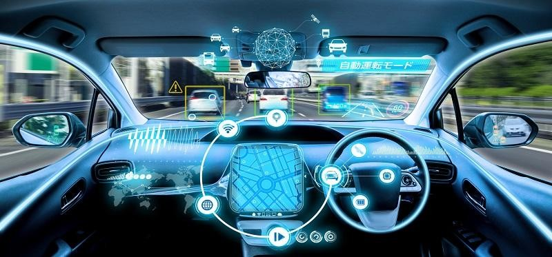
The convergence of AI and self-driving (autonomous) vehicles is a big step for both the automobile industry and the AI industry. Artificial Intelligence holds, but one of the most well-known topics related to AI potential is that of autonomous driving. In recent years, major progress has been made by companies like Tesla, Waymo, and Alibaba towards the creation of fully autonomous vehicles powered by AI.

Applications of AI in social media
In the last decades people increasingly use Social Media (SM) platforms such as Instagram, Twitter and Facebook for every day communication. Also SM are used during disasters and emergencies to post situational updates including reports. Information on SM comes in many forms, such as textual messages, images, and videos.
Instagram, On Instagram, AI considers your likes and the accounts you follow to determine what posts you are shown on your explore tab.
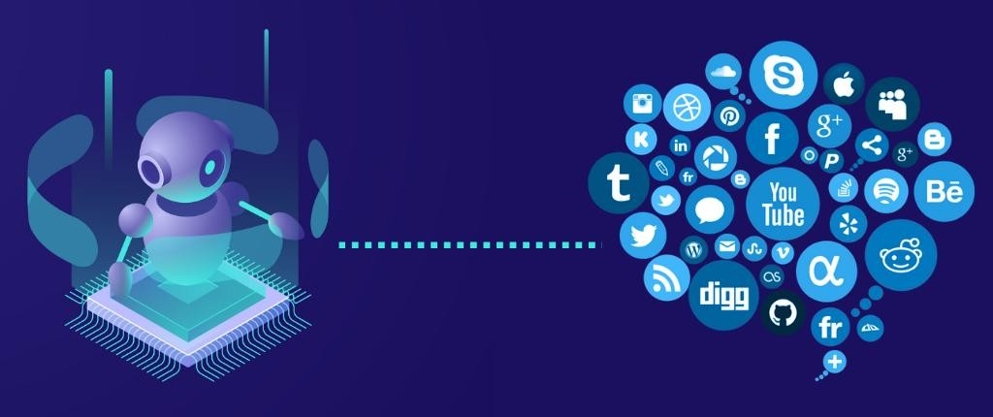
Facebook, Artificial Intelligence is also used along with a tool called DeepText. With this tool, Facebook can understand conversations better. It can be used to translate posts from different languages automatically.
Twitter , AI is used by Twitter for fraud detection, for removing propaganda, and hateful content. Twitter also uses AI to recommend tweets that users might enjoy, based on what type of tweets they engage with.¹⁹

Applications of AI in the Marketing domain

Marketing is one of the areas of business operations where it is widely predicted that artificial intelligence (AI) will drive enormous change. In fact, a McKinsey study found that, along with sales, it is the single business function where it will have the most financial impact. This means that if you’re a marketer and you’re not using AI, you’re missing out on the benefits of what is possibly the most transformational technology.

Using AI, marketers can deliver highly targeted and personalized ads with the help of behavioral analysis, and pattern recognition in ML, etc. It also helps with retargeting audiences at the right time to ensure better results and reduced feelings of distrust and annoyance. AI can help with content marketing in a way that matches the brand's style and voice. It can be used to handle routine tasks like performance, campaign reports, and much more. Chatbots powered by AI, Natural Language Processing, Natural Language Generation, and Natural Language Understanding can analyze the user's language and respond in the ways humans do. AI can provide users with real- time personalizations based on their behaviour and can be used to edit and optimize marketing campaigns to fit a local market's needs.

Applications of AI in Chatbots

A chatbot or chatterbot is a software application used to conduct an online chat conversation via text or text-to-speech, in lieu of providing direct contact with a live human agent. Chatbots are computer programs that are capable of maintaining a conversation with a user in natural language, understanding their intent, and replying based on preset rules and data.


Applications of AI in Banks and Business Finance
It has been reported that 80% of banks recognize the benefits that AI can provide. Whether it’s personal finance, corporate finance, or consumer finance, the highly evolved technology that is offered through AI can help to significantly improve a wide range of financial services.
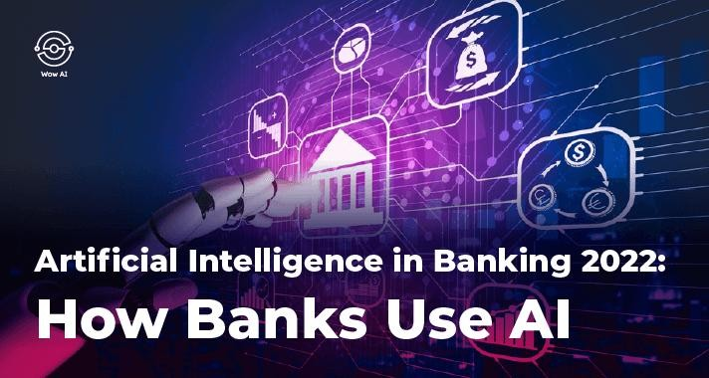
The banks and financial services sector represents 25% of the global economy and its growth is essential to the future prosperity of families, businesses and nations. The AI is a great help to banks and financial services to be more efficient and secure from cypercrime. Banks with the use AI models can provide customized financial advice, targeted product recommendations, proactive fraud detection and short support wait times. AI can guide customers through onboarding, verifying their identity, setting up accounts and providing guidance on available products. Also, customers can get help regarding wealth management solutions. Also, can easily get the information they need through SMS text messaging or online chat, all AI- powered. Artificial Intelligence can also detect changes in transaction patterns and other potential red flags that can signify fraud, which humans can easily miss, and thus saving businesses and individuals from significant loss.

AI applications in Astronomy
If there's one concept that has caught everyone by storm in this world of advancing technology, it has to be the AI (Artificial Intelligence), without a question. Artificial Intelligence (AI) has seen a wide range of applications

throughout the years, including healthcare, robotics, e-Commerce, and even bank and market finance.

Astronomy, on the other hand, is a largely unexplored topic that is just as intriguing and thrilling as the rest. When it comes to astronomy, one of the most difficult problems is analyzing the data. As a result, astronomers are turning to machine learning and Artificial Intelligence (AI) to create new tools. Recently, a group of scientists used AI in a galaxy merger investigation to establish that galaxy mergers were the primary force underlying starbursts. Given the size of the collection, the researchers created a deep learning system that trained itself to locate merging galaxies. According to one of the astronomers, the advantage of Artificial Intelligence is that it improves the study's repeatability. Finding the signals of the universe's most catastrophic events is critical for astronomers.

Artificial Intelligence in Data Security

Many industry leaders (CEOs) employ AI for a variety of purposes, including providing valued services and preparing their companies for the future. Data security in a company is considered as one of the most important assets of any technology-oriented firm. Data security is one of the most prevalent and critical applications of AI. With confidential data ranging from consumer data (such as credit card information) to organizational secrets kept online, data security is vital for any institution to satisfy both legal and operational duties. This work is now as difficult as it is vital, and many businesses deploy AI-based security solutions to keep their data out of the wrong hands. Because the world is smarter and more connected than ever before, the function of AI in business is critical today. According to several

estimates, cyber attacks will get more tenacious over time, and security teams will need to rely on AI solutions to keep systems and data under control.

ΑΙ Identifies unknown threats
Computer hackers and data breaches are one of the top concerns for today’s business organizations. The costs of these breaches continue to increase, with the average global cost of a single breach hovering at $3.62 million. Beyond the financial consequences of a breach, network security is also hugely important for any business because an attack can compromise the trust of company’s customers.
It is estimated that 60% of small companies go out of business within 6 months of falling victim to a data breach or cyber attack. Every year, computer hackers launch hundreds of millions of assaults to business for a variety of reasons.
A human may not be able to recognize all of the hacking hazards that a business confronts. Worse, they can have an impact before a person responsible with security recognize, identify, and prevent them. As attackers test different tactics ranging from malware assaults to sophisticated malware assaults, contemporary solutions should be used to avoid them. Artificial Intelligence (AI) has shown to be one of the most effective security solutions for mapping and preventing unexpected threats from wreaking havoc on a corporation.

AI-Flaw identification
AI can assist in detecting data overflow in a buffer. When programs consume more data than usual, this is referred to as buffer overflow. Aside from the fault caused by human triggers breaking crucial data. These blunders are also observable by AI, and they are detected in real-time, preventing future dangers. Also, AI can precisely discover cybersecurity weaknesses, faults, and other problems using Machine Learning, which assists AI in identifying questionable data provided by any application. Malware or virus used by hackers to gain access to systems as well as steal data is carried out via programming language flaws.

AI-Threat prevention
AI technology is constantly being developed by cyber security vendors. In its advanced version, AI is designed to detect flaws in the system or even the update. It’d instantly exclude anybody attempting to exploit those issues. AI would be an outstanding tool for preventing any threat from occurring.

AI-Responding to threats
Various threats can enter a computer system and data collection. As previously explained, AI can be used to detect unusual behaviour and create an outline of viruses or malware. AI is currently taking appropriate action against viruses or malware.

AI-recognize un characterised action
AI allows customers to detect unusual behaviour in a business computer system. It is capable of detecting unusual behaviour by continually scanning a system and gathering an appropriate amount of data. In addition, AI identifies illegal access. When unusual behavior is identified, Artificial Intelligence employs particular elements to determine whether it represents a genuine threat or a fabricated warning. Machine Learning is used to help AI determine what is and is not aberrant behaviour.

AI-ride-sharing
Platforms like Uber and OLA leverage AI to improve user experiences by connecting riders and drivers, improving user communication and messaging, and optimizing decision-making.

AI-Route planning
AI-enabled route planning using predictive analytics may help both businesses and people. Ride-sharing services already achieve this by analyzing numerous real-world parameters to optimize route planning.

AI-enabled route planning is an important approach for businesses, particularly logistics and shipping industries, to construct a more efficient supply network by anticipating road conditions and optimizing vehicle routes. Predictive analytics in route planning is the intelligent evaluation by a machine of a number of road usage parameters such as congestion level, road restrictions, traffic patterns, consumer preferences, and so on. Cargo logistics companies, may use this technology to reduce delivery costs, accelerate delivery times, and better manage assets and operations

AI-applications in manufacturing
Infusing AI into the manufacturing production experience allows companies to benefit from smarter factories, boosting productivity and lowering costs. AI may be utilized in manufacturing assembly, supply chain optimization, employing robots on the manufacturing floor, improving performance using sensors, and in post-production activities.

AI-efficiency in workplace and productivity
Artificial intelligence (AI) can improve the efficiency of a manufacturing workplaces and can increase productivity. When AI takes over repetitive it frees up the human workforce to undertake tasks that involve creativity and increase job satisfaction. With better monitor and diagnostic capabilities, AI can dramatically influence worker’s healthcare.

AI-work inspections and quality control
AI can improve work inspection and quality control. With AI, inspection of manufacturing products may go digital.

How AI impacts on the future of work

While no one knows how Artificial Intelligence (AI) impacts the future of work, scientists agree that AI is one of the world's most essential technologies today. Artificial intelligence is already at work in our daily lives, influencing everything from our search results to our online dating chances to how we shop. According to data, using AI in several commercial areas has increased substantially in the last decade. The big questions are if AI will result in a permanent underclass of people who cannot find work because their jobs have been automated? Will super-intelligent computers take over the planet one day, leaving the humans who built them with little use? According to PwC (Price Waterhouse Coopers, accounting/consulting firm) research, by the mid- 2030s, 1/3 of all employment will be at risk of being automated. The workforce segment most likely to be affected will be individuals with a low level of education.
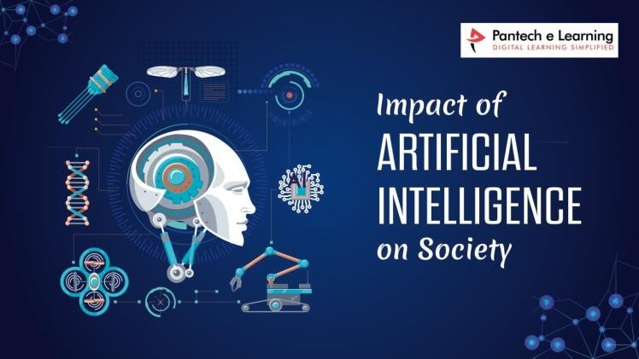
Humans may appear to be swiftly overtaken in industries where AI is becoming more extensively incorporated. However, humans are still capable of doing a variety of complicated activities better than AI. For the time being, tasks that demand creativity are beyond the capabilities of AI computers.
Furthermore, while natural language processing has advanced significantly, AI is still not very adept at truly understanding the words that it reads. While language is frequently predictable enough that AI can participate in trustworthy communication in specific settings, unexpected phrases, irony,

References
- Wirtz BW, Weverer JC, Geyer C. Artificial Intelligence and the public sector—applications and challenges. International Journal Public Administration 42:596-615, 2018.
- Avijeet Biswal, AI Applications: Top 18 Artificial Intelligence Applications updated in 9.3.2023 [https://www.simplilearn.com/tutorials/artificial- intelligence-tutorial/artificial-intelligence-applications ]
- REPORT EMR, Expert Market Research, Sheridan, Wyoming, USA and Delhi NCR, Global Artificial Intelligence Market Outlook, 2023 [https://www.expertmarketresearch.com/reports/artificial-intelligence- market ].
- Song X, Yang S, Huang Z, Huang T. The Application of Artificial Intelligence in Electronic Commerce. J Phys Conference Series 1302(3): 1302032030, 2019.
- Pallathadka H, Ramirez-Asia EH, Loli-Poma TP, et al. Applications of artificial intelligence in business management, e-commerce and finance. Materialstoday Proceedings 10.7.2021, [https://doi.org/10.1016/j.matpr.2021.06.419 ].
- Holmes W, Bialik M, Fadel C. Artificial Intelligence in Education. Pomises and Implications for Teaching and Learning. Centre for Curriculum Redesign, 2019 https://curriculumredesign.org/wp-content/uploads/ AIED-Book-Excerpt- CCR.pdf ].
- Hwang G-J, Xie H, Wah BW, Gasevic D. Vision, challenges, roles and research issues of Artificial Intelligence in Education. Computers and Education: Artificial Intelligence 1, 100001, 2020.
- Kay J. Artificial Intelligence (AI) and education: Grand challenges. IEEE Intelligent Systems, 27(5): 66-69, 2012.
- Tran T. Six (6) Typical Examples of Robots in Everyday Life, Orient Software, 7.1.2022 [https://www.orientsoftware.com/blog/robots-in-everyday-life/ ].
- People Hum, The role of AI in the hiring process, 6.3.2023 https://www.peoplehum.com/blog/the-role-of-artificial-intelligence-in-the- hiring-process#:~:text=Onc...].
- Velvetech, Technology Potential Realized, AI in healthcare, Applied Uses, https://www.velvetech.com/blog/artificial-intelligence-healthcare/ ].
- Delvensight, AI in healthcare 9.2.2022 https://www.delveinsight.com/ blog/top-applications-of-artificial-intelligence-in-healthcare ].
- Foresee Medical, AI in Healthcare https://www.foreseemed.com/ artificial-intelligence-in-healthcare#:~:text=Deep%20learning%20AI%2].
- The Agrotech Daily, Artificial Intelligence in Agriculture, 2022, https://theagrotechdaily.com/ai-in-agriculture/ ].
- Latent View, 20.7.2020 Artificial Intelligence and Agriculture, [https://www.latentview.com/blog/artificial-intelligence-in-agriculture/ ].
- Airplus Info, AI and autonomous driving, 23.2.2023, https://www.aiplusinfo.com/blog/ai-and-autonomous-driving/ ].
- Mercedes-Benz Group. ―Computer Brains and Autonomous Driving. How Artificial Intelligence Makes Cars Fit for the Future.‖ Mercedes-Benz Group, https://group.mercedes-benz.com/innovation/case/ autonomous/ artificial-intelligence.html.].

- Mercedes Benz, intelligent drive. [https://group.mercedes-benz.com/ innovation/case/ autonomous/intelligent-drive-2.html ].
- Raymond S. T. Lee. Artificial Intelligence in Daily Life. Springer. Singapore, 2020, ISBN 978-981-15-7694-2 ISBN 978-981-15-7695-9 (eBook) https://doi.org/10.1007/978-981-15-7695-9.
- Forbes 9.6.2022 Artificial Intelligence and the future of marketing,
[https://www.forbes.com/sites/bernardmarr/2022/09/09/artificial- intelligence-and-the-future-of-marketing/?sh=28fa6a02697f ].

