The Development of Traditional and Contemporary Folk Art in Medinipur (Mid 19th To 21st Century)

Dipak Barai

Department of visual Arts, University of Kalyani, West Bengal

Email: dipakbarai84@gmail.com

Abstract:
The Naya, Pingla partchitra was the oldest culture for Audio-Visual medium for enlightenment/entertainment of the people about the versatile mythological (Ramayana, Manshamangal, Mahabharat etc.) and contemporary social features/events. The chitrakar/patua use to adobe this culture as the choice of profession for the purpose of subsistence of life by virtue of displaying Audio-Visual features before the public for enlighten & entertaining mythological and contemporaneous features. The sangrahasala (museum) had been established by Sri Bahadur Chitrakar in Naya, Pingla village where huge collection of old and modern patachitra (scroll painting) and other modern artistic features like latest handmade design in unisex garments, decorative household commodities. The usual ingredients for the preparation of typical patachitras are the herbal & natural colours especially used in only old/traditional scroll painting where as in modern scroll painting both traditional colour & synthetic colour like enamel, fabric & other artificial colour available from market.
The significant achievement of the lot of pingla, Naya patachitra (old and new) are the center of attraction for the people in home and abroad for the purpose of gathering experiences in the horizon of unique art culture at large.
Keywords: Historical Development Of Pingla Patachitra Museum/ Naya Village, Development Of Patachitra On Commercial View Point, Significant Socio-Economic Status Of Pingla Patachitra, Research And Devlopment Scroll Painting, Usage Of Tools & Gadget In Scroll Painting, Maintenace Process Of Old Scroll Painting, The Old And New Scroll Painting Case Study.

INTRODUCTION:
It is learnt from the primordial rock shelters in Vindhya Range (Bhimbetka, cave painting) that from time immemorial(ca.30000 BC) the glorious Indian civilization had been crowned with philanthropic culture impregnated with profundity of humanitarian texture accelerating the trend of optimum artistry within the human society like an un-interruptive stream of a river. The fact of the matter though the tendency of succession had been retarded for the time being on ground of the sporadic socio-economic-political disturbances, but still the eternal propagation of advancement had not been discontinued at all followed by the centuries. Under the compulsion of the alleged crisis the so-called Pata-Chitrakars at large might have taken advantage of the policy of safe-escapism by way of taking shelter at different villages of West Bengal and other sector of the country for the sake of upholding or cherishing their excellent creativity and
Conservation of the traditional arts. The researcher left no stone unturned for achieving the mystery of livelihood about the struggle for existence as well as survival of existence of the patachitrakar at large The exceptional Chitrakar community lived in the district Medinipur at Naya village; Pingla.
In view of unquenchable thirst for the persistent investigation in the matter of perpetual development of the excellent traditional folk art; the researcher visited various famous institutions like sri Bahadur Chitrakar Museum, sri, ‘Shyamsundar Chitrakar House’, 'Bahadur Chitrakar Museum', ‘Swarno Chitrakar House', ‘Chandan Chitrakar House' etc. for the purpose of enrichment with profound experience regarding technical & analytical aspects of traditional development for the diversity in the horizon of Scroll painting.
Noteworthy to mention the blooming of Art, literature, Architecture etc. are the fundamental materialization of human creativity which are motivated by the significant momentum of time period, place and personality. Art has its versatile manifestation which can never be restricted within any boundary.
The fact of the matter during the transitional phase from the far end of Mughal dynasty to the arrival of the British regime the overall impact of religious & socio-economic crisis so far being experienced on the human society as observed in mid-18th century; a lot of Artist community had been scattered in different localities in India as well as in West Bengal like Medinipur, Calcutta Kalighat, Birbhum, Burdwan, Bankura, Purulia, Murshidabad, Hooghly, 24 Parganas, Howrah ,Chandannagar etc. for safe-escapism of their survival of existence in order to save-guard the professional entity as Artists. Subsequently the few section of Artist community took their shelter in Medinipur District at Pingla, Naya village which was obviously celebrated as renowned “Chitrakar Community”. The specific Chitrakar community used to cultivate for the epoch making culture of mythological and pertinent socio economic aspects. In course of time under the compulsion of spiraling impetus on the advancement of human civilization, the so called Bengali painters (Chitrakar community of modern out-look) used to engage themselves in the creativity of manifold popular art-culture like fabric design, enamel design associated with traditional herbal and natural mechanism. On the contrary, the community of old generation use to preserve the heritage culture for the sake of enhancement for dynamic creativity in Scroll painting by virtue of adoption of traditional mechanism till date.
Under the circumstances the researcher used to take advantage of studying different books & manuscripts available from multiple Libraries and museums namely “National Library” (Kolkata), “Gandhi Smarak Sangrahalaya Library” (Barrackpore), “Centre for Archaeological Studies and Training, Eastern India”, “Bahadur Chitrakar House” (the Museum in Pingla; Medinipur), “Birla Academy of Art and Culture”(Kolkata) etc. and he had an opportunity to take interview with the multiple Chitrakars being engaged in diversity and everlasting modulating purview of “Pingla Patachitra and Chitrakar community” of different time period.
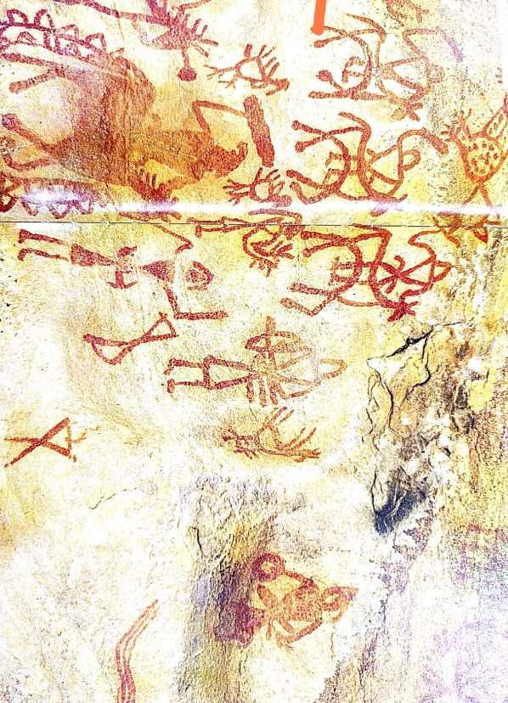
Bahadur Chitrakar, the eminent Patachitrakar of Pingla expressed his views on the advent of patachitra in the manner that in the primitive age the human being when lived together in the multiple caves they could not be able to express their views in language. They represented their views or expression by virtue of different sketches in sign language on the intramural wall inside the cave similar to the cave painting at Bhimbetka, in Vindhya Range, in Central India. The typical sign language sketches guided for the next group of people or generation for the survival of existence. When the people were capable of expressing their views in vocal language they learned the process of cultivation in the vacate lands which are delineated also in the form of sketches saturated with sign language. On the other hand, the peculiar sketches used to utilize for the enlightenment purpose for the learner people. The technique of sign language sketches had been promulgated in home and abroad. In course of gradual development of cultivation the chitrakars used to exercise the process of enlightenment in audio- visual method.

Fig-1, the ancient cave picturein Bhimbetkar in M.P

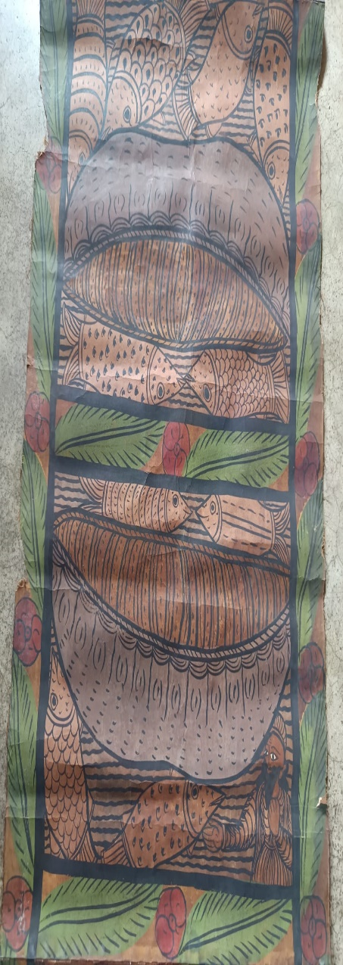
The Researcher collected the” BHIMBETKA”, Cave Painting, and Mineral Colours on rocks, ca. 3oooo BC (contested) Artist: Unknown, ca.30000 BC (contested), Dimensions: Variable In situ at Raisen district, Madhya Pradesh, India. The Author text by Sushma k Bahl, page no…. Bhimbetka, cave paintings the primordial rock shelters in the Vindhya Range of central India are replete with painting, inscriptions, petroglyphs, etc. Bhimbetka is believed to be the largest repository of old. It is a UNESCO listed world heritage site. The excavated material here includes stone tools and chalcolithic pottery, Mesolithic rook art with etched images of rituals, fertility, divinities, battle scenes, and hunting. There is enough circumstantial evidence of pre-agricultural Stone Age communities. The paintings located in pitch dark cave interiors and drawn several times over chronicle the evolution of the civilization. Layers that started as single line sketches of simple life in the wild, changed to agricultural motifs with time. The imagery painted in natural pigments, charcoal, and animal and plant extracts with fingers, feathers and twigs, speaks of the different epochs that Bhimbetka had witnessed.

Fig-2, Old Scroll Painting, more than 70year old, artist by Late Dukhusham Chitrakar.
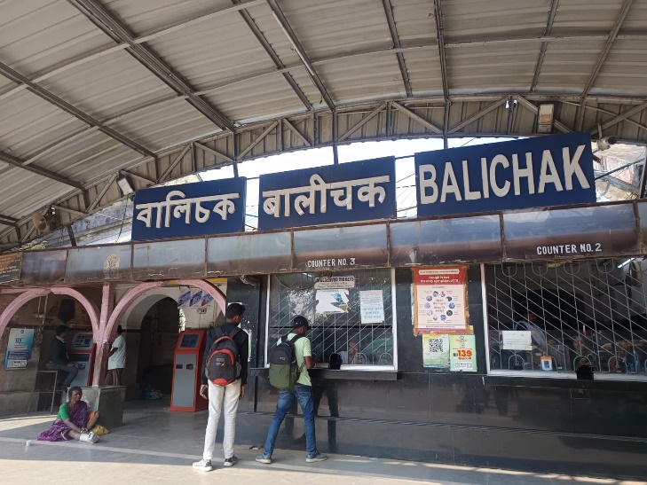
Fig-3, Railway station from Destination point at petrol pump at the left side of highway the main moyna rod.
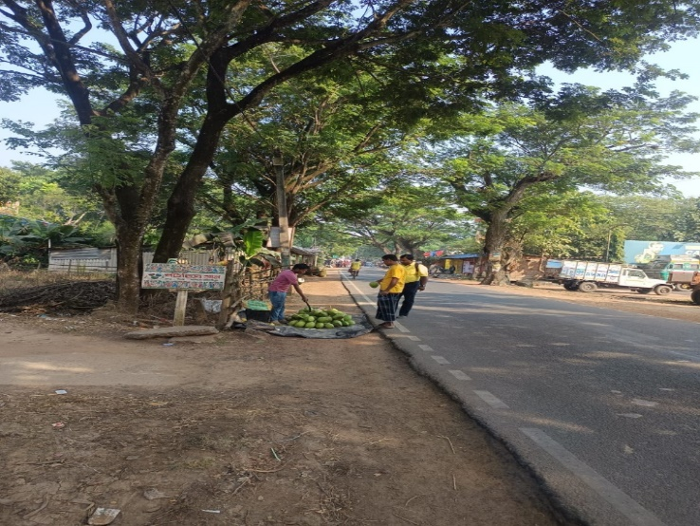
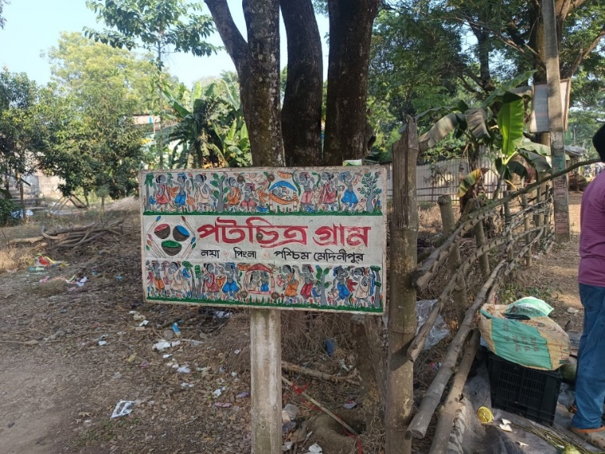
Fig-4, the entrance in the left side Naya; Pingla

After the arrivel of Balichak railway station, the Balichak to Moyna route bus to be availed one hour for the destination point Naya village neyer indian petrol pamp.

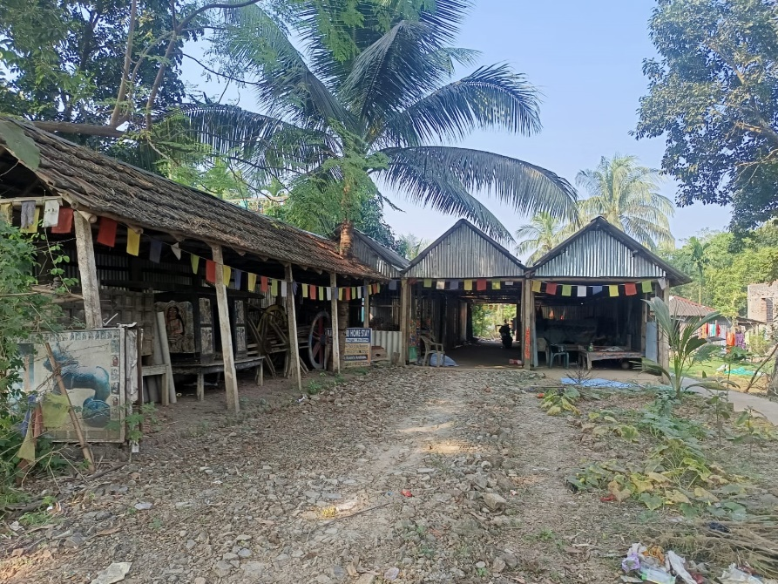

Fig-5, Front view of the Naya village, Pingla.

This is a concrete sign board indicating the entrance of Naya vailleg, Pingla, this sign board fully decorated by local patua /chitrakars

Fig-6, Name-sri Mahamod Chitrakar, alias Montu (Father of Bahadur Chiratkar) aged-76, engaged in domestic drudgery, in front of Bahadur Chitrakar Museum.

At the entrance of Bahadur Chitrakar house one thatched house is there where huge collection of verity of decorative articles are provided for the attraction of the newcomers.

He is one of the famous chitrakar/ composer of folk lyric, hi is the pioneer of the artistry scroll painting.

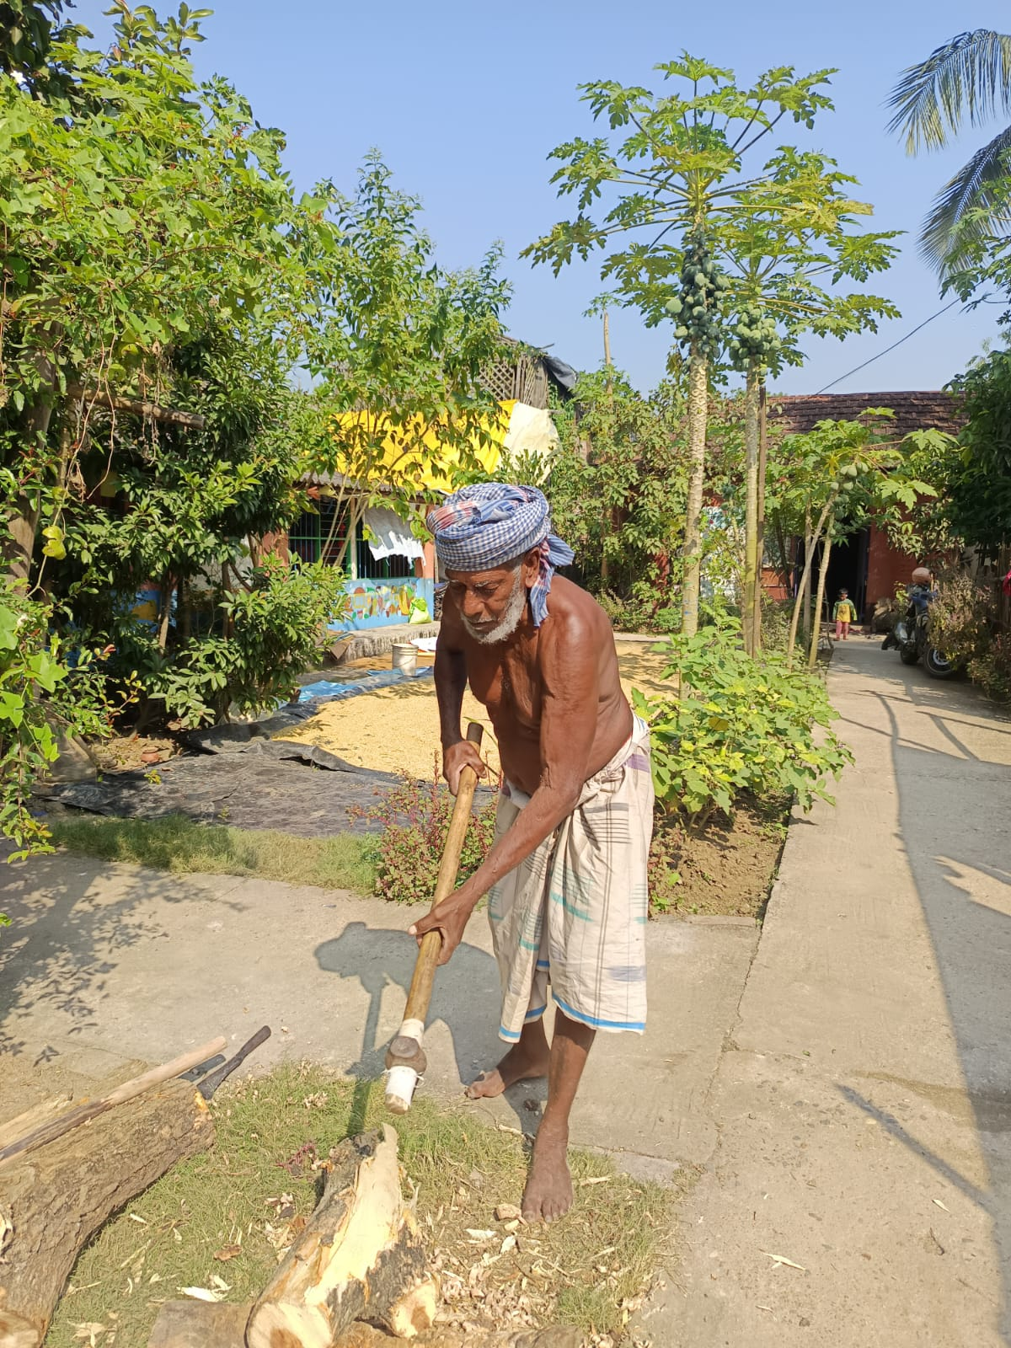
Fig-7, A Small museum in Bahadur Chitrakar House inside and outside.

Historical development of Pingla Patachitra Museum/ Naya village:

This Pingla area of West Medinipur has attained the status of much praise-worthy achievement in creativity of their Patachitras. The Patachitra museum of Pingla area now draws the attraction of the visitors of the whole world (Africa, Japan, U.S.A etc.). Now Chitrakar Bahadur established a museum with lot of collection of various equipment’s/instruments of more than 100 years old for the creation of scroll painting, such as painting brush (old), carry bag (glipe), different foreign currencies, postal and various pot related books. Stony idols in dilapidated condition of elephant, horses, deity etc. in addition to Egyptian manuscript, bronze idols, wooden mask etc. These collections are very popular to the interested visitors who used to visit the museum. These visitors were also collected various traditional commodities in modern outlook such as small patachitra, household commodities for beautification purpose on commercial basis. People from different countries assembled here to watch and enjoy this museum at Naya Pingla-gram which is very famous for its perspective Patachitras. Everybody will be pleased to come here for solving their different objects. Some appeared to make their documentary films and some of them come here for their research works.

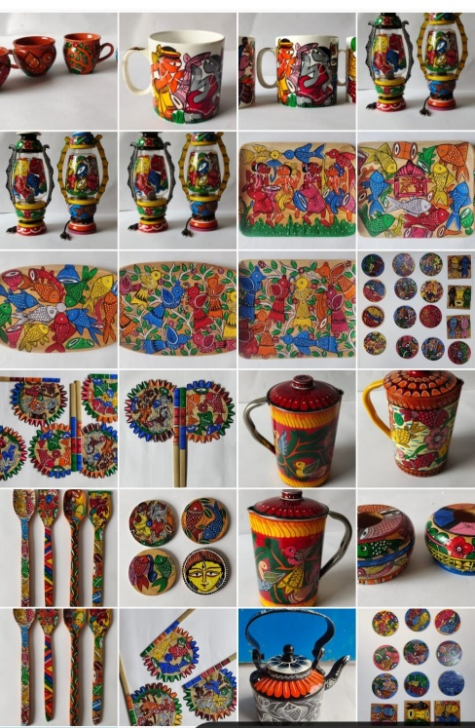

Fig-9, Variety colourful productive work for present time
Fig-8, Varieties Old scroll Painting more then 100 years explained by Bahadur Chitrakar.

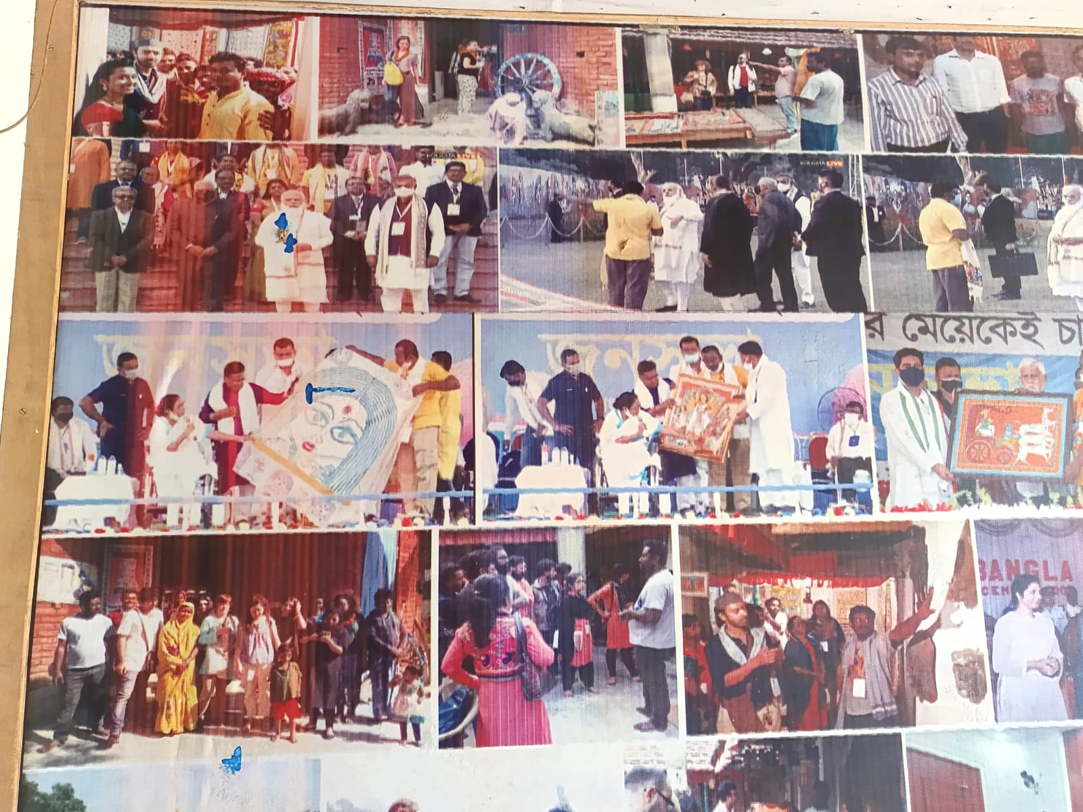

Fig-10, Award ceremony of Bahadur Chitrakar from the galaxy of intellectuals

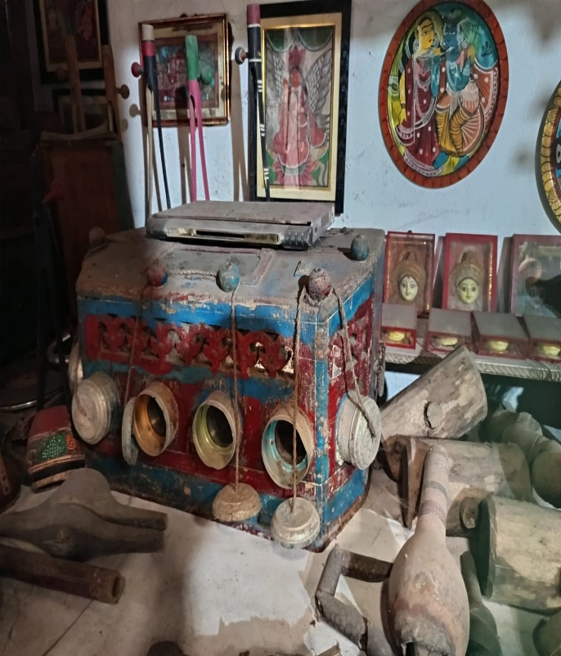
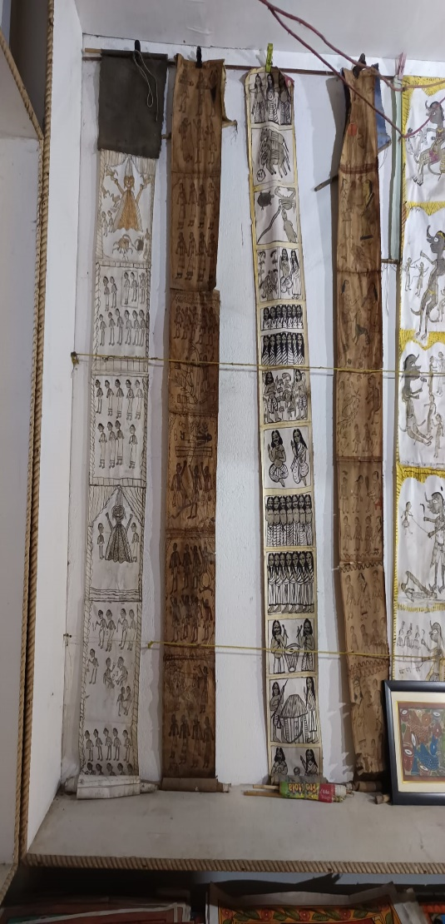

Fig-11, Old scroll painting on display in museum
Fig-12, Baroscopic instrument
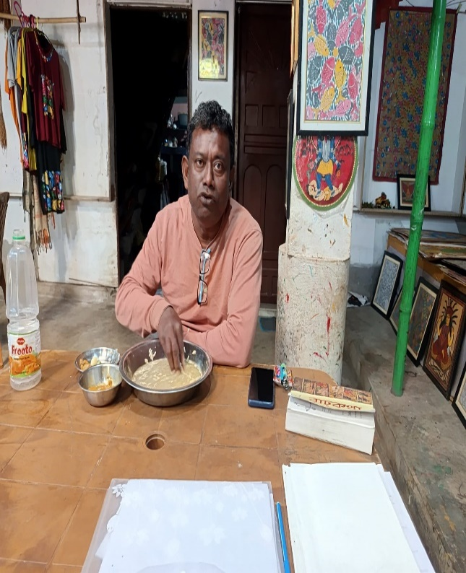
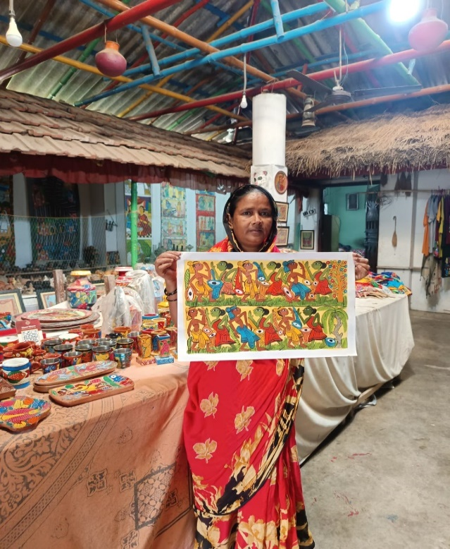

Fig-14, Name-sri Bahadur Chiratkar (son of Mahamod Chitrakar), aged-53.
Fig-13, Name-Najara Chitrakar, alias Montu (wife of Bahadur Chiratkar) aged-46,

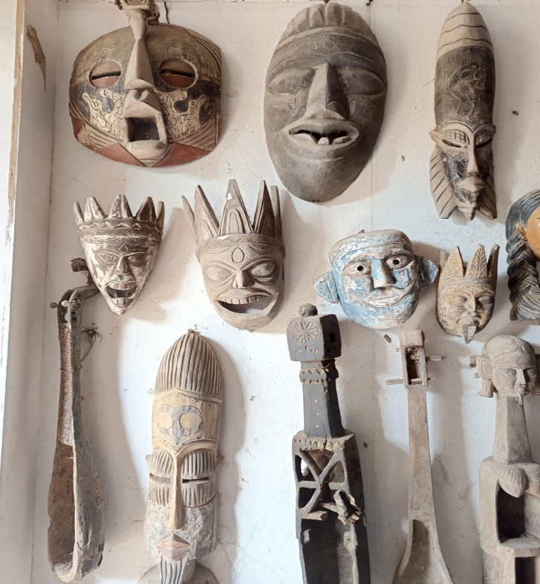
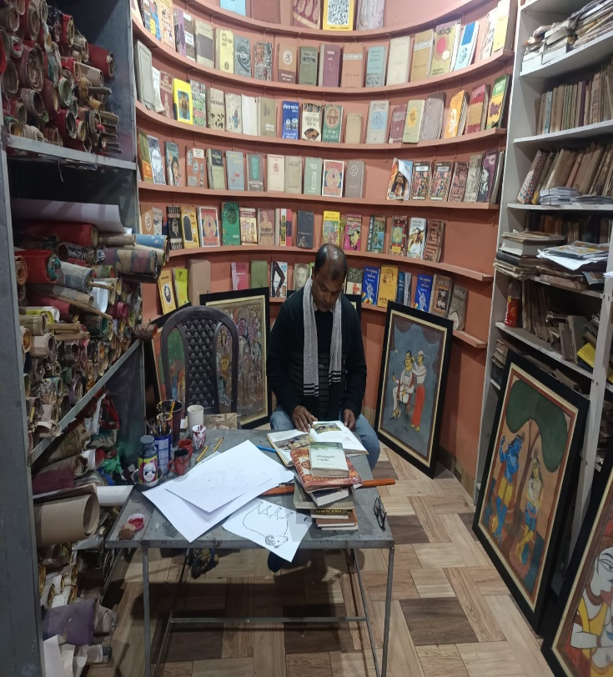

Fig- 16, The researcher engaged in sturdy within the Bhadur Bhitrakar Museum, Pingla.
Fig-15, Wood carving max the Bhadur Bhitrakar Museum, Pingla.

Development of patachitra on commercial view point:

During the course of threadbare discussion, Sri Bahadur Chitrakar specified that in the year 1995 one schedule training program had been conducted in Pingla; Naya village in collaboration with large number of patachitrakars participated from different localities on the issue of variety of business development features except the traditional patachitra. There after the diversity of creativity in the sphere of patachitra had been developed in the creativity of various decorative household commodities like Wooden Trays, Wooden lid of Teapots, Wooden Hurricane, Ceramic Teapots, Aluminum Plate, Tea Kettle, Tin hurricane, Night Lamp; on commercial view point In addition to variety of fancy dress material like Saree, Churidar, Tee-shirt etc.

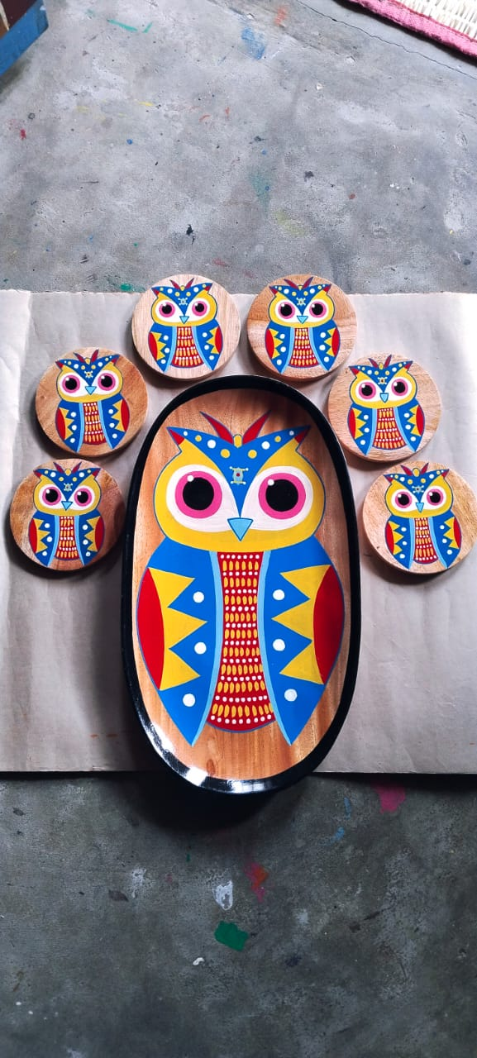
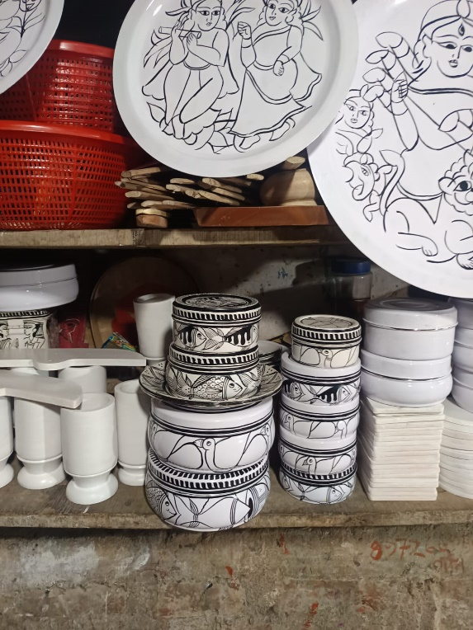

Fig-18, Wooden Trays
Fig-17, Wooden pots
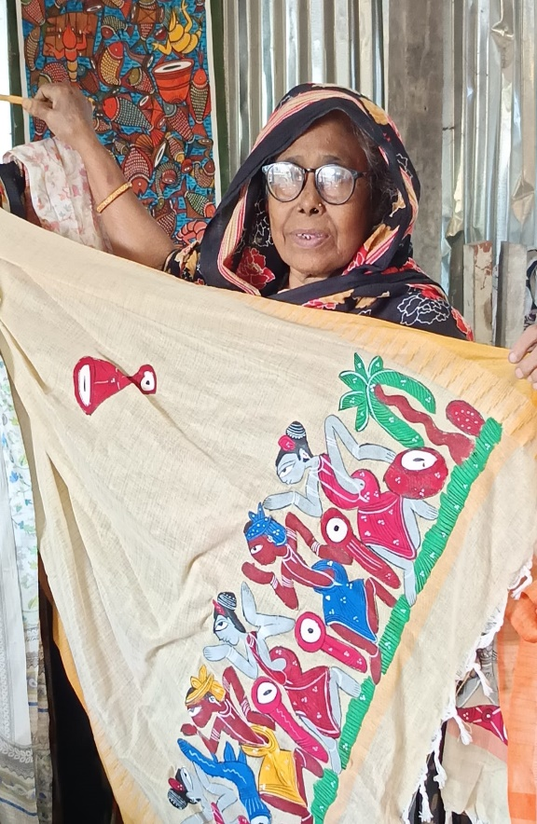
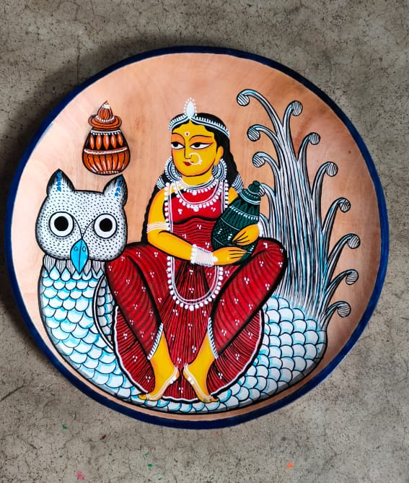
Fig-20, Saree,
Fig-19, Wooden plate
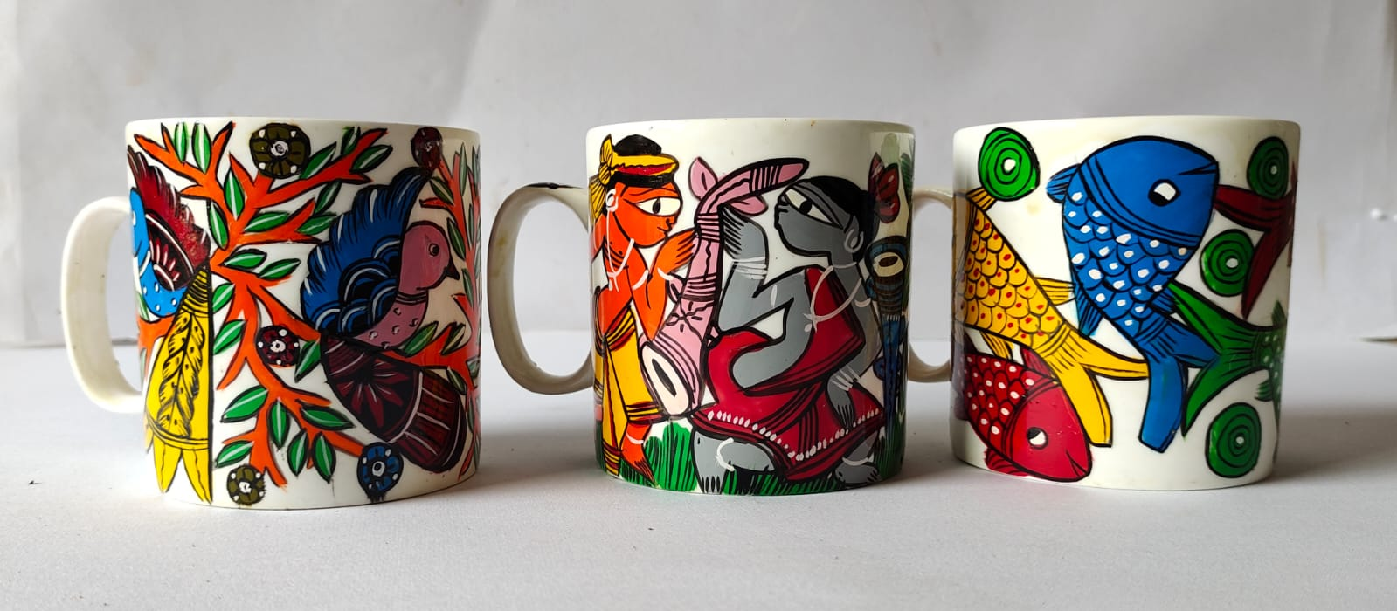
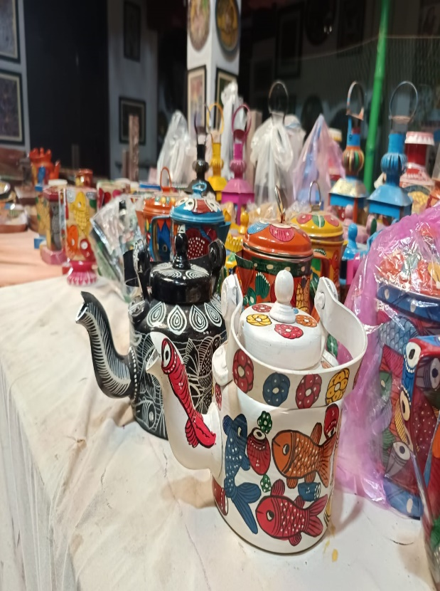
Fig-22, Tea Kettle
Fig-21, Ceramic Teapots
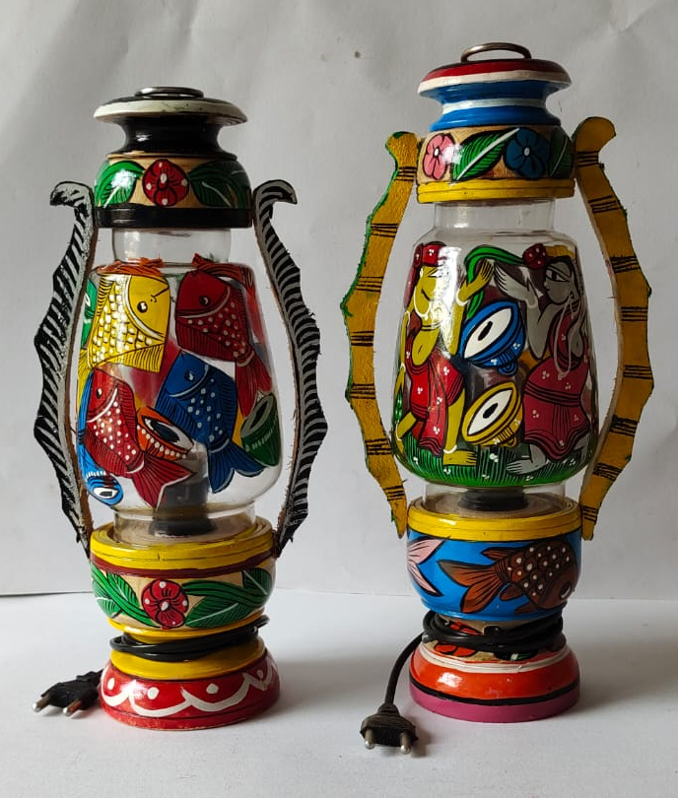
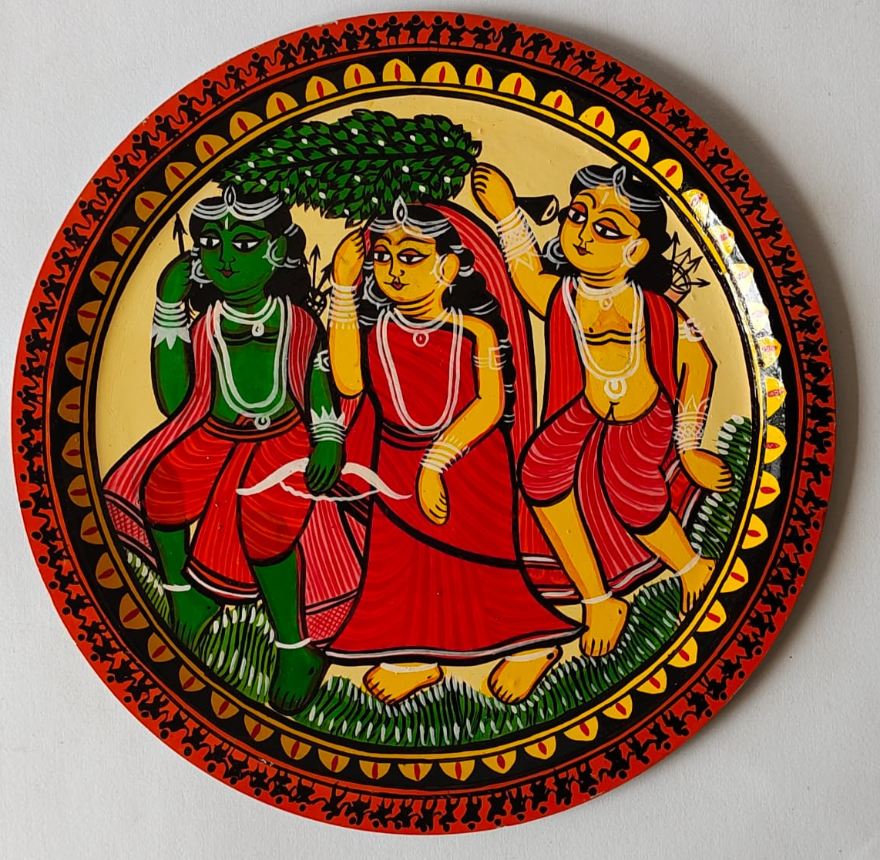

Aluminum Plate,

Fig-24, Wooden hurricane
Fig-23, Aluminum pots,

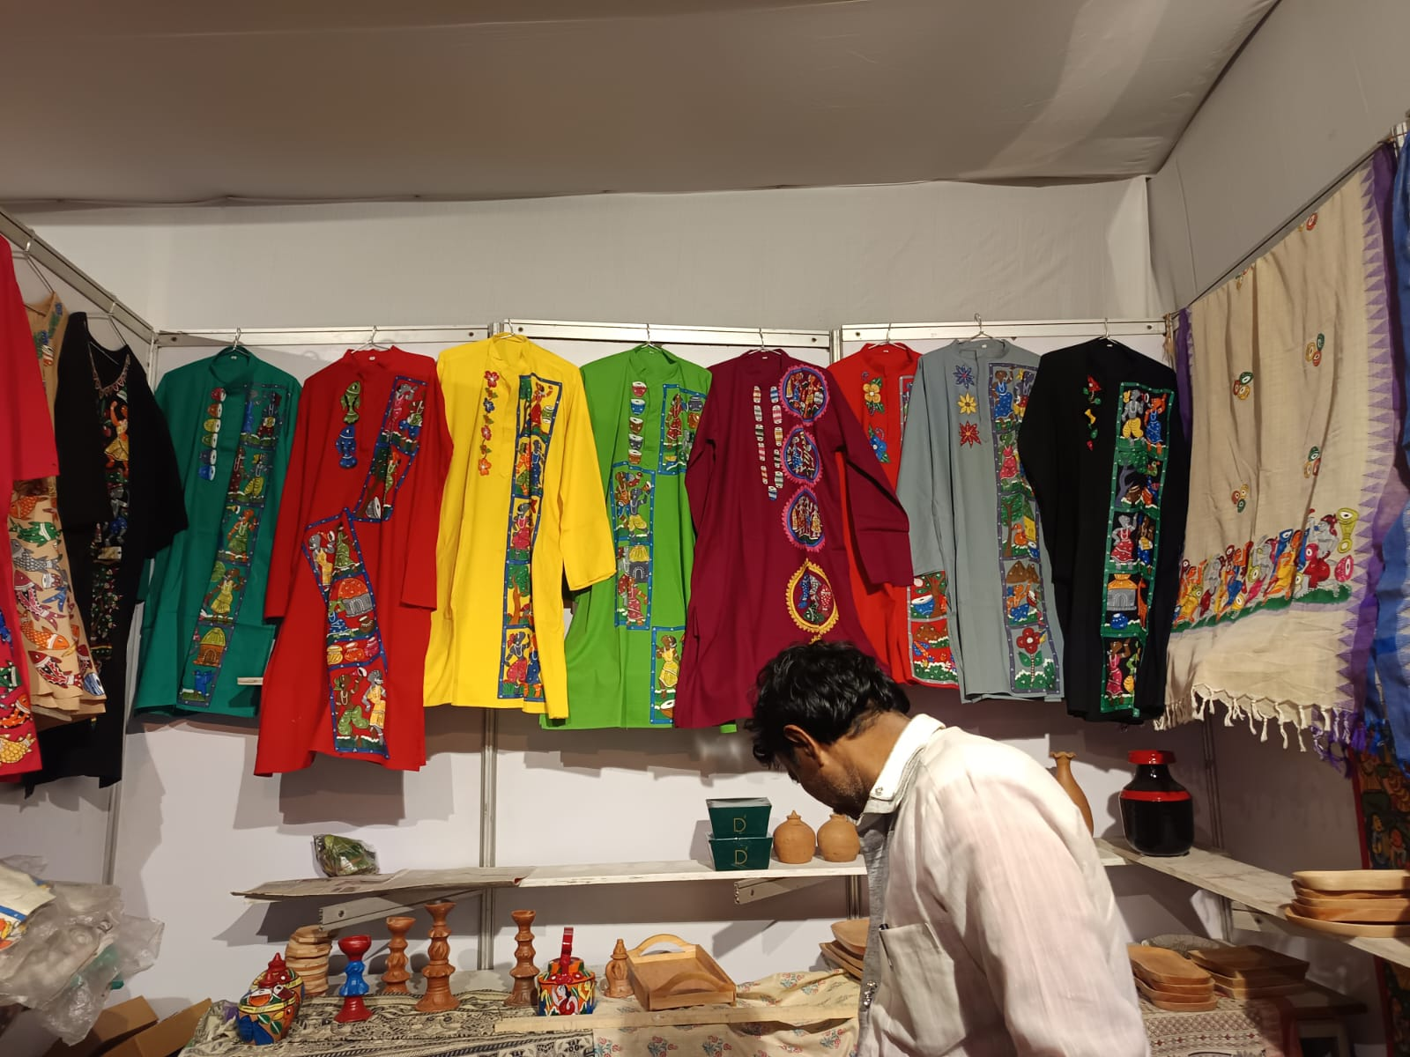

Fig-25, Unisex dress material like Churidar orna, Tee-shirt (Pangabi) etc.

Significant socio-economic status of Pingla Patachitra(time: mid 18th to 21st Century):

At present several chitrakar had been engaged themselves for advanced outlook in the field of patachitra saturated with mordern concept applicable in various puja pandals (esp. in Durga Puja) & other veriety of advertisement; this versatile concept had been introduced in the art of patachitra. That is why the demand of scroll painting has been reduced to a great extent in comparison with latest achievement. In various handicraft festivals such as Handicraft fair in Kolkata and different side.
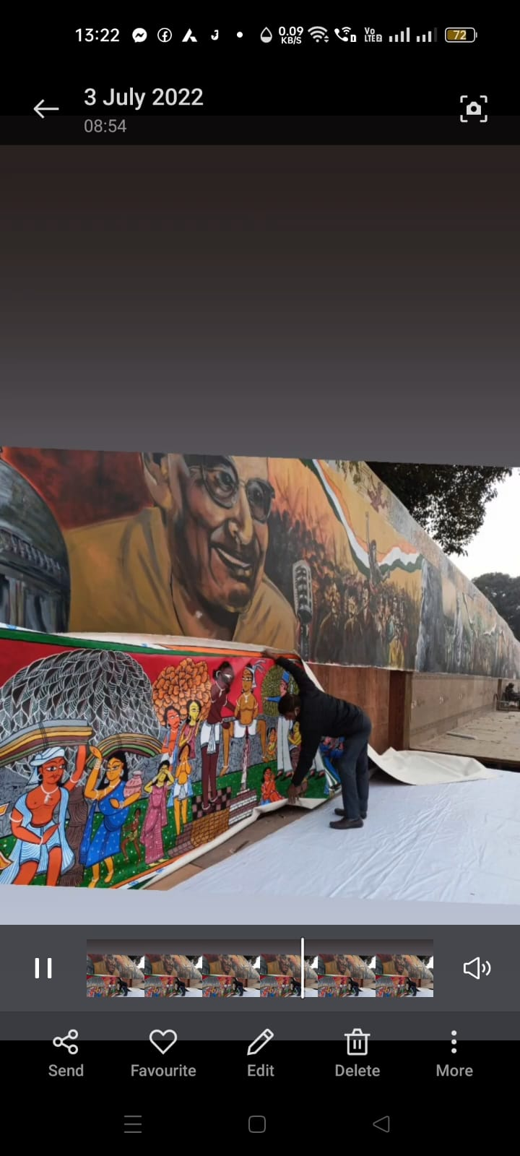
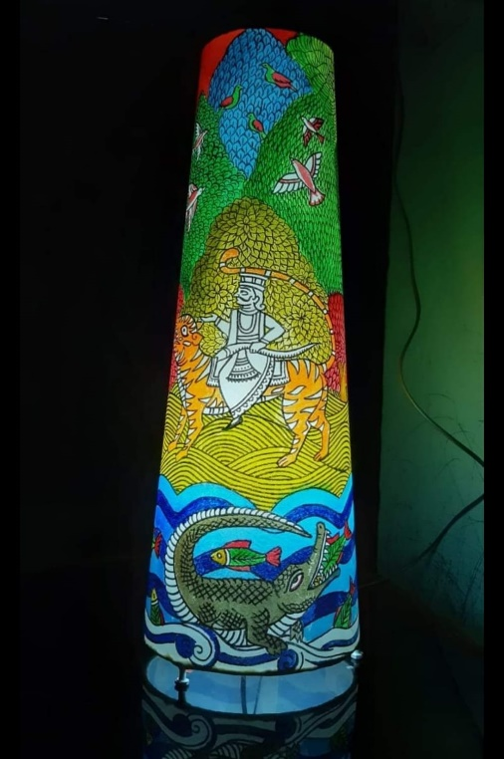

Fig-27, Application of modern concept with the decoration in puja pandals(lamp).
Fig-26, In 2022 sri Bahadur Chitrakar engaged in decoration with folk arts on both sides of the entrance of honorable President House, New Delhi.
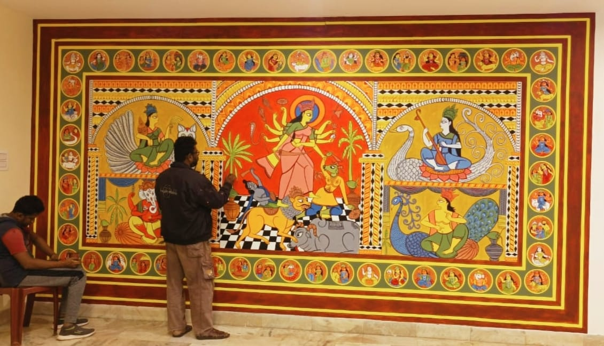
Fig-28, Decoration within the tack Sal, Salbani, Medinipur. Time-2023 for the commercial purpose.

RESEARCH AND DEVLOPMENT SCROLL PAINTING:
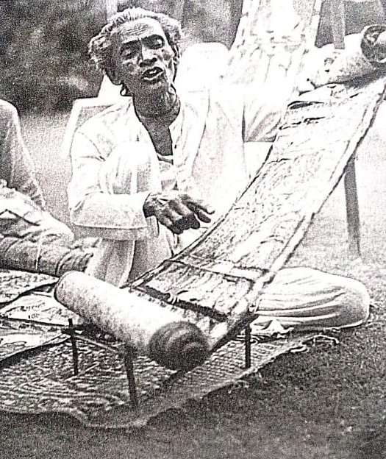
Really this community draws on the Pata, this word comes from Sanskrit word ‘Patta’ that means cloth. This group of patua had not only been drawn the sketches but also composed folk-lyric telling a tale about the relevant drawings when he unfurled his scrolled painting to the visitors concern.
Fig-29, DISPLAYED OF SCROLL BY FOLDING WITH LEFT HAND, AND PERFORMING WITH RIGHT HAND The researcher found a picture of demonstration of patachitra collected from the author Thomas Kaiser “Painted song” continuity and changes in an indian folk Arts. Page ref-42...

This peculiar pata-song being defined as ‘Pitar song’ played a vital role for most entertaining feature for the people of Bengal in various religious and social rituals. In the particular area in Naya village there are more than 135 families attached with the profession of pata-art and Patua-songs (patachitra). Patua-songs are cultivated with the versatile topics of “Manasa Mangal”, “Ramayan”, “Krishna-lila”, “Fish marriage” & the relevant “social events message” etc. The following renowned Chitrakars namely, Sri DukhuShyam Chitrakar, Samsunder Chitrakar, Husbend of Swarna Chitrakar, Bahadur Chitrakar, Mohim Chitrakar, Rani Chitrakar, Gouri Chitrakar, Jaya Chitrakar, Pulin Chitrakar had been concentrated their achievement in the Lila episode and mordant topics to the great extent.

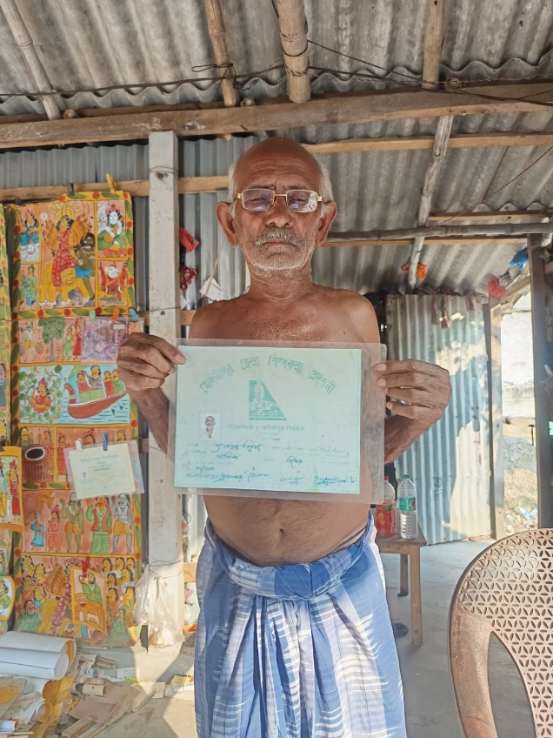
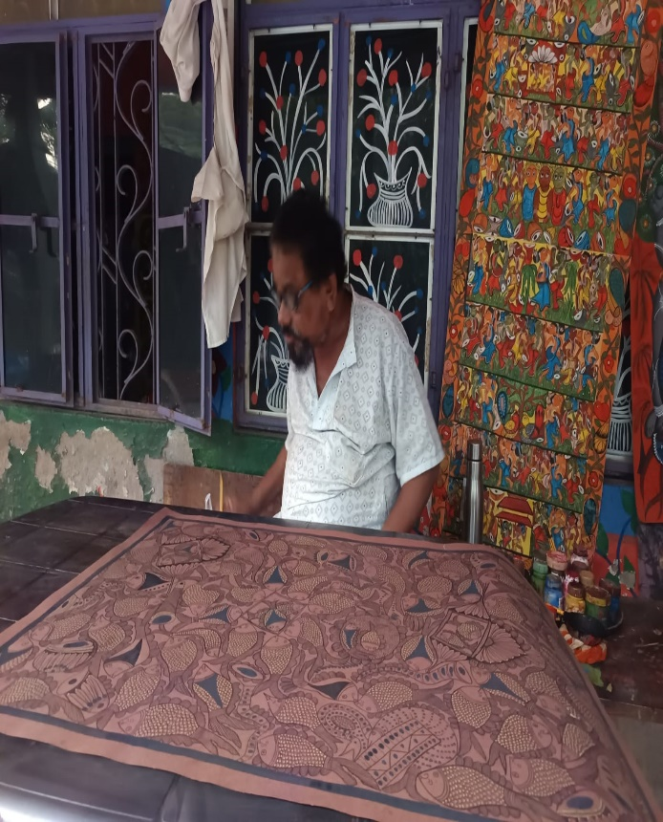
Fig-31, Samsunder Chitrakar,
Fig-30, Husbend of Swarna Chitrakar
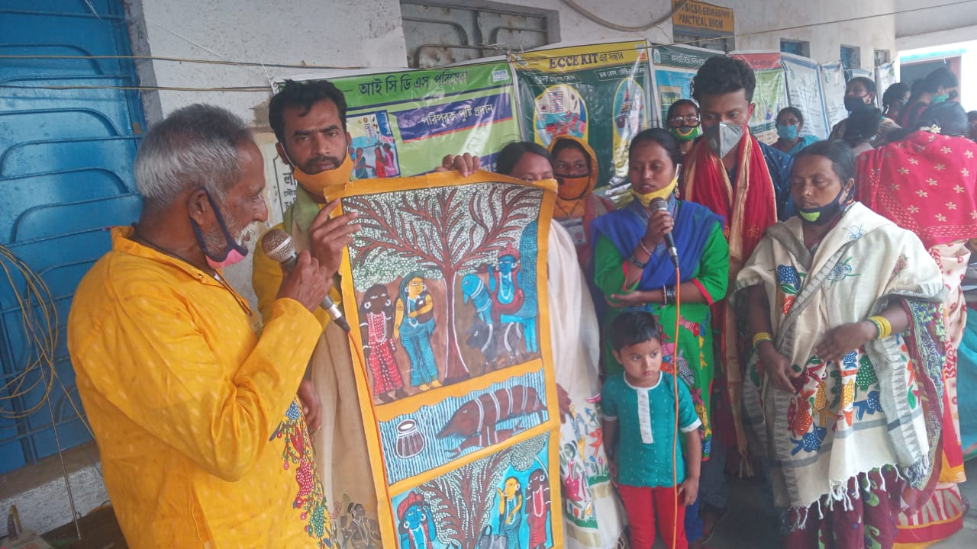
Fig-32, DukhuShyam Chitrakar, and Mohim Chitrakar.

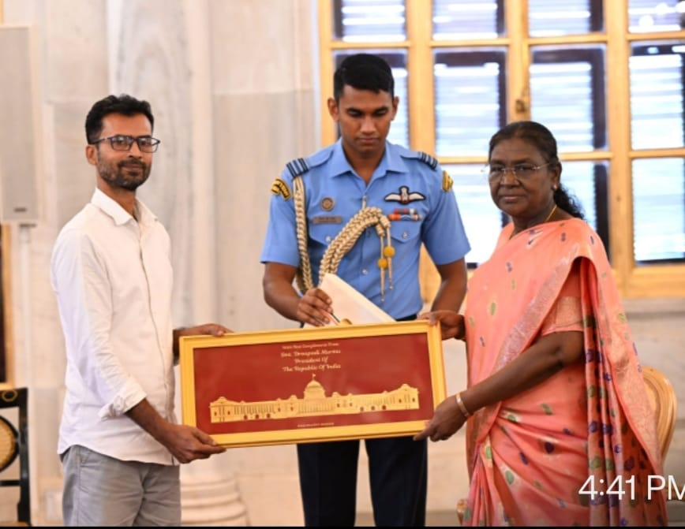
Fig-33, Mohim Chitrakar the Awarded by honorable President in India.
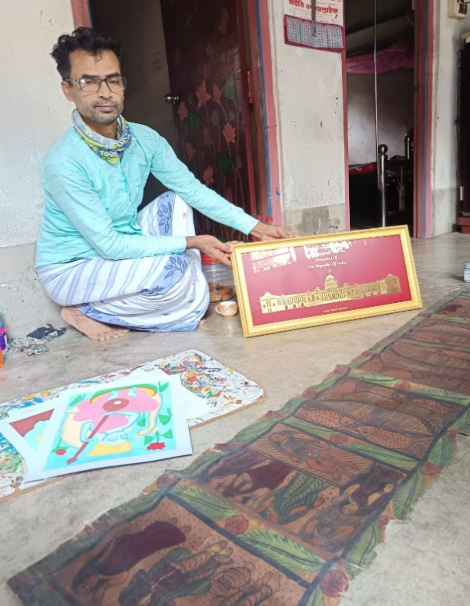
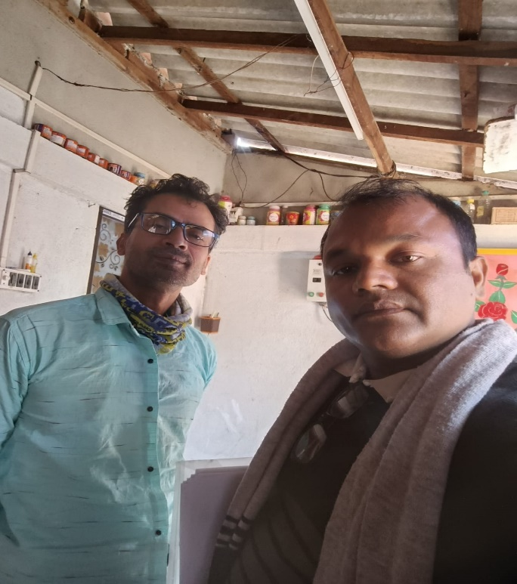

Fig-34, Mohim Chitrakar,
Fig-35, Mohim Chitrakar, and researcher

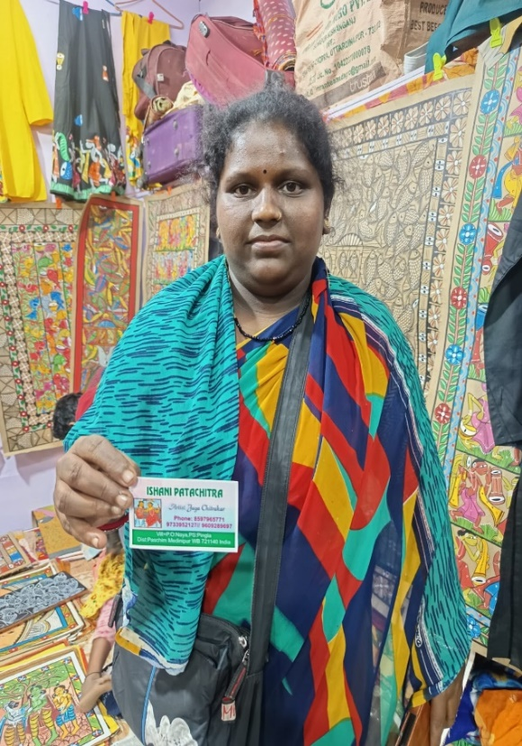
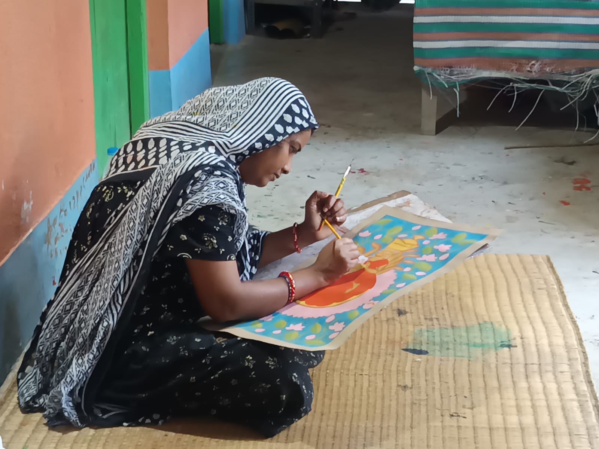
Fig-36, Jaya Chitrakar, Naya.
Fig-37, Daughter of Bahadur Chitrakar (Rupsona Chitrakar)

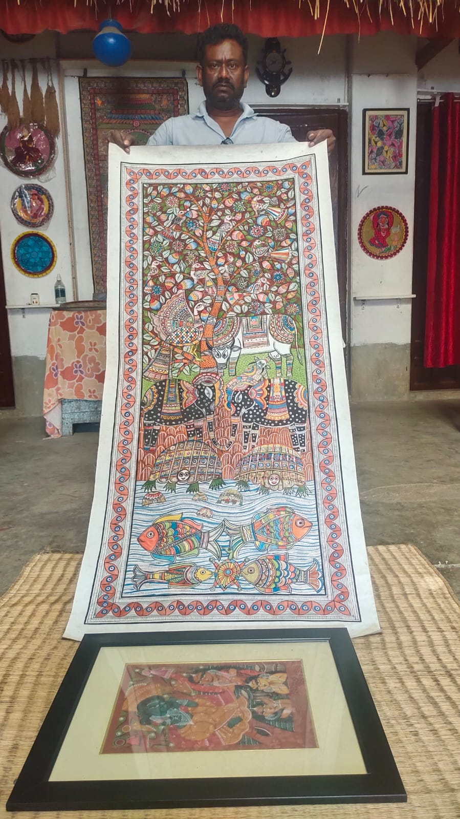

4

Fig- 38, Mr. Bahadur Chitrakar, displayed the medium size scroll painting based canvas, analogous to Madhubanu style, with Acrylic colours.

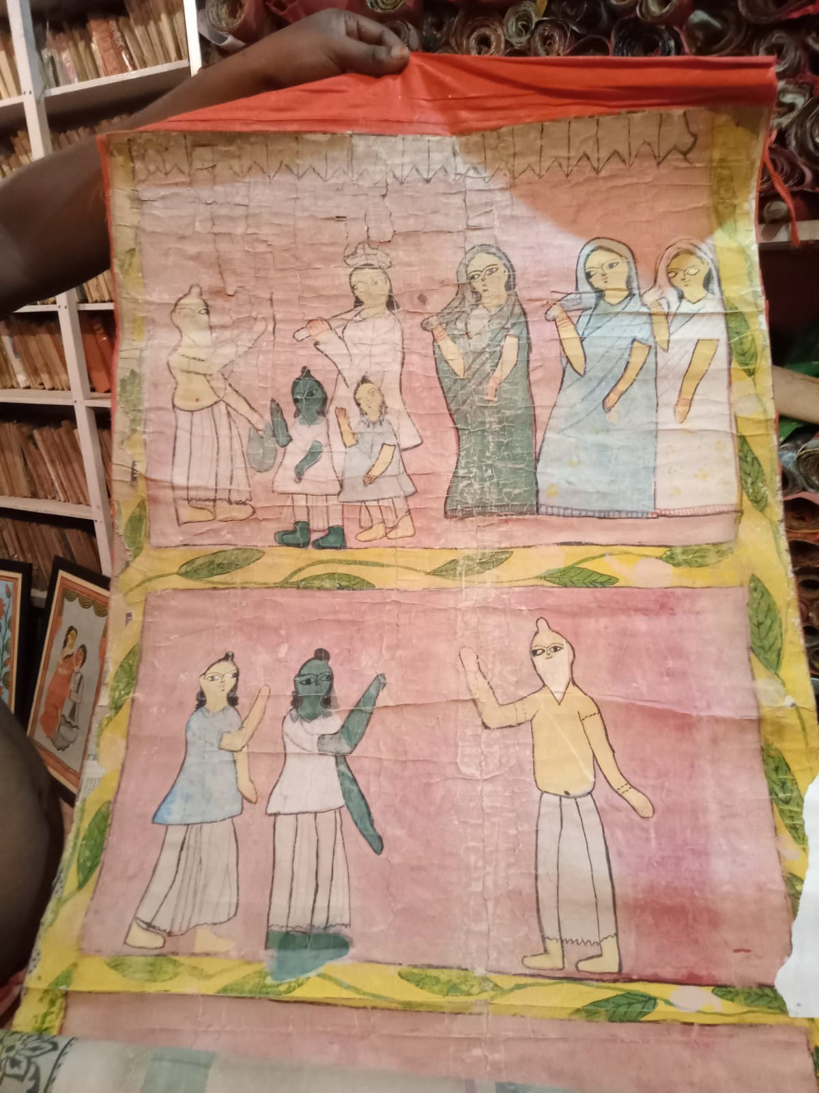
The main ingredient of patachitra was the “pachi” worn cloth. It was the net like /rough cloth. This rough cloth by the treatment of solution of chalk dust amalgamated with seed of “tamarind” Suitable for smooth Scroll painting. This proses was carried out before the invention of modern paper. When the modern paper was available in affordable price the chitrakar use to carry out their activity in modern Chinese paper. Usually the length of patachitra was twenty to thirty feet approx. One and hale feet with but initially such lengthy paper was not available in the market. That is why they use to combine small pieces paper by stitching as per their requirement. Then started sketching the relevant patachitra, the length of the patachitra was proportional to the volume of the folk lyric. And the pratachitra was segmented to ten to twenty parts approximately. In course of time the patachitra was deteriorated gradually due to overuse of the patachitra. In order to strengthen the patachitra the use to laminate with worn cloth with the solution of flour, gum made of tamarind seed and “copper phosphate” etc.

Fig- 39, The Old Scroll Painting in painted more than 100 years.
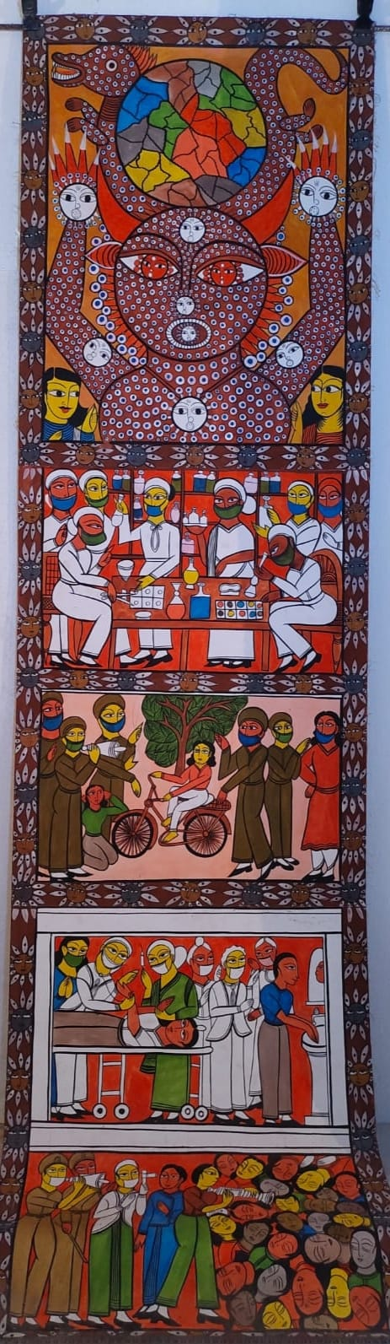
Bahadur chitrakar expressed his views that in mordant times the chitrakars use to create various patachitras on the use of contemporary features like R.G.Kar issue, “kanyasree”, “social knowledge or perception of a situation or fact Coronavirus disease”(COVID-19), “pradhanmantri sachya bharat”,”women education” etc. The colour use in patachitra was changed as per the demand of the customer but the image of personality was differentiated by dress. Now a days the patachitra is manufacture on commercial view point asper the choice of the costumer. The main ingredient of patachitra was the “pachi” worn cloth. It was the net like /rough cloth. This rough cloth by the treatment of solution of chalk dust amalgamated with seed of “tentul” Suitable for smooth Scroll painting. This proses

Fig-40, Latest Scroll Painting (COVID-19)

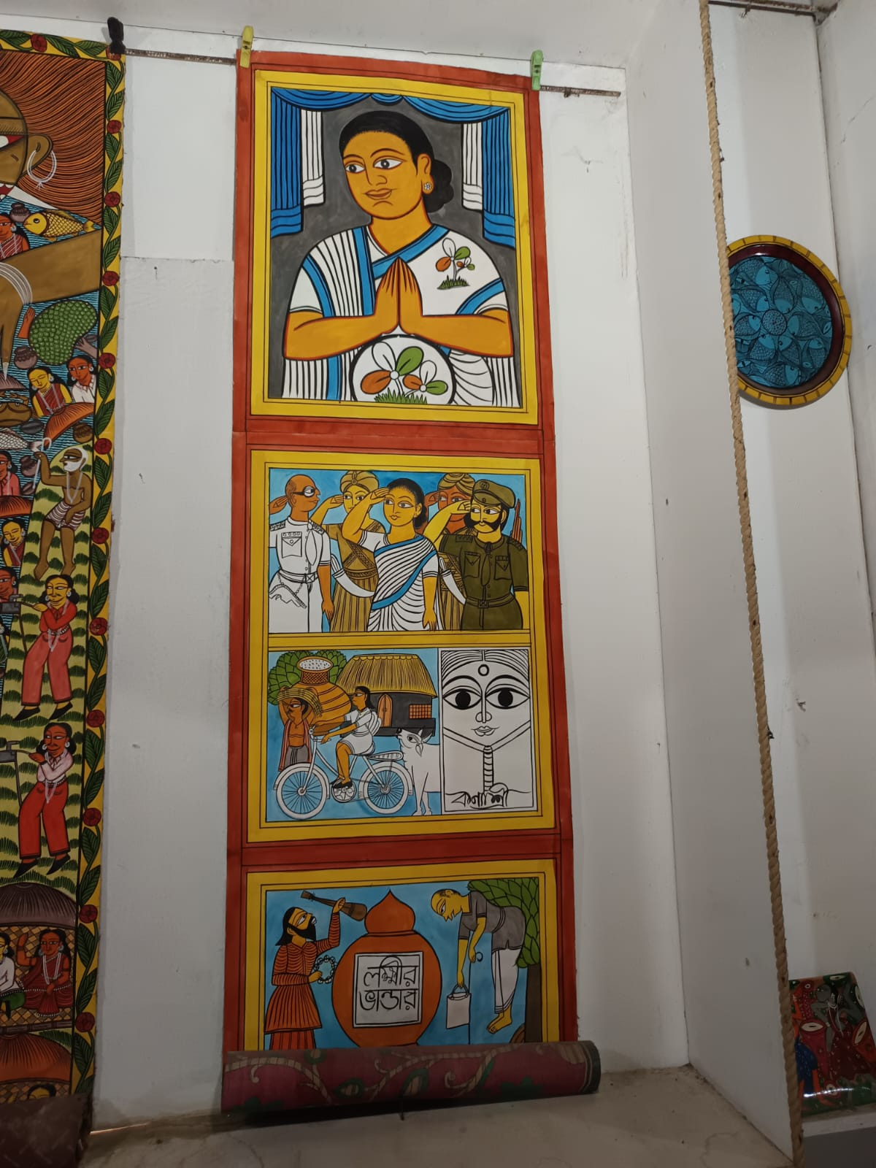
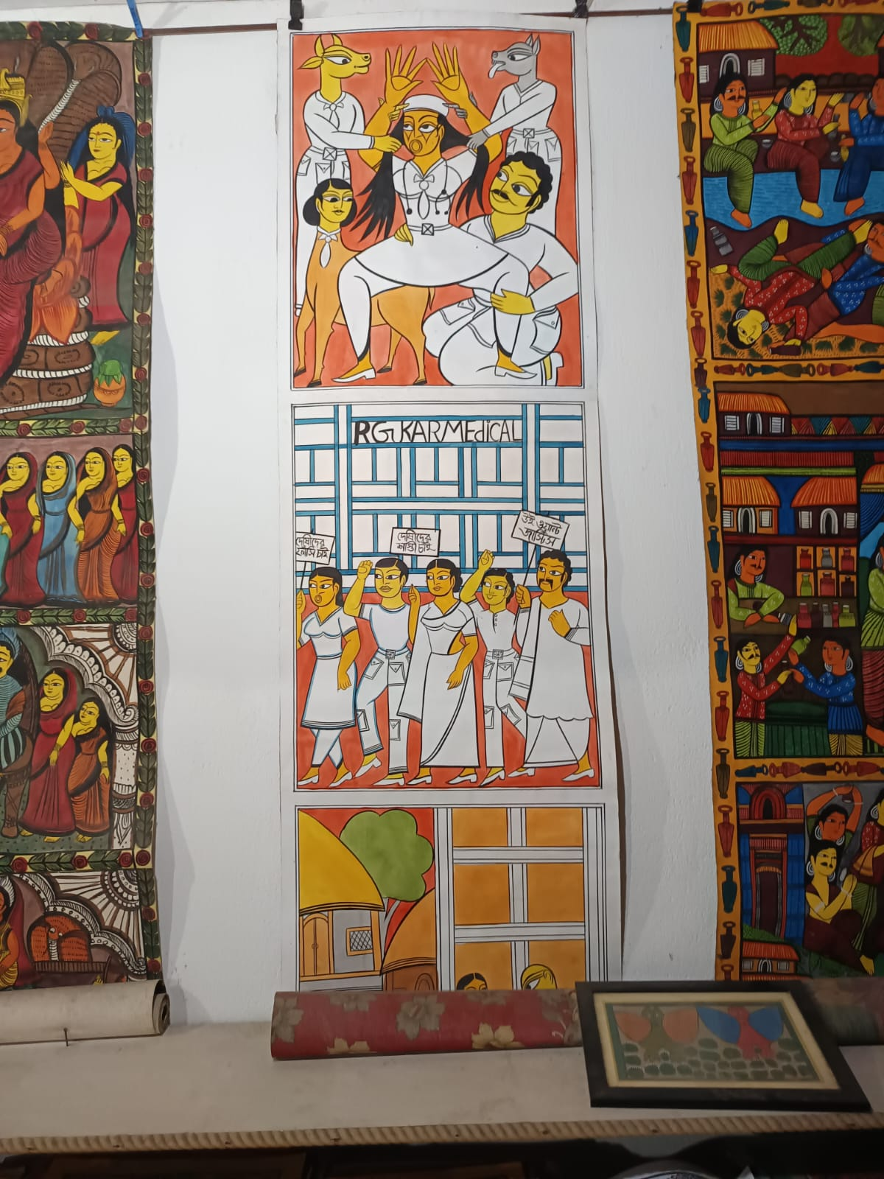

Fig-42, Latest Scroll Painting Laxmi Vhander.
Fig-41, Latest Scroll Painting R.G.Kar issue.

USAGE OF TOOLS & GADGET IN SCROLL PAINTING:

Painting brush: In old period the Chitrakars themselves made brushes with long hair which was cut from the neck and tail of the goat, tail of Squirrel and jackal etc. Then these were tied to small branch of a bamboo (The cut piece would be 10 inch to 12 inch long) stick with the help of thread. In case of fat brush more hair was used, for medium brush medium quantity of hair was used, again for eye drawing long hair very small quantity was used.
Glipe(Container for Gadget): These Chitrakars always used bag for carrying the equipment of scroll paintings.

Technical Process of Glue making for colour of Durability in Scroll Painting:

Glue from wood apple: The chitrakars used to prepare colour from various ingredients. Then glue of ripe wood apple which is adhered to its seeds was collected and mixed it with water to strain through a sieve or mosquito net. Next it was stored in clean bottles. These bottles were kept in sunshine day after day for its relevant consistency. In this way this glue of wood apple was made through heat of the sunshine.

Process of Barley (Hordeum vulgare) Glue making:
Glue of barley was gotten from the stem of barley plant. It is white in colour but as like as ginger to look. After washing them in water its skin was peeled off. Next it was rubbed with water on strainer to get pulp. This pulp was stored in a pot. After two or three hours the heavy particles were collected precipitated down of the pot. Clean water of the surface of the pot was thrown out. Then heat was applied on it with water (Ratio Barley: water: 1:10). At the time of heating when the mixture would become thick then the glue of barley was made. A little Copper Sulphate (Cu SO4) was also added to it so that the insects were unable to deteriorate the quality of scroll painting.

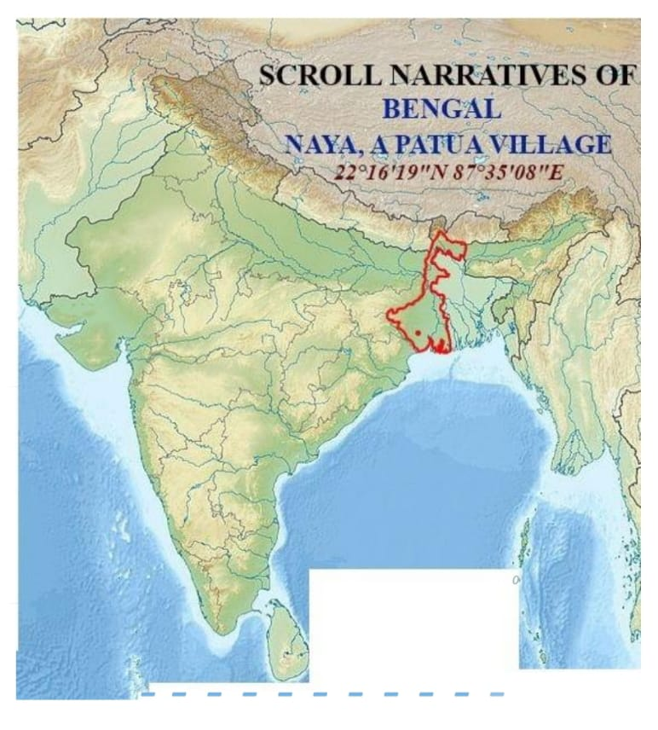
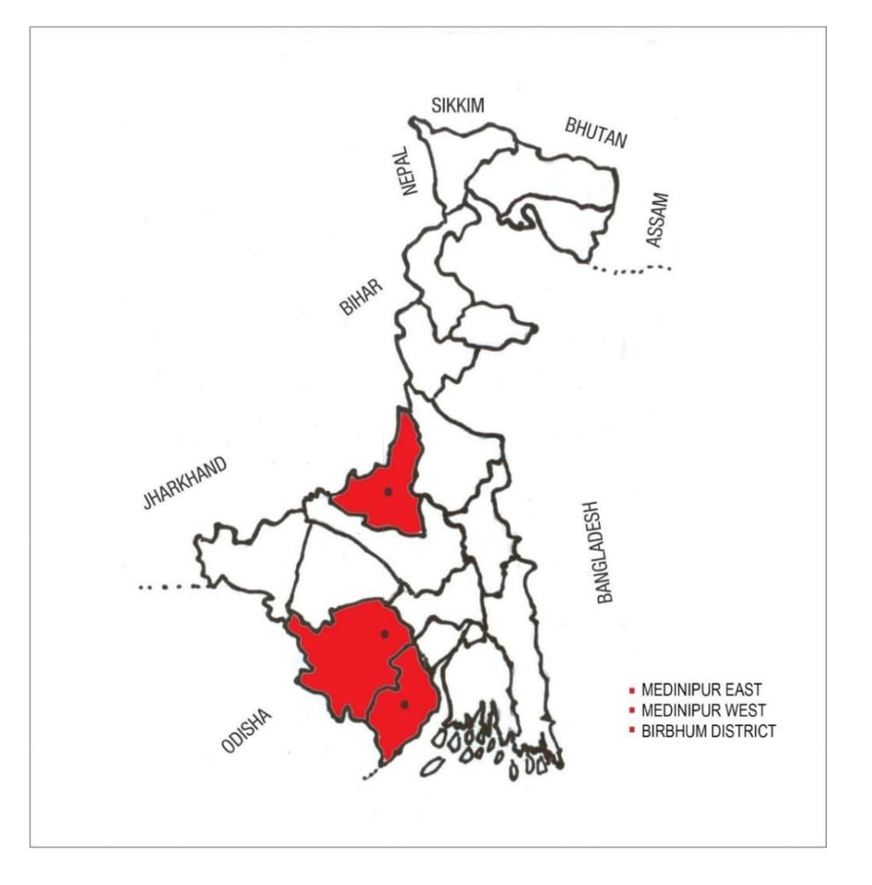
Fig-43, THE MAP OF INDIA
Fir-44, MAP OF INDIAN STATE WEST BENGAL
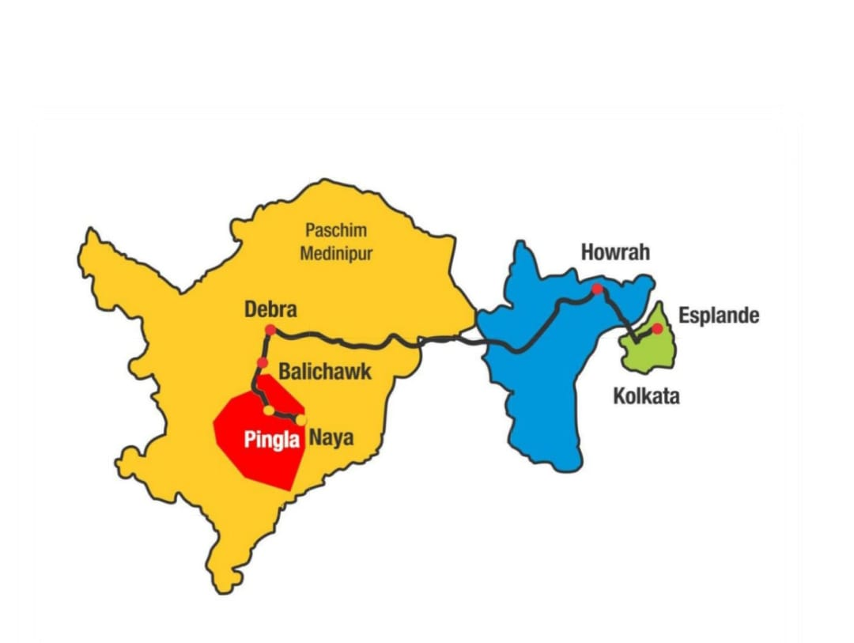

Fig-45,VILL- NAYA, PINGLA. DIST-WEST MEDINIPUR-721140, STATE- WEST BENGAL

MAINTENACE PROCESS OF OLD SCROLL PAINTING:
The age of the picture (scroll painting) is about hundred years old. For this, it is not in good condition. In one time this scroll painting was carried to villagers to display their picture in compatible with the folk-lyric. In this way the scroll painting was unfurled and furled repeatedly, so the consistency was deteriorated gradually.
Problem of identity:
- In course of time the colour of the scroll painting has become fade in various segments. Especially the yellow colour is converted to fade rapidly.
- The Scroll painting is just 14feet 7 inches long and 21 inches wide. Because of such length the upper part of the unit has become badly deteriorated.
- This scroll painting was divided in to 11 segments concentrated with the story of Ramayana. Among them the deterioration of 1st, 2nd and 3rd segments had become very prominent.
- Among these Kahini chitras 6 & 7 episodes have been restored in good condition more or less.
- The 11th segment of the episode (the last part) is large enough and its deterioration status is negligible.
- The colour of the picture in the last part is still bright.
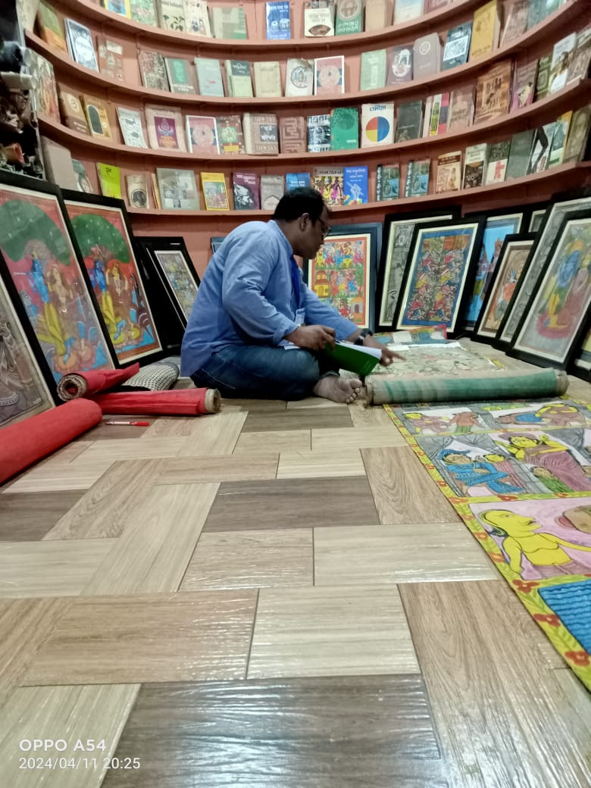
Fig-46, Researcher at Observation of old Scroll Painting
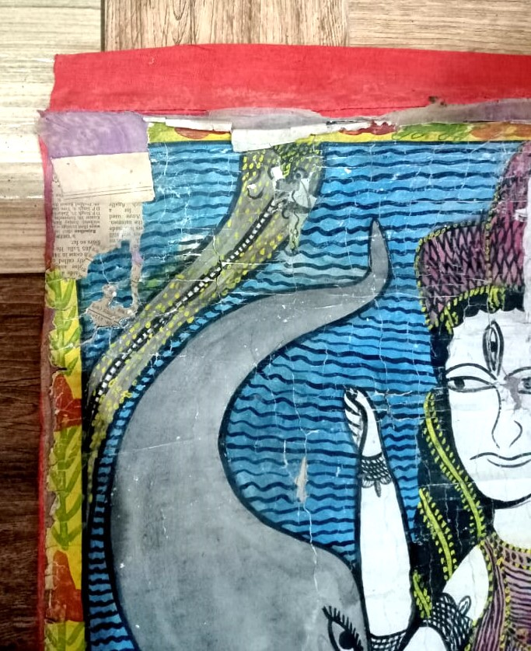
Fig-47, Deterioration Part of old Scroll Panting

Fig-48, Old Scroll Painting of “Manasha Mangal”

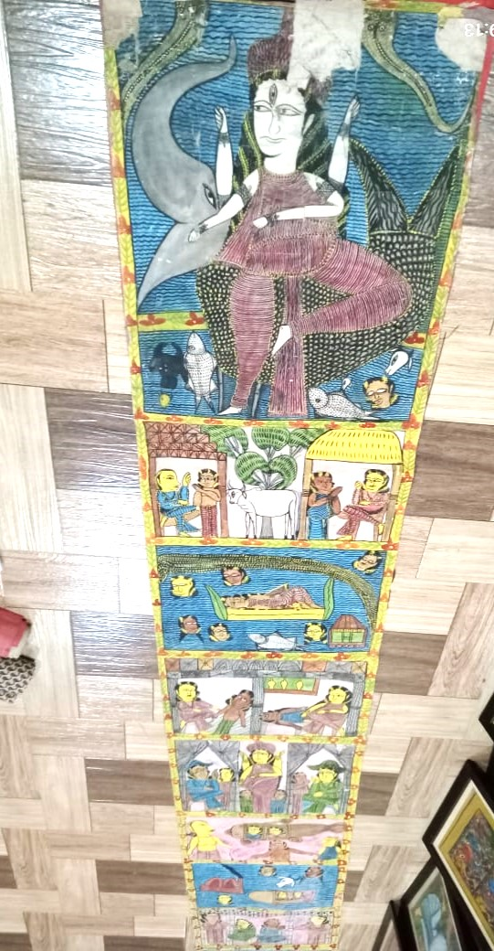
CASE STUDY:
Introduction:
The Bahadur Chitrakar has possessed of an own museum where the researcher observed many scroll paintings belonged to Pingla and other sector of the country. He carried out a thorough case study of one old scroll painting collected from the museum and another new scroll painting collected from Sri Shyamsundar Chitrakar House. Two scroll paintings were of Pingla Village.

OLD SCROLL PAINTING:

Artist Name: not mention the Scroll Painting Chitrakar name,
Time Period: The Scroll painting time more than 90 to 100 years old (specified by Bahadur Chitrakar).
Size: 14 feet 7 inches X 21 inches
Collection: The museum by Bahadurb Chitrakar house.
Title: Ramayan is the main subject of these scroll paintings.
After the marriage ceremony of Ram-Sita, Ram went to forest for exile to reside for 14 years. During the phase of settlement in the forest Laxmana the younger brotherof Ram Chandra cut the nose of Supanakha (Rabana’s Sister). To take revenge of that action Rabana abducted Sita(wife of Ram Chandra) and carried her forcefully to the kingdom Lanka.
Material: old scroll paintings was made on the basis of technical aspect.
Fig-49, Old Scroll Painting in Naya, Pingla
Paper:
Thin handwriting paper and thin art paper were used for this purpose. Total measurement of this scroll painting is length 14feet 7 inches and width 21 inches. In that period it was impossible for the chitrakars to buy such lengthy paper. So they joined many pieces of papers and art papers by stitching with needle and thread. In this way they could increase its length and width as per the requirement for the episode. That is to say, the chitrakars could make scroll painting of different sizes in proportional to the volume of episode. The scroll paintings are divided into different segments in proportional to the volume of the folk-lyric as well as for the purpose of easy access.

Cloth:
When painting was completed on paper, after stitching several pieces of papers, After prolonged usage these thin papers become deteriorated gradually, then the segments are laminated with the worn dhuti and saree being pasted with additive dough (herbal gum & relevant chemicals) at the rear side of the scroll painting for enhancement of its durability.

Colour: In Old Scroll Painting the natural colours like Red, Yellow, Green, Blue etc. were used which were prepared by handmade process from herbal organism and mineral resources. The researcher observed minutely the practical colour processing from Sri Shyamsundar Chitrakar house, Bahadur Chitrakar & Smt. Swarna Chitrakar etc. at their homestead.
Green Colour: From bean leaves, Halencha leaves, Mint leaves etc.
Red Colour: (i) Seed from Latkon fouit.
Yellow Colour: From Turmeric, Raw Turmeric, Yellow purple of Marigold flower etc.
Blue Colour: From Clitoria ternatea. (Nil kanthya)
White Colour: From sunned rice, Ghusum soil etc.
Black Colour: Sublimate of lamp soot, charcoal from burnt wood etc.
Purple: Seed of puin vegetable organism.

New Scroll Painting:
Title: Flood
- Artist: Name: Shyam Sundar Chitrakar, Time Period: The time- 2023 AD,
- Size: 34 inches X 8 inches
Collection: Shyam Sundar Chitrakar House.
The researcher met with Sri Shyam Sundar Chitrakar on 10.04.2024 and he was experienced with the number of epoch making scroll paintings of his own being preserved in his home. There was a lot of diversity in the Scroll painting being observed in his home.
The researcher wanted to know about the reason for the small (miniature) size of the scroll painting than earlier period. Shyam Sundar Babu clarified that at present the large scroll painting is hardly made because

Fig-50, New Scroll Painting , Artist by Samsundar Chitrakar.
Of inadequate space provision for the consumers who purchased the items at the affordable price @ Rs. 500.00 to 1000.00 or more. Usually the larger scroll painting were provided within the large spaces in the large house or king’s palace. At present there is hardly any king’s colossal palace found anywhere. So, pictures (scroll) are not made any more for the Babu Shahib of the king’s palace. Now most of the scroll paintings are made for all interested consumers belonged to middle class of the society so that they can purchase these products easily at affordable cost price.

Reference: Once when Medinipur district had undergone inundation (flood), at that time Hon’ble Chief Minister, Sri Jyoti Basu of West Bengal accompanied with Hon’ble Prime Minister of India, Sri Morarjee Deshai visited many flood affected areas and distributed relief among the flood victims. Sri Shyam Sundar Chitrakar displayed many different scenario of that time through his scroll paintings.

Surface: This new scroll painting was not drawn on paper. It was totally drawn on the cloth.This cloth which is naturally used in making shirts and trousers is pure cotton which was purchased from the market according to public demand.
Thr horizontal size is only 34 inches and width 8.5 inches. Natural Colour is done directly on cloth.
Colour processed after mixing leaves, flowers, terracotta ect with the herbal glue of wood apple etc.

This scroll painting is usually made by drawing on a single full cloth without any stitch anywhere.
The researcher found an Old and New Scroll Painting collected from the author Dr. Subrata Kumar Manna“Banglar Patchitra, Patua Sangeet, Patua Samaj O Lokosanskriti Vijnana”, page ref 21.
1. The main ingredient for Old Scroll Painting were used for jute cloths or coarse cloths. And the main ingredient for New Scroll Painting are used for loin cloth or silk cloths.
2. Old scroll painting jute or coarse cloth were laminated with the dough of cow-dunk solution with gum (Herbal). And new scroll painting no such lamination process are used over this cloth.
3. Old scroll painting the wrinkling surface over cloths were saturated with dew for whole night, then the uneven surface is smoothened by virtue of ironing with the rolling pin. On the other hand new scroll painting the cloth are smoothen by way of calendaring process.
4. Old scroll painting base surface of the cloths were painted with white colour (Natural/ Herbal). And no such colours are used on the base surface in case of new scroll painting.
5. Old scroll painting variety of indigenous handmade colours were used for painting purpose. And in case of new scroll painting generally variety of synthetic colours (fabric, enamel, acrylic etc.) available from market are used and in addition to traditional handmade colours may be used.
6 Old scroll painting usage of herbal gums being prepared from wood apple, Sulphur, copper, sulphate, wax, seed of Tamarind, gruel of sunned rice. New scroll painting indigenous handmade colours especially traditional wood apple glue are used, otherwise the major synthetic colours materials being available from market are utilized for the sake of commercial gain.
7. Old scroll painting: selective colours like Red, Yellow, Blue, Green, were not only used for prominent shade but also they adopted various skillful manipulating process of colour mixing for preparation of new synthesis of colour combination. And new scroll painting the selective colours like crimson red, deep red, saffron, blue, deep blue, sky blue, reddish yellow, yellow, green, bright red, white etc. are all available from market at affordable price.
8. Old scroll painting handmade brushes made of hair of different aged goat, fur of squirrel tail, fur of jackle, jute wool, and cocoanut fiber (husk) etc. And new scroll painting generally all types of brushes made of synthetic materials are available from the market; sometimes they may be used traditional handmade brushes prepared from the hair of the goat and fur of the squirrel tail.
9. Old scroll painting cloth ware rolled on the bamboo-stick for the length of 20-30 feet or more and width of approx.1.5 to 2 feet. And new scroll painting in the set of long cloths of saree, dhuti, churidar orna, and pandel decorative cloth materials etc. are used for the purpose of scroll painting of miniature size in accordance with the public demand.

Conclusion:
The researcher conducted several investigations on the topic of technical and analytical aspect of old and new Pingla patachitra, he had come to the conclusion as follows:
It was learnt from the book “5000 years of INDIAN ART” texted by Sushma k Bahl on the issue of BHIMBETKA cave painting that the primitive men created the surface cave wall processing by rubbing with harder material and it was smoothened by the process of lamination with the fatty viscera of different animals similarly in 5th century AD the identical surface processing was experienced in various intramural painting like Ajanta, Badami, Sigeriya, etc. Thereafter the Scroll Painting of more than 100 years old the technique of surface processing adopted the same principle of ancient method by the Pingla Patachitrakars. When the modern papers and cloths were available in the market the chitrakars used to utilize the ingredients directly for painting purpose without surface processing.
The treatment of variation of colour combination in ancient process had been adopted in modern technique of Scroll painting more or less. On the contrary (during the phase mid-18th to 21st century) the modern contemporary chitrakars had been used variety of synthetic colours available from market at affordable price for achievement of commercial gain.
In view of Socio-economic-politico changes during the phase of mid-18th to 21st centuries the contemporary chitrakars used to take advantage of several methods for creativity in the modification of Scroll painting in home and abroad(like- U.S.A, Japan, U.K, Africa, etc.) for the massive economic development. At present the modern chitrakars used to encourage their next generations to uphold and cherish and subsequent development of this profession. Thus the overall socio-economic development had been experienced in the Patachitrakar society.

BIBLIGRAPHY:

- Frank, J. Korom. (2006). Village of Painters, Narratine scroll from West Bengal. China; Library of Congress Cataloging-in-Publication data.
- Maiti, Dr. Chittaranjan.(2001). Prasanga: Pat, Patua O Patua Sangit. Kolkata; Published by Nepal Chandra Ghosh.
- Thomse, Kaiser, (2012) Painted songs. Continuity and change in an Indian Folk Art, Germany, Printing; Leibfarth & Schwarz, Dettingen/Erms.
- Manna, Dr. Subratakumar. (2012). Banglar Patchitra, Patua Sangeeet Patua Samaj O Lokosan- Skriti Vijnana, Kolkata; Published by Pharm K.L.M. Private limited.
5. Smith, Edward Lucie (1992). Art and Civilization. Published by Laurence King.
6. Kejriwal, H.Kcollection (2003). “Arts of the earth. Sponsored H.K. Kejriwal Foundation Bangalore.
7. Pati Bhaskarbrata (2019). Loukik Medinipur, 1st Edition. Published by Kamolesh Nandi.
8. Kishore Naveen, Seagull Books (1990). Gurusaday Duitt, Folk Arts and Crafts of Bengali the Collected Papers. Published by Naveen Kishore, Seagull Books,Calcutta.
9. Mandal Keya, (First: 2014). Folk Album. Published by Corpus Research Institute, Kolkata.
10. Mandal Keya, (First: 2016). “FOLK HISTORY AND ART”, Vol-1. Published by Corpus Research Institute, Kolkata.

11. Santra Tarapada (2011). Folk Arts of West Bengal and the Artist Community, Published by Niyogi Books:New Delhi, India.
12. Raut D.Khokon, (2023).Early Bengal Oil Paintings. Published by Aayu Publications, New Delhi.
13. Santra Tarapada,(1987).পুরাকীর্তিসমীক্ষা:মেদিনীপুর, প্রকাশকঃ প্রত্নতত্ত্ব অধিকার তথ্য ও সংস্কৃতিবিভাগ।
14. Bhowmik Shibapada and Bhowmik Susmita(2006).Loksanskriti Charcha; (লোক সংস্কৃতি চর্চা), Kolkata.

