Socio-Cultural Elements, Customary Legal Mechanisms Versus Legal Marital Termination: in the “KINNAURA” Tribal Community in the Kinnaur District in Himachal Pradesh

¹ Ravindra Kumari
Research Assistant (ICSSR- Project)
Department of Civil Engineering,
Indian Institute of Technology
Ropar, Punjab
**Dr. Sanjay Kumar
PhD, PDF Education
Sanjayt247@gmail.com
***Sreekuttan E
Research Assistant (ICSSR- Project)
Department of Civil Engineering,
Indian Institute of Technology
Ropar, Punjab

Abstract
This research focuses on the dynamics of the marital breakup in the changing marriage dynamics in the most traditional tribal civilization of Himachal Pradesh, the Kinnauri tribe, whose historical patterns have been typified by unique social arrangements such as, fraternal polyandry. Based on the latest figures, Kinnaur has a higher rate of separation of 0.30 percent as compared to Himachal Pradesh, which has the lowest rate of legal divorce in India (0.18 percent). This implies that traditional settlement is the choice of action as opposed to civil action.
Objective: Finding the economic and cultural factors that favor divorce within the Kinnauri community and documenting the practices based on such disintegrations are the primary objectives of the study.
Methodology: The research is based on the qualitative research technique, with the study being carried out in the Kinnaur district, with six tehsils. First-hand data was collected using twelve focus groups, interviews with tribal women to be supplemented with additional documents provided by the academic journals, the 2011 census and NFHS-5 reports.
Findings: The findings indicate that shifting gender roles, financial independence of women, and the impacts of migration and urbanization are some of the factors that are causing divorce. Although old issues, such as issues of wealth and jealousy in polyandrous marriage, remain relevant, more individuals, particularly women, are now being empowered to seek separation because of the growing judicial consciousness and the decreasing social stigma. In this paper, the traditional procedure called the Shing Tag Tag was outlined, whereby conflicts were settled and property shared under the supervision of Panchayats and the village elders. Ultimately, the divorce in Kinnaur is a community but not an individual legal issue, which is a skillful attempt to create a balance between tribal traditions and adaptation to individualistic values of modern life.
Keywords: Divorce, Kinnaur, Customary-Law, Marriage, Ethnic-Study, Fraternal-Polyandry
Introduction
Like many other ethnic tribes, the divorce rate in Kinnaur is affected by traditions and mutual values that are rooted in the community. Kinnauri people are famous because of their own traditions, such as polyandry- a tradition where a woman is married to several men, who are brothers, and in some cases. Wedding rituals and overall lifestyle in the society in this environment are mixed up with the concept of separation.
In Kinnaur, divorce is a normal right, although it is not as common as in cities. It is often caused by such factors as spousal strife, incompatibilities, or the failure of a polyandrous relationship. However, depending on the specific tribal practices of the involved parties and the degree of adherence to the customary regulations, the separation process and its consequences might vary.
Kinnaur takes the issue of divorce very seriously because matrimony is a sacred institution that has significant social and economic consequences. Local authorities and parents often play a great role in resolving marital disputes in a bid to keep communal peace and family unity. Therefore, rather than a strictly legal or personal-level affair, the divorce proceedings seem to be very social, and the parents, relatives, grandparents, and maybe the entire community take part in it.
According to the 2011 census and the National Family Health Survey-5 its clearly stated that from the total 84121 number of populations of the state, 57.95% are from the tribal community and 51% of them get married and the divorced are 0.19%, 0.30% are separated. The higher rate of separation points to the wide practice and acceptance of customary law for discontinuing marriages in the communities and less legal orientation for divorce, as table below.
Table 1: Demographic and Marital Status Profile of Kinnaur District (Census 2011 & NFHS-5)
Indicator Value
Total Population 84,121
Tribal Population 57.95 %
Married Population 51 %
Legally Divorced 0.19 %
Separated 0.30 %
State Divorce Rate (Himachal Pradesh) 0.18 %
Source: Census of India (2011); NFHS-5
The separation rate in Kinnaur surpasses both the district divorce ratio and the state average, indicating a strong reliance on customary mechanisms rather than formal legal divorce.
This paper identifies those variables that are the main cause of strengthening marriage termination. The objective of the paper is listed below to achieve the main goal of this paper.
Literature Review
Negi (2014) Negi in his research regarding tribal women of Kinnaur states that both cultural tolerance and feminism exist within tribal cultures. This study reveals that the women of Kinnauri community historically have a relatively higher amount of rights such as inheritance and divorce as compared to women in most other Indian communities. This cultural tolerance will minimize the stigma associated with marital dissolution and enable women to demand separation in cases when they have to (Negi, N. K. 2014).
In this paper will discuss marital and family behavior in the tribal communities in Himachal Pradesh. The authors highlight the fact that such traditional marriage structures as polyandry play a major role in the stability of marriage. Dissatisfaction between husband and wife due to jealousy, sharing of resources and role demands frequently causes separation which is usually meted out through the traditional systems instead of the formal courts (Pathania, R., Kaur, P., and Pathania, P., 2008).
NFHS-5 Demographic census of 2011 and the NFHS-5 demonstrate that the percentage of separation is higher in the Kinnaur district than the legal divorce, although divorce rates in Himachal Pradesh are among the lowest in India. The literature confirms this argument that customary law is still predominant in marital dissolution in tribal areas such as Kinnaur (Census of India., 2011)
The study conducted by India Today on the trends of divorce in India, it is observed that increased education, exposure to the west and the empowerment of women is changing the marriage and divorce attitude. Though in Himachal Pradesh, the rates of legal divorce are low, this study indirectly supports the view of the fact that the decision to marry is highly influenced by the social acceptance and cultural norms in an ancient society (INDIATODAY, 7-April-2017).
The article by Adjuva Legal is devoted to discussion of growing divorce rate in India and emphasizes that women are the ones who start divorce cases most of the time. This trend is associated in the literature with the increased awareness of the law and financial independence. Although it is dealing with legal divorce, the findings are useful in putting the same changes in tribal societies in perspective, whereby awareness and empowerment have already strengthened the practice of separation in the past (Adjuva Legal, December 28, 2022).
Research Gap
Despite the available literature on the role of marriage and divorce in tribal cultures, less focus has been put on customary divorce procedures, experiences of women in societies where divorce is a customary event, and the comparison between the result of a customary and a legally process divorce. These are gaps that limit a holistic explanation of marital dissolution within the setting of the tribal of the Kinnauri.
  - There is a paucity of empirical records of traditional procedure of divorce and decision-making of tribal society in Kinnauri.
  - Insufficient research on the experience of women living before and after divorce in Kinnaur.
  - Lack of comparison of the customary and legal outcomes of divorces in the tribal societies.
Objective of the Study:
- To identify the various factors that strengthen the situation of divorce of tribal society of Kinnaur.
- Mentioning the procedure of divorce in the Kinnauri tribal society.
Methodology:
The first-hand information was given by the participants, and it was collected using additional sources like scholarly journals and reports on press releases. This investigation is carried out at the Kinnaur district of Himachal Pradesh. The responders were selected in the geographical area of Kinnaur in six tehsils. A qualitative research design was used in the research conducted. The sample was chosen as two groups in every tehsil and information was gathered through the focus group discussion method. In the whole study, 12 groups were taken as the sample. Also, the information has been collected with the help of the focus group discussion and interviews.

Table 2: Tehsil-wise Epitome of Data Collection Methods in District Kinnaur
Tehsil | Number of Focus Group | Method Used
Pooh | 2 | Focus Group Discussion / Interview
Kalpa | 2 | Focus Group Discussion / Interview
Nichar | 2 | Focus Group Discussion / Interview
Sangla | 2 | Focus Group Discussion / Interview
Moorang | 2 | Focus Group Discussion / Interview
Hanggrang | 2 | Focus Group Discussion / Interview
Total | 12 Group | FGD/ Interviews
According to the table, focus group discussions and interviews were carried out in the same manner in all the picked tehsils of Kinnaur district. A total of two focus groups were used in each tehsil, namely, Pooh, Kalpa, Nichar, Sangla, Moorang and Hangrang, to maintain a balance. Overall, twelve focus groups were carried out with the help of FGDs and interviews that enhance the reliability and comparability of the data obtained in the region.

Various Factors that Strengthen the Situation of Divorce:
Divorce is common and widely accepted in the Kinnaur tribal society for several reasons. The socioeconomic, financial, and ecological backdrop of the area plays a major role in these issues. The following are the main elements that support divorce in the Kinnauri tribal society.
- Polyandry and Polygamy:
  - • Polyandry: Traditionally, women in Kinnaur have been wedded to several brothers in an arrangement known as fraternal polyandry. Due to this unusual marriage structure, partnerships may get complicated and may end in separation due to envy, arguments concerning assets, and uneven affections.
• Polygamy: Possessing numerous wives, although less prevalent than polyandry, also causes spousal turmoil, especially if wives consider themselves undervalued or competitive with one another.
- Gender Roles and Expectations:
  - • Altering Gendered Behavior: As many women pursue education and work, typical gendered patterns in Kinnaur are shifting. Weddings face problems as a result of this change, particularly if the spouse or his family has traditional ideas about women's responsibilities.
• Empower Women: Women now can stand up for their privileges and file for separation if they feel repressed or dissatisfied in their marriages.
- Economic Factors:
  - • Monetary autonomy: Women find it less financially advantageous to stay in an unsatisfactory relationship as they become better off financially via jobs or investments.
• A lack of Assets: In an area wherein property or animals are essential for subsistence, disagreements on how to divide such assets within a couple might result in a separation, particularly when polyandry or polygamy is involved.
- Migration and External Influences:
  - • Immigration: Men moving to cities in search of employment have put pressure on marriages and caused problems such as adultery, desertion, or protracted isolation that have resulted in divorce.
• Urbanization's Impact: Being exposed to urban lives and ideals has altered standards for marriage and reduced acceptance of customs that are perceived as repressive, like polyandry.
- Social and Cultural Shifts:
  - • Degradation of Customary Behaviors: As monogamous weddings and polyandry become more common, conventional behaviors are gradually disappearing, which is changing how people see and preserve relationships and occasionally raising the separation ratio.
• Judicial Knowledge: People, especially women, now find it simpler to file for separation if they are dissatisfied in their respective relationships thanks to enhanced knowledge of their constitutional privileges and greater accessibility to the justice procedure.
- Community Influence:
• Elders' Role: Although they have historically served as mediators in marriage conflicts, industrialization and shifting societal frameworks have reduced their power in certain regions. As many spouses decide to pursue choices on their own, this change has increased divorces.
• Support of Divorce: Compared with certain different traditions, Kinnauri society does not place as much taboo on divorce, which may make it simpler for people to obtain a divorce without worrying about facing harsh societal consequences.
These variables, separately or in combination, influence the mechanisms of divorce in Kinnauri tribal community, representing the interaction between tradition and technology in this particular historical framework.
The major socio-cultural factors that have strengthened divorce in Kinnaur are:
Table 3: Key Socio-Cultural Factors Strengthening Divorce in Kinnaur
Sr. No. | Category | Factors Identified
1. | Marriage Structure | Polyandry, Polygamy
2. | Gendered Behaviour | Women empowerment, Changing gender role
3. | Economic Aspect | Financial independence, urban exposer
4. | Relocation or Restatement | Male out-migration, urban- exposure
5. | Legal Knowledge/ Consciousness | Judicial Consciousness
6. | Cultural Context | Reduce Stigma
Divorce in Kinnaur is not caused by a single factor but emerges from the interaction of traditional marriage systems and modern socio-economic transitions.
Procedure of Divorce in Kinnaur:
The divorce process has its roots in rituals and traditions among the Kinnauri indigenous community, which is mostly found in the Kinnaur district of Himachal Pradesh, India. Divorce is a personal right that a person can use in any adverse situation. The process of divorce is done by the Customary-Law and is called “Shing- Tag Tag”, and the process is done in the respective village Panchayat. Hence, most of the divorce cases are not in the Civil Court. The procedure is controlled by tribal regulations and is lower conventional than in contemporary judicial frameworks, with a focus on peaceful problem resolution. This is a summary of the standard process:
1. Beginning of Divorce:
- Mutual Acceptance: Divorce is frequently started with the assent of both parties. It is agreed upon by both that they have no desire to stay married.
- Independent Choice: If one person wants to file for divorce, they have to tell the parents, middlemen (the person who conducts marital activity between the bride's side and the groom’s side, which is accepted by both parties) or the elder members of the village why they want a separation.
- Gender Functions: Men and women play different roles during the separation procedure in Kinnaur. Women have greater liberty or power when it comes to separating choices in Kinnauri traditions, while men have significant power or impact elsewhere.
2. Seniors' and the Collective's Function:
- Conflict Resolution: Generally, respected village leaders or seniors intervene to settle disputes between spouses. Their job is to mediate disputes and, if feasible, promote peacemaking.
- Collective Sessions: Both sides may be invited to a local conference to air their concerns if the settlement is unsuccessful. After deliberating, seniors provide suggestions.
- Elders' Role: In many tribal societies, the separation procedure is significantly influenced by the elders. In accordance with conventional procedures, they might assist with the regulation of the separation, provide legal advice, or control conflicts. Elders can have a complicated and multidimensional function during navigating separation, serving as societal and traditional law enforcement, as well as consultants, intermediaries, and supportive networks.
3. The Settlements of Matters:
- Properties Divisions: Usually, with the help of the seniors, the spouse divides their possessions and assets according to regional traditions. Equality is typically the goal of the distribution, which takes into consideration the requirements and responsibilities of individual partners.
- Reimbursement of Dowry: If the bride carried a dowry into the marriage, there may occasionally be talk of giving it back. In the event of a separation or divorce, the traditional procedure frequently handles the partition of properties and dowry. The separation arrangement could include things like dividing up property or returning the dowry to the bride’s family.
- Societal and Financial Consequences: For those living in tribal groups, separation has a big monetary and socioeconomic consequence. These effects, which are frequently influenced by conventional standards, have an effect on the procedures and results of separation.
4. Divorce Becomes a Legal Process:
- Public Proclamation: Following an agreement, the separation is typically made official in society by way of a general proclamation. There may be a ceremonial or ritual involved in this declaration.
- Paperwork: Although there are no official records in ancient Kinnauri, the community. In contemporary periods, a paper settlement or evidence is prepared, particularly if the spouse wants a separation to be recognized legally.
- Consequences for Society:
Societal Stereotypes: Separation is legal, but it can still be stigmatized, especially for women. In contrast to other regions of India, the Kinnauri community is renowned for being very liberal when it comes to gendered norms.
- Remarrying: Following a divorce, either party is normally allowed to find other partners, and society usually accepts the choice to go on.

Table 4: Comparison of Customary Divorce and Legal Divorce
Aspect | Customary Divorce (Shing-Tag-Tag) | Legal Divorce
Authority | Village Panchayat & Elders | Civil Court
Nature | Community-based | Individual-centric
Time | Short | Lengthy
Cost | Minimal | High
Property Settlement | Customary division | Court-mandated
Social Acceptance | High | Moderate
The priority for customary divorce reflects trust in community institutions and cultural legitimacy. Separation has many different repercussions on families, including sentimental, mental, social, and financial ones. Depending on the specifics of the separation, the household individuals' resiliency, or the availability of supportive networks, the effects can differ substantially. Although going through a separation can be challenging, several households ultimately adjust and discover fresh strategies for thriving after the separation.

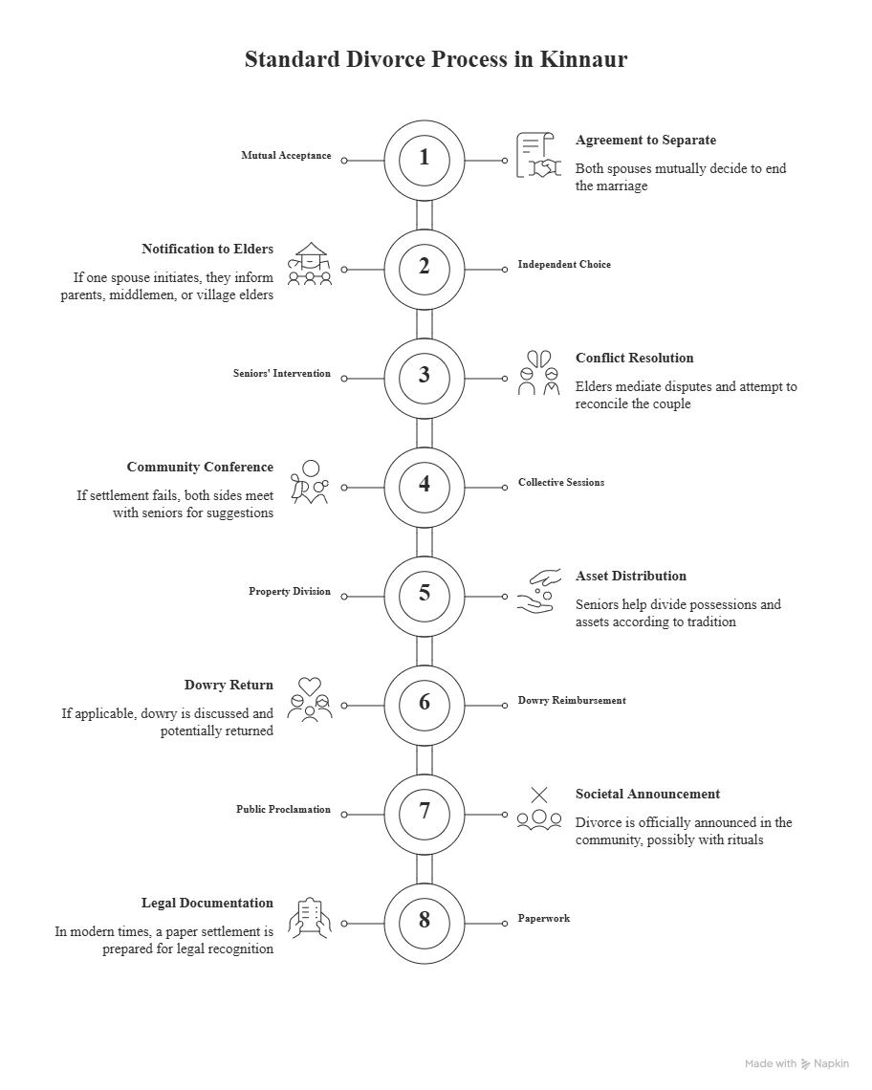Conclusion:
Separation in indigenous areas like the district Kinnaur in the Indian state of Himachal Pradesh has different societal, interpersonal and judicial obligations. Kinnauri tribes have their respective habits, practices, and socioeconomic mechanisms in Kinnaur. Marriages in such type of tribes are a connection between families, clans and the society, besides being a union between two individuals. Divorce is a complex process in Kinnaur, which is a product of the unique cultural atmosphere of the region. It is a process that takes much consideration and involvement of society due to its extreme focus on families, customary law and cohesiveness in society.
Marriage separation customs may be greatly influenced by culture, as well as law and geography. The traditions of the last centuries affect the process of divorce in the Indian district of Kinnaur. Divorce is influenced by place traditions and social mores in somewhat traditional settings. The social perception and traditions tend to play a significant role in Kinnaur, as there is a significant focus on tribal practices, but they do not always agree with the accepted course of justice. It is a balance between the needs of the members of the society and the preservation of historical legacy in the form of integration of traditional customs and the increasing standard of living of the Kinnauri citizens.
There is a significant variation in customary law marriage dissolution among ethnic groups and communities. The customary law is a term that is used to refer to the established norms and customs that govern social behavior in a group; the norms may differ significantly across tribes. The below are some general information on divorce in the various tribal settings in customary law. Each tribe has marital and separation rituals and ceremonies.
With the stigma surrounding divorce slowly disappearing, increasing numbers of couples are now taking the bold step and asking to be separated. This can be justified by the fact that perceptions towards marriage and home life are evolving, particularly among the younger generations of adults to come.
Today, people see separation not just as a chance to get their personal freedom back and start afresh, but also as an injustice or a thing to be embarrassed about. Along with this, women tend to step out of bad partnerships since women believe that there is little chance of recovery as they gain independence in their personal lives.
References:
- https://adjuvalegal.com/divorce/divorce-rate-in-india/#google_vignette
- https://www.indiatoday.in/lifestyle/people/story/india-increase-divorce-rate-good-maharashtra-marriage-empowerment-lifest-970147-2017-04-07
- Negi, N. K. (2014). Feminism and Cultural Tolerance: An Empirical Study of Tribal Women of Kinnaur in Himachal Pradesh. Labyrinth: An International Refereed Journal of Postmodern Studies, 5(4).
- Pathania, R., Kaur, P., & Pathania, P. (2008). Marital and family practices among tribals of Himachal Pradesh. Studies of Tribes and Tribals, 6(2), 73-78.

