Modification of Scrolls: Tools and Techniques
Dipak Barai
Department of visual Arts, University of Kalyani, West Bengal
Email: dipakbarai84@gmail.come

Abstract
The folk art patachitra was the oldest culture of Audio-Visual medium for the enlightenment/entertainment of the people about the versatile mythological and contemporaneous social features. The chitrakar /patua / Folk artist used to adopt this culture as the choice of profession for the purpose of subsistence of life by virtue of displaying Audio-Visual features before the public for the sake of enlightenment as well as entertainment on the issue of the mythological and Morden contemporaneous features. The researcher surveyed the village of Mednapur in Naya, Pingla where huge collection of old and modern patachitra and other artistic features are observed. The usual ingredients for the preparation of typical folk art are the herbal colours especially usage of only old/traditional scroll painting where as in modern scroll painting and others artistic features the latest usage of technique like enamel, fabric and old herbal colour are experienced.

Keywords: Making scroll painting, Details of scroll surface or grounds used by Patua community as per availability, Preparation of Gums, Sizes of Scroll Painting in Vertical, Sizes of Scroll Painting in Horizontal.

Modification of Scrolls:

Modification of scrolls itself is a crucial achievement of the patua community for the survival of existence as painters. Therefore, they take immense care in preparation, preservation and conservation of the scrolls. The art tradition featured in long vertical multi panelled scrolls is known as Jarano patas1 or latai scroll painting. Every panel of those lengthy scrolls represents a particular episode within the story and as they unfold for displaying, the associated folk-song which tell the story is recited. On sheets of paper painting is done and affixed them together to create one continuous roll; these scrolls are mounted on clothes, sometimes used saris2 for better strength and durabilty. The Patua narrative art tradition is expressed through scrolls as the Patuas combined in themselves the skills of storytelling as well as representation of it through graphic images; thereby it came to be known as scroll narrative art tradition or simply Patua tradition. This art is of two kinds; the one is on broad sheet of rolled cloth (scroll) and the other is done on a short piece of fabric also known as ‘eye-art’ or chouka scroll. Patua’s scroll paintings are rolled up for preservation and transportation.

The technical modification of patachitra:

Scroll painters adopted the versatile techniques to prepare their scrolls. The term folk art is used as an encompassing term as it can define a diversity of mediums and materials. One such class encompasses medium or form of expression that may be applied on cloth, canvas, paper or on any board. In the ancient times, pata painters used to prepare scroll on Tasar3 silk cloths. Sometimes it is also made on cotton cloths:
Development of scroll: Diversity of Surface Preparation

(i) Used cotton cloths, and (ii) Unused cotton cloths...
They possess little institutional art training and hence, approach their subject matter in a simple and non-scientific composition and involve in utilization of flat, bright and energetic colours. Generally, scroll painters like to depict monumental figures of deities to provide allegoric character to the gods or goddess with rich 100 embellishment in brilliant profound colours with the intention of making an immediate and long-lasting impact. There is hardly a scroll today that dates to early 19th century, as this was never a prized courtly or aristocratic art but rather one that lived in the villages, thrived in weekly market and perished from floods, fires and termites.
Before beginning any scroll painting, Patuas concentrate on base or surface preparation. The scroll fabric in fact forms the base for scroll art. Originally scrolls were painted on cloth of cotton or silk or on modern mill made paper in the standard full-scale size; sometimes backed with cloth and stitched together to form a long continuous roll the tattering sheets show signs of thousands of times thus have been rolled and unrolled.
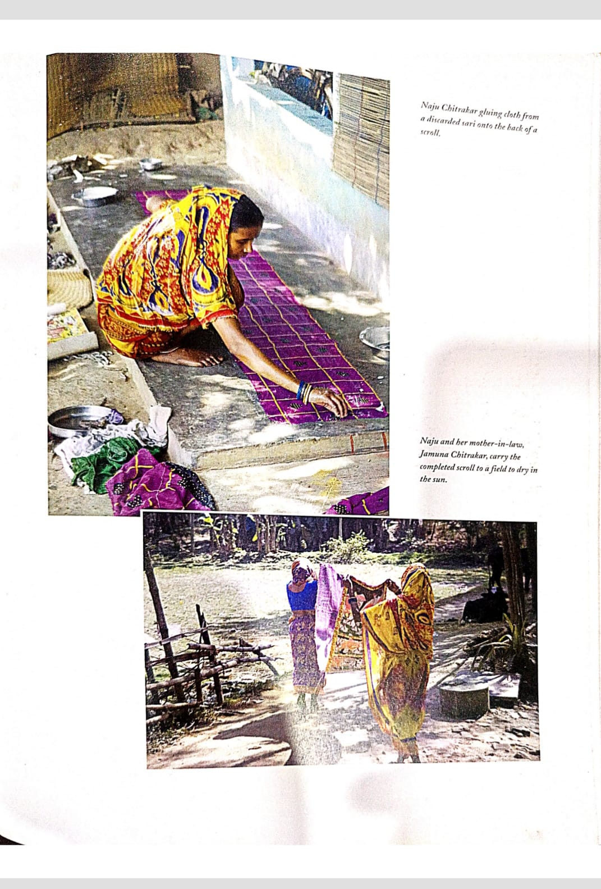

Naya Chitrakar gluing cloth from a discarded sari on the rear side of a scroll painting.

Naju Chitrakar and her mother-in-law, Jamuna Chitrakar, carry the finished scroll to a field to dry in the sun.

Description of old/modern method of preparation for scroll surface adopted by Patua community as per circumstantial availability

Cotton cloth surface
Thin bamboo stick surface
Tree bark surface
Palm leaf surface
Handmade or papier mache surface
Mill made paper or cartridge paper surface
Silk cloth surface
Jute cloth surface
Cotton or rice paper surface

1st process:
A. Filtering process is done through cotton cloth to avail semi liquid chalk i.e., well purified chalk. Semi liquid chalk is poured in a container then mixed it well with liquid and sticky tamarind gum.
B. Above mixture have to be sprouted skilfully on long fabric.
C. Once it is dry, Patuas rub the scroll surface by fine glass paper weights or smooth rounded stone pieces to make the scroll surface smooth resulting in nice scroll surface which is ready to draw images.
2nd process:
A. Purified white ink, it’s a kind of earthen pigment in Bengali known as Kaat
Khadi powder is collected after numerous attempts of water processing; finally, excellent fine white clay slit obtained.
B. White clay is mixed with well filtered cow dung then liquid sticky tamarind glue is added to this mixture all together and sprouted on fabric for layers to create leather like surface.
C. Once scroll surface is dried up then Patuas need to make it smooth by rubbing with rounded stone pieces or by fine glass paperweights.

3rd process:
a. Well purified Ghusum or ghusom soil4 is collected from the deep underground; a good quality ghusom soil colour looks like a while marvel.
b. Patuas prepare slits of this soil, a type of liquid and then add cow dung to it.
c. With the mixture of soil and cow dung, they add tamarind gum and mix it well.
d. After stirring well, they filter it with a cotton cloth. Residue is thrown out and filtered part is skilfully applied on the surface of scroll ground.
e. The fabric turns into a tough material when dried, but at the same time remains smooth enough to uphold the stroke of the artist’s brush.
f. On the dried out ground surface, Patuas have to make it smooth by rubbing with rounded stone or by fine glass paperweights.
4th Process:
A. According to the length of the scroll Patuas sew the mill made drawing papers one after the another to make a long or lengthy scroll about 15-40feet.
B Samsunder Chitrakar says it is far better to paste drawing sheets one after another. Sometimes scrolls get damaged due to sewing of the drawing sheets.
C. After that they have to give support from the back. They paste cotton cloth or used sari by gum obtained chiefly from starch of cooked white rice5
.
Scroll surface gets stiffened with the rice glue. If it is commission based work, they will stitch canvas sheet, otherwise they use cheap drawing sheets priced at Rs. 8 to 10 per piece.
D. For commission based work, they paste new markin6 cloth from back to
Make long-lasting scrolls. If they use rice starch then tunte7
Is added to
Rescue the scrolls from insect bites.

Method of preparation of Gums as Binder for Scroll Surface

1 st Process from Rice:
a. They collect white rice grains from non-steam paddy; either they may go to husking mill to get it husked or they do it at home by traditional chakki grinder or
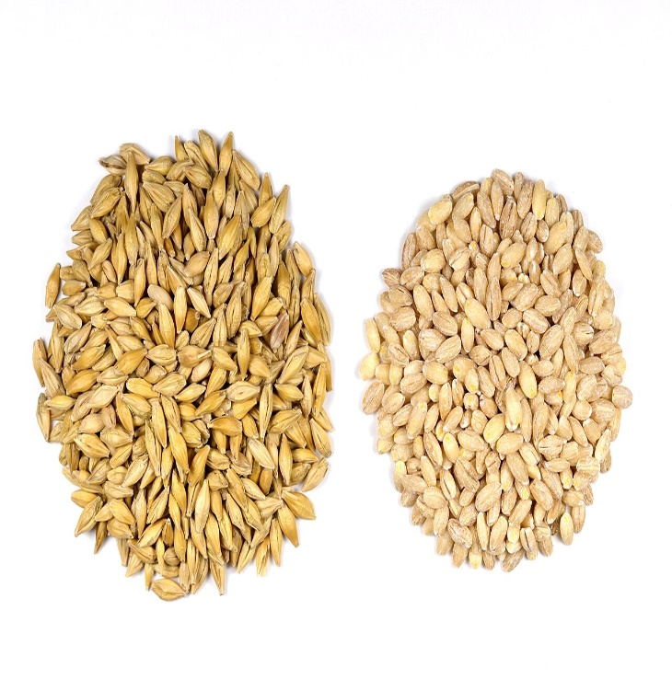
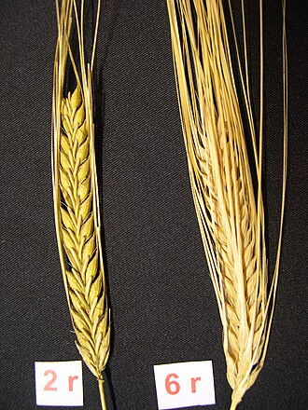

Barley seeds
Barley Ears

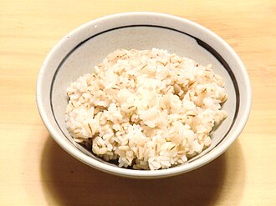

Steamed Barley

through husking peddle or mortar and pestle. The non-steamed paddy provides good quality of rice grains or starch is to be obtained. Most of the Bengalis use cooked rice as a staple food, availed from steamed paddy.
b. The steamed gum or starch that is availed from white rice grains are not at all steamed in a boiler. Patuas follow two kinds of process to prepare gum which would act as a pesticide. A stuff used for annihilating insects or other creatures is harmful for scroll. In the first process, they mix blue vitriol with rice grains while boiling, blue vitriol crystals are good pesticides, and scrolls does not get disturbed or affected by any pest or insects like cockroaches or silverfish bugs. Other process for the safety of scroll painting is to protect from those insects is kuchla or kuchila8 seed which can be mixed while boiling the gum.

c. Patuas are very much fluent enough with this rice starch while pasting cloths to support the scrolls from the back

2 nd Traditional Process from Tamarind Seed:
a. Patuas have earthen oven at their home. An earthen terracotta pot with half-filled river sand is to be kept on earthen oven to make hot sand, fire for burning woods.
b. Once sand is hot, coffee colour tamarind seeds are poured on it to bake. The way they make traditional muri or mouri or murmure9 that way they have to bake it on the hot sand by stirring continuously.
c. Once it reaches normal temperature, they will allow it to become cool.
d. Baked tamarind seeds will be grinded on a hailstone by the pestle in a mortar or with husking peddle or by sil-norra , or by haman dista.
e. Grinded seed grains are poured onto the kula12 to separate black or dark brown tamarind seed husks.
f. Grinded particles of tamarind seeds are soaked in water for 24 hours or more and then they are boiled in hot water and that hot liquid gum is filtered by cloth, after that a sticky liquid tamarind gum is ready to use
3 rd Process from bel or Wood Apple Seed
a. Patuas collect half-unripe and half ripen bel13 fruits in large quantity. They cut it into half, so that the gum holes are visible from both the parts.
b. They take out all the sticky seeds along with sticky gum from the holes. They take a cup of milk and add a little amount of mustard oil and mix nicely.
c. All the collected sticky bel seeds are poured in this mixture. Then it is slowly kneaded by hands.
d. All sticky elements come out from the seeds and it turns out to be a sticky liquid.
e. Then they filter it by a good cotton cloth. This filtered liquid mixture is kept in open air for one or two nights to capture dew which makes it stable.
f. This gum is very much useful to prepare pigments or colours for scrolls which last very long

Traditional method for Preparation of Gums:

Gum | Materials Used/Source | Preparation process | Remarks
Rice (oryza sativa) | Patuas collect white rice grains from non - steamed paddy either they may go for husking with mill or they do it at home by traditional chakki grinder or through husking peddle or mortar and pestle. | The gum or starch availed from white rice grains are without steamed, means paddy grains are not at all steamed in boiler. Patuas follows two kinds of processes to prepare gum which would act as pesticide. A substance used for destroying insects or other organisms is harmful for scroll. (i) In first process they mix blue vitriol with rice grains while boiling, blue vitriol crystals are good pesticides, and scrolls are not disturbed or affected by any pest or insects like cockroaches or silverfish bugs14 . (ii) Other process for the safety of scroll painting is to protect from those insects is kuchla or kuchila15 seed which can be mixed by boiling the gum. | Rice gum is easily available and preparation is easy to make.
Tamarind (tamarindus indica) | Patuas collect tamarind seeds from tamarind tree (tamarindus indica). Tamarind is an evergreen tree of the pea family. It is widely cultivated in other regions as an ornamental and edible fruit. From the tamarind seed grains or powder Patuas collect gum or .glue | They fry seeds on hot sand on a tava16, or terracotta khola17 and then crush these seeds into grains. They take dried grains and fried tamarind seed grains in a huller of wheat grinding or flour machine. They take dry tamarind seeds in wheat grinding or flourmachine, when they put it in atta flour mill or atta chakki convert tamarind seed gains into powder. This powder has to be well mixed with water after boiling the mixture. Thus, they get tamarind gum. In other process, crushed tamarind seeds grains are soaked in water overnight or more. These wet and soft gains are boiled for few minutes to have sticky gum. It provides a strong gummy consistency. | This viscid or sticky content is ideal to prepare pata or scroll, where insects cannot do any harm to their scroll paintings. However it is additionally helpful as a decent binder orgum. That way, they are well tailored in adapted in commixture these colours. These mixed pigments with the appliance of above mention paste retain the brilliance of the pata for an extended time.
Bel fruit (aegle marmelos) | Patuas made gum from ‘bel fruit’, (aegle marmelos) means ‘bel’ tree, and an adhesive is prepared from the fruit of the ‘bel’ in English. It is also called wood apple- aegle marmelos is the scientific name of the tree. ‘bel’ is also known as ‘Sriphal’ in local Bengali or Hindi language. It’s above mentioned paste retain the brilliance of the pata for a longer time. Its English names are Stone apple or Wood apple and Bengal quince. | Gum from bel is also a good option for scroll painters. Bel fruits need to be more in quantity and should not be exactly ripe. The inside of the fruit gum chambers is scooped out, and then boiled in water. The glue from the seeds is separated. It is filtered and collected in a bottle. This stock solution is thick. It is diluted to the right consistency before mixing with colour. The solution from wood apple normally stay for a long time and acts as an insect repellent to protect the painting. Patuas colour is mixed in an empty coconut shell, acting as a container. They keep colour in this container mixed with binder and at the time of the nextday’s work, they add few drops of diluted binder solution to soften the paint. | One of the most useful medicinal trees of India is aegle marmelos tree or bel tree. Bel’s remedial properties have been explained in the ancient medical treatise in The aegle marmelos tree is one of the most useful medicinal plants of India written in Sanskrit, Charaka Samhita.
Sagu Dana ( metroxylon sagu) | The name sago is also sometimes used for starch which is useful gum for Patuas. | Patuas soaked the Sagu in water for one hour or more than that sagu dana will become soft and gets four times puffed up. Now Patua or his wife arranges an earthen pot or container with water. They prefer earthen oven as a fuel. They use wood or bamboo is used to make hot water. While water is boiling, the wet Sago dana or Sagu18 grains are poured into the hot water. Slowly colour of the water will become faded. Simultaneously gum will become sticky and thicker. Patuas use this gum but they have to mix copper sulphate or boric acid with this sticky content as a pesticide. | It is called sabu dana in Bengali and Hindi, saggu biam in Telugu. Viscid quality of those sagu grains or pearls are analogues in manifestation to a starchy substance within the style of exhausting white grains or food product pearls and therefore the two could also be used interchangeably in some dishes.
Arrowroot (maranta arundinacea) | From arrowroot Patuas obtain a sticky content called gum. Its sticky substance to be added to a liquid to make it firmer and having several favourable or superior positions over cornstarch. A big proportion of the edible thickener is obtained from the rhizomes or root-stocks of various plants known as arrowroot. | Patuas purchase corn flour or arrowroot from market in powdered form. Ratio to prepare the gum is 1:1, means one spoon arrowroot power is to be mixed with one cup of hot water. It boils at a low temperature for 5-10 minutes. Arrowroot gum looks more fresh, transparent and concentrated type. Of course, Patuas use some boric acid, Copper Sulphate or  cuchila as pesticide. | This sticky starch substance has several options over corn-starch. It has more neutral flavour, so it's a good thickener for delicately flavoured sauces.
Gum from Neem (azadirachta indica) | Patuas also collect neem gum from neem tree in crystal state. Expected gum is availed from plants/trees is moreover water soluble or absorb water to form a glutinous solution. Neem has been commercially a broach for operation its gum that is of use in considerable amount of industries. | Patuas purify the gum after it is melted in water. Then Patuas separate dust and tree barks from liquid neem content by filtering this gum by cotton cloth or gamcha (cotton towel). Sands, stones grains, tree barks are separated this way. | Neem gum is used as an adhesive and to strengthen the paper. In Textile Industry, it is used in dyeing and printing of fabrics.

In Medinipur and 24 Parganas, Patuas use gum from bel or Indian bel fruits or called Bengal quince (aegle marmelos), a big tree. By using this gum, scroll will not be eaten by insects. In other districts, Patuas use gum from neem (azadirachita indica). By using this gum scroll will not be eaten by insects. Earlier days, all pata painters used to prepare the colours by processing flowers, creepers, soil, rice, coconut choirs, etc through boiled water. Then gum is extracted from tamarind and wood apple seeds. Nowadays, many mischievous Patuas habituated with the synthetic glue and synthetic paints and those commodities are purchased from the bazaar and as a result the brightness is reduced. Many Patuas are getting out of track and not going through the laborious jobs. They use squirrel hairbrush and glue from tamarind seed, black from burning lamp and coconut shells and green from leaves.

Variety of Sizes of Scrolls:

Patuas make three kinds of scrolls- a lengthy scroll is known as Latai scroll, another lengthy scroll known as Ade-Latai, and Chauka scrolls.

1. Scroll paintings made in vertical shape are called Latai scrolls or dighal pats
2. Scroll paintings made in horizontal shape are called Ade- latai scrolls or also other format of dighal pats. Lamba or dighal pata22 is vertically more lengthy, about 30’ to 50’long: size varies from 2’x8’, 2’x 12’, 2’x15’, 3’x20’ and 2 ½ ’x50’maximum. Dighal pata contain varied panels. This kind of scroll paintings depict an elaborately interconnected story, consisting of many elements. Since the dighal pata is rolled up, it is also known as rolled up scroll painting, jarano pata. The scroll painters or Patuas sing while showing the dighal patas. 3. Chauka scrolls in rectangular or square size are known as ‘Eye art’. Chauka pata widths 2’ to 2 ½ ‘and Lengths 14’ to 50’ is applicable for latai and Ade- latai scroll. In any case, when it is chauka scroll, around then, most extreme width 2' and length 2 ½' as it were. Very rarely they narrate chauka patas or scrolls

Sizes of Scroll Painting in Vertical

1. Maximum length of long vertical scroll or latai scrolls is approximately 1000-
1200 centimetres. This type of long scroll is having maximum 25-30 panels and follows stories from Ramayana or Mahabharata. This kind of scroll work is done as a commissioned work from patron.
.
2. Another length of scroll painting is vertical. It’s up to 500-800 centimetres long. It is having more or less 12-20 panels. Pata painters typically make this kind of scrolls for displaying in any district level or State level exhibitions24
.
3. Third longest scroll is vertical size in length up to 340-450 centimetres. It is having maximum 10 panels. Maximum Patuas make these sizes of scrolls. In other words, the length of the scroll is a common phenomenon to Patuas for making patachitras.
4. Some of the vertical scroll length would be approximately 170-200 centimetres. Nearly 4-6 panels would be there. This length is portable for
Patuas. They carry it to display in the National or International craft fairs and
National and International book fares stalls.

Sizes of Scroll Painting in Horizontal

1. This horizontal scroll length tall is with the length of vertical scroll but all the time they do not make the same size like vertical scrolls. But the highest length never reaches up to 1000 centimetres.
2. As per the horizontal scrolls which are called Ade-latai, the maximum length is up to 600 centimetres. Maximum numbers of panels are ten.
In addition to the above scroll paintings which contain more than twenty frames, there wxist the parallelogram scroll, containing six to eight frames. Yama pata or
Jadu pata and also the Chakkhudaan pata deals with eschatology and is also known as parani scroll, painted for a family that has recently undergone an incident of death in the family. Chitrakar chose themes from Hindu myths and epics convert it in the form folk literature. The human and the divine characters look alike except for the crowns and a few iconographic signs look slightly different.

Sizes of Scroll Painting in Chauka Scroll or Eye-art

‘Eye-art’ or scroll depicts on a short piece of fabric as per intended themes are called chauka or chouka pata chitra or eka chitra.
1. Chauka or Ekachitra which is rectangular in size is generally painted on a single picture plane. Sizes of - 1’x1’, 2’x2’ & 2’x 2 ½’, - containing many small chaukas or square patas have only one continuous story on the small pictorial plane

Preparations of Colours

The scroll painters depicted their scroll in watercolour treatment. Those treatments are even continuing today through traditional organic and vegetable dyes only. Extracted from their rural environment, they have proven to retain their brightness and clarity after years of continuous use.

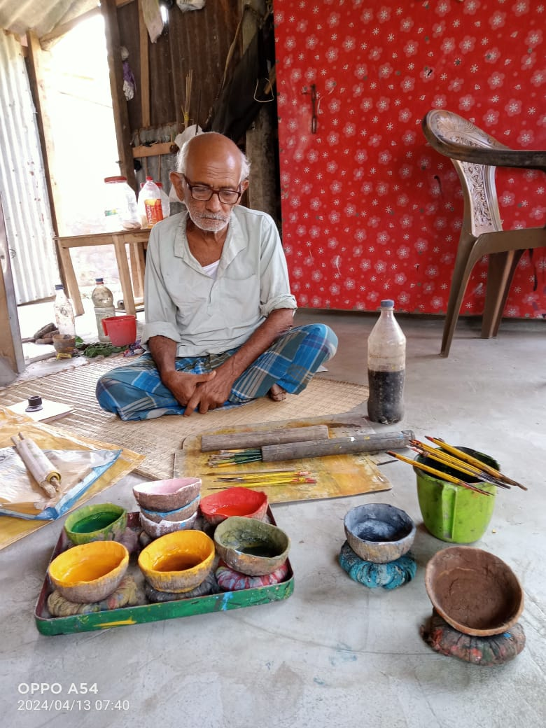
CONCLUSION:
The Chitrakars are getting chance to exhibit and sell their products through different stalls of different cities or countries with the help of the relevant Government Administration. In the conclusion, it is established that Indian and /or Universal Patachitrakar of modern outlook concentrated their achievement in small size with bulk production availability at the affordable price and on this typical venture the Chitrakars concentrated their endeavours for the production of miniature size attractable to consumers for usage at an affordable price. As a result they have been improved economically and artistically. Their next generation are getting confidence to take advantage of this profession. It is hopeful for the country. The tiny village Pingla famous for its versatile traditional and contemporary features of scroll painting throughout the world. The Chitrakar of this typical scroll painting had been adopted for the subsistence of life but at present this Art culture promoted the social development. These Chitrkars encouraged the various aspects of the scroll painting culture in home and abroad.
Demonstration for natural colours preparation by Shamsunder Chitrakar.

BIBLIGRAPHY:

- Frank, J. Korom. (2006). Village of Painters, Narratine scroll from West Bengal. China; Library of Congress Cataloging-in-Publication data.
- Maiti, Dr. Chittaranjan.(2001). Prasanga: Pat, Patua O Patua Sangit. Kolkata; Published by Nepal Chandra Ghosh.
- Thomse, Kaiser, (2012) Painted songs. Continuity and change in an Indian Folk Art, Germany, Printing; Leibfarth & Schwarz, Dettingen/Erms.
- Manna, Dr. Subratakumar. (2012). Banglar Patchitra, Patua Sangeeet Patua Samaj O Lokosan- Skriti Vijnana, Kolkata; Published by Pharm K.L.M. Private limited.
5. Smith, Edward Lucie (1992). Art and Civilization. Published by Laurence King.
6. Kejriwal, H.Kcollection (2003). “Arts of the earth. Sponsored H.K. Kejriwal Foundation Bangalore.
7. Pati Bhaskarbrata (2019). Loukik Medinipur, 1st Edition. Published by Kamolesh Nandi.
8. Kishore Naveen, Seagull Books (1990). Gurusaday Duitt, Folk Arts and Crafts of Bengali the Collected Papers. Published by Naveen Kishore, Seagull Books,Calcutta.
9. Mandal Keya, (First: 2014). Folk Album. Published by Corpus Research Institute, Kolkata.
10. Mandal Keya, (First: 2016). “FOLK HISTORY AND ART”, Vol-1. Published by Corpus Research Institute, Kolkata.

11. Santra Tarapada (2011). Folk Arts of West Bengal and the Artist Community, Published by Niyogi Books:New Delhi, India.
12. Raut Dr.Khokon, (2023).Early Bengal Oil Paintings. Published by Aayu Publications, New Delhi.
13. Santra Tarapada,(1987).PURAKIRTY SAMIKHA: MEDINIPUR, Published by Pratnatatta Adhikar Tathya O Sanskriti Bibhag.
14. Bhowmik Shibapada and Bhowmik Susmita(2006).Loksanskriti Charcha; (লোক সংস্কৃতি চর্চা), Kolkata.
15. “RARH KATHA” Birbhum, by Itihash, Janajiban O Sanskritick Bishak Patrika,
16.Bhattacharjee Bholanath (1975), “SHILPO BHABANA”, by Boiparttar, kolkata.
17. Bhattacharjee Budhadev, “JELA LOKE SANSKRITI PARICHYEA GRANTHA”,Nadia.
18. Bhattacharjee Budhadev, “JELA LOKE SANSKRITI PARICHYEA GRANTHA”, Burdwan.
19 Bhattacharjee Budhadev, “JELA LOKE SANSKRITI PARICHYEA GRANTHA”, Howrah.
20. Bhattacharjee Budhadev, “JELA LOKE SANSKRITI PARICHYEA GRANTHA”, Bankura.
21. Bhattacharjee Budhadev, “JELA LOKE SANSKRITI PARICHYEA GRANTHA”, Medinipur.

