A Study of Models of Information Seeking Behavior and Their Relevance in Digital Information Environments
Dr. Surendra Singh*
*Assistant Professor
Department of Library and Information Science
Centre for Distance Online Education
Swami Vivekanand Subharti University, Meerut (U.P.) E-mail: Surendrasingh2015@rediffmail.com

Ashutosh Kushwaha**
*Assistant Librarian
Central Library
Swami Vivekanand Subharti University, Meerut (U.P.) E-mail: ashutoshzxcv@gmail.com

Abstract
Information seeking behavior (ISB) is a fundamental area of research in Library and Information Science, focusing on how individuals identify information needs, search for information, and use retrieved information. This study examines major models of information seeking behavior, including Wilson’s Model, Kuhlthau’s Information Search Process, Ellis’s Behavioral Model, Dervin’s Sense-Making Model, and Bates’ Berrypicking Model. The objective of the study is to analyze the core concepts of these models and assess their relevance in contemporary digital information environments. Using a qualitative review of existing literature, the study compares the models based on their focus on cognitive, emotional, and contextual factors influencing information seeking. The findings indicate that no single model fully explains information seeking behavior; rather, each model contributes unique perspectives. The study concludes that an integrated approach combining multiple models is most effective for understanding user behavior in modern, technology-driven information systems.
Keywords: Information Seeking Behavior, ISB Models, Library and Information Science, User Behavior, Digital Information Environment
1. Introduction
Information is a vital resource in modern society, influencing decision-making, learning, research, and professional practice. The way individuals recognize their information needs and seek information has become an important area of study within Library and Information Science (LIS). This area of study, commonly referred to as Information Seeking Behavior (ISB), examines the processes, strategies, and factors that shape how users search for, access, evaluate, and use information from various sources.
With the rapid growth of digital information systems, online databases, search engines, and social media platforms, information seeking behavior has become increasingly complex. Users are no longer dependent solely on traditional libraries; instead, they interact with multiple information environments that influence their searching patterns. Understanding these behaviors is essential for designing effective information systems, improving information services, and enhancing user satisfaction.
Over the years, several theoretical models have been developed to explain information seeking behavior. These models aim to describe different aspects of the information seeking process, including cognitive, emotional, social, and contextual factors. Prominent models such as Wilson’s Model of Information Seeking Behavior, Kuhlthau’s Information Search Process, Ellis’s Behavioral Model, Dervin’s Sense-Making Model, and Bates’ Berrypicking Model have significantly contributed to understanding how users seek and use information. Each model offers a unique perspective and highlights different dimensions of user behavior.
This study focuses on examining major models of information seeking behavior and analyzing their relevance in contemporary information environments. By understanding these models, information professionals can better anticipate user needs, reduce barriers to information access, and develop user-centered information systems. The study also emphasizes the importance of integrating multiple models to gain a comprehensive understanding of information seeking behavior in today’s dynamic and technology-driven world.
2. Earlier Studies
The research on information seeking behavior has developed significantly over the past several decades, with scholars proposing various models to explain how individuals recognize information needs and seek information. One of the earliest contributions was made by Taylor (1968), who identified four levels of information need—visceral, conscious, formalized, and compromised—highlighting the difficulty users face in clearly expressing their information needs. Taylor’s work laid the foundation for user-centered approaches in information services.
Belkin (1980) introduced the concept of the Anomalous State of Knowledge (ASK), suggesting that information needs arise from a gap or anomaly in a user’s knowledge structure. This model influenced the design of information retrieval systems by emphasizing the importance of understanding users’ imperfect or incomplete knowledge during the search process.
Wilson (1981, 1996) presented a comprehensive model of information seeking behavior that integrates information needs, seeking behavior, and information use within a broader context. Wilson emphasized the role of intervening variables such as psychological, demographic, environmental, and social factors that may facilitate or hinder information seeking. His model is widely recognized for its holistic approach and continues to be extensively cited in LIS research.
Ellis (1989) focused on identifying common patterns of information-seeking activities rather than linear stages. Through empirical studies of researchers, Ellis identified behaviors such as starting, chaining, browsing, differentiating, monitoring, and extracting. This behavioral approach provided valuable insights into how users interact with multiple information sources, particularly in academic and professional environments.
Kuhlthau (1991) proposed the Information Search Process (ISP) model, which introduced the emotional dimension of information seeking. Her model describes six stages of the search process and associates each stage with specific feelings, thoughts, and actions. The ISP model has been especially influential in educational contexts, demonstrating how uncertainty and anxiety affect users during information seeking.
Dervin’s Sense-Making Theory (1983) approached information seeking as a process of constructing meaning to bridge gaps in understanding. This model emphasizes the user’s situation and context, focusing on how individuals use information to make sense of their experiences. Dervin’s work has been widely applied in studies of communication, information behavior, and user-centered system design.
Bates (1989) introduced the Berrypicking model, which challenged traditional linear search models by proposing that information seeking is an evolving and non-linear process. According to Bates, users gather information incrementally from various sources, modifying their queries as their understanding develops. This model has gained relevance in digital and web-based information environments.
Dhiman and Rani (2013) have also explored various models prevalent in contemporary times briefly. Further, recent studies like that of Pandey and Dhiman (2020) hhave explored the applicability of these classical models in digital contexts, such as online databases, search engines, and social media platforms. Researchers have emphasized the need for integrating multiple models to better understand complex user behaviors in contemporary information environments. The literature suggests that while traditional models remain relevant, they must be adapted to reflect technological advancements and changing user practices.
3. Objectives of the Study
The main objectives of this study are as follows:
- To identify and analyze major models of information seeking behavior proposed by leading researchers.
- To compare different information seeking behavior models based on their approaches, components, and applicability.
- To evaluate the relevance of classical information seeking behavior models in contemporary digital information environments.
- To explore recent trends and developments in information seeking behavior research.
- To highlight the implications of information seeking behavior models for information system design and library services.
- To examine the concept of information seeking behavior and its significance in Library and Information Science.
- To suggest an integrated approach for understanding user information seeking behavior in modern information environments.
4. Methodology of the Study
The present study adopts a descriptive and analytical research design to examine various models of information seeking behavior and their relevance in contemporary information environments. The study is based primarily on a qualitative approach, focusing on the analysis and interpretation of existing scholarly literature.
5. Sources of Information & Collection Method
The study relies on secondary data collected from a wide range of published sources. These include textbooks, scholarly journals, conference proceedings, research reports, and doctoral theses related to information seeking behavior. Electronic resources such as online databases, digital libraries, and institutional repositories are also consulted to access recent and relevant studies.
Relevant literature was identified through systematic searching using keywords such as information seeking behavior, ISB models, user information behavior, and digital information environments. The literature selected for review includes classical works as well as recent publications to ensure both theoretical depth and contemporary relevance.
6. Various Information Seeking Models
Information seeking models explain how individuals identify information needs, search for information, interact with information sources, and use the obtained information. These models help librarians and information professionals understand user behavior and design effective information systems.
6.1. Wilson’s Model of Information Seeking Behavior
Background of Wilson’s Model
Wilson developed his model to explain human information behavior, i.e., the ways in which people seek, obtain, and use information. Unlike simple models that treat information seeking as a linear process, Wilson’s model emphasizes:
- Complexity of human needs
- Motivations for seeking information
- Barriers that may prevent seeking or obtaining information
Wilson’s model has evolved over time, with three major versions:
- 1971 – Initial Model: Focused on information need as a response to stress or problem.
- 1996 – Second Model: Included activating mechanisms, mediating factors, and context.
- 1999 – Third Model: Added intervening variables and made a more dynamic and systemic model.
Concepts of Wilson’s Model
- Information Need
- Central to Wilson’s model is the information need, which arises when a person recognizes a gap in their knowledge.
- This gap triggers information seeking behavior.
- It can be conscious (aware) or unconscious (latent need).

Activating Mechanisms: These are triggers that motivate a person to seek information:
  - Stress/cognitive need: Realizing one doesn’t know enough.
  - Role expectations: Responsibilities at work or social expectations.
  - Personal factors: Curiosity, interest, or career goals.

Intervening Variables: These factors mediate or influence information seeking:
  - Personal characteristics (age, education, experience)
  - Psychological factors (motivation, perception)
  - Environmental factors (availability of resources, social networks)
  - Demographic factors (location, socioeconomic status)

Information Seeking Behavior: The actual process of actively looking for information in many forms:
  - Passive seeking: Stumbling upon useful information.
  - Active seeking: Using libraries, databases, or the internet deliberately.
  - Interactive seeking: Asking experts or consulting peers.

Information Use
- Once obtained, information is evaluated, interpreted, and applied.
- The information use can lead to Solving a problem, making a decision, satisfying curiosity and Reducing uncertainty.

Feedback Loop
- Information use may create new needs, starting a cyclical process.
- Wilson emphasized that information seeking is rarely linear.
Wilson’s 1996 Model (Simplified Visual Description)
- Contextual Factors
→ Environmental influences, role demands, technology availability.
- Intervening Variables
→ Psychological, social, personal factors affecting behavior.
- Activating Mechanisms
→ Stress or problem recognition that triggers seeking.
- Information Seeking Behavior
→ Active or passive pursuit of information.
- Information Use
→ Application to resolve problem or satisfy need.
- Outcome / Feedback
→ Leads to new needs or knowledge improvement.
Key Features of Wilson’s Model
- Human-centered: Focuses on the person, not just the system.
- Dynamic: Feedback loop acknowledges evolving needs.
- Barrier-conscious: Recognizes obstacles to seeking or using information.
- Multi-dimensional: Integrates personal, social, and environmental factors.
- Applicable broadly: From library users to online information behavior.
Criticisms of Wilson’s Model
- Too abstract and sometimes hard to operationalize.
- Doesn’t fully capture digital-age behaviors like social media or AI-based search.
- Feedback loops are acknowledged but can be more explicitly modeled.
- Some critics argue the model overemphasizes “needs” while downplaying chance or accidental discovery.
Proposed by: T.D. Wilson (1981, 1996)
Wilson’s model views information seeking as a response to an information need arising from a specific context. It emphasizes intervening variables such as psychological, demographic, social, and environmental factors that may influence or hinder information seeking.
Significance:
- Holistic and comprehensive
- Widely used in LIS research
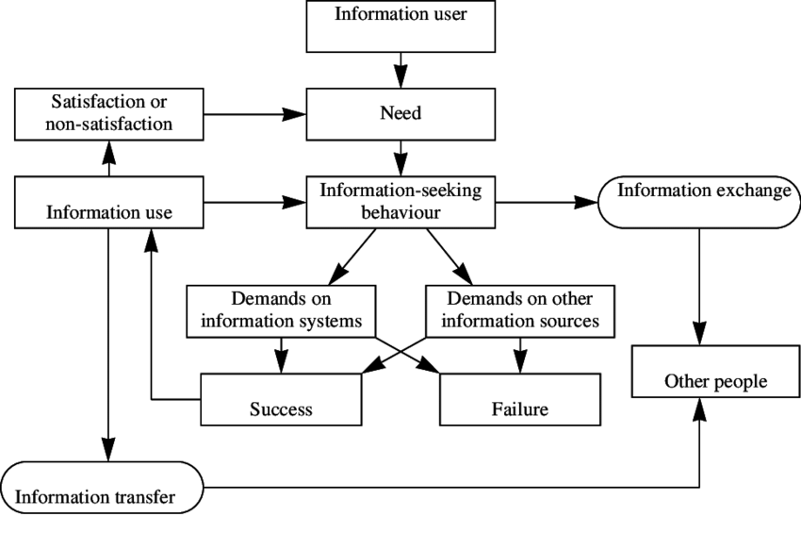
Figure 1: Diagram of Wilson’s Model of Information Seeking Behaviour
(Source : https://www.researchgate.net/profile/Thomas-Wilson-103/publication/228784950/figure/fig1/AS:368282285690880@1464816747829/Wilsons-model-of-information-behaviour.png
6.2. Ellis’s Model of Information Seeking Behavior
Ellis’s Model was proposed by David Ellis in 1989, based on empirical research into how researchers seek information. Unlike models that are purely theoretical, Ellis’s approach is behavioral, meaning it’s grounded in the actual patterns of information-seeking activities observed in researchers across disciplines.
The model is often applied in library science, information studies, and user behavior research, helping us understand not just what people look for, but how they go about seeking it.
Key Idea of Ellis’s Model
Ellis identified that information seeking is not random; researchers and information users tend to follow specific patterns or strategies. His study analyzed interviews and observations of researchers and concluded that these behaviors could be grouped into distinct activities.
The model emphasizes that information seeking is iterative and flexible—people may repeat, skip, or combine these activities depending on their needs.
The Six Key Features of Ellis’s Model
Ellis identified six behavioral features commonly observed in information-seeking processes:
1. Starting
- Activities that help the user begin the information search.
- Consulting reference materials, general web searches, or reviewing previous research.
- Helps in forming an initial understanding or identifying key sources.
2. Chaining
- Following references or leads from one source to another.
- Backward chaining: Looking at the references cited by a source.
- Forward chaining: Looking at later sources that cite the current source.
- Reading a journal article, then examining its bibliography to find more relevant studies.
3. Browsing
- Semi-directed, exploratory searching through a collection of information.
- Helps users discover relevant information without a precise goal.
- Skimming journals, scanning shelves, or scrolling through online databases.
4. Differentiating
- Selecting sources or channels that are more relevant or credible.
- Focuses on quality and efficiency by avoiding irrelevant sources.
- Choosing peer-reviewed journals over general websites, or relying on subject-specific databases.
5. Monitoring
- Keeping up-to-date with new developments in a field.
- Ensures the researcher does not miss current research or trends.
- Setting up alerts, subscribing to newsletters, following citation networks.

6. Extracting
- Identifying and retrieving specific information from sources.
- Pulling out the most relevant facts, data, or insights needed for the task.
- Copying statistics, taking notes from articles, or summarizing research findings.
Characteristics of the Model
- Non-linear: Users can jump back and forth between features.
- Iterative: Information seeking often involves revisiting sources or repeating strategies.
- Behavioral focus: Focuses on what users actually do, rather than what they “should” do.
- User-centered: Acknowledges that individual differences (experience, expertise, and preferences) shape information behavior.
Applications of Ellis’s Model
- Library Science: Designing library layouts and catalog systems to facilitate browsing and chaining.
- Information Retrieval Systems: Helping database designers understand how users search and navigate.
- Research Skills Training: Teaching students strategies like chaining, monitoring, and differentiating.
- User Experience (UX): Creating interfaces that support diverse search behaviors.
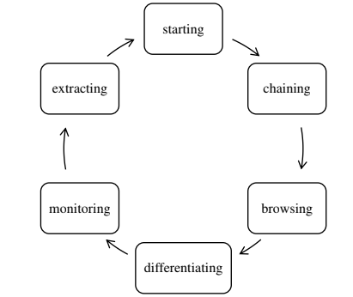
Figure 2: Diagram of Ellis’s Model of Information Seeking Behaviour (Source: https://www .researchgate.net/publication/377804042/figure/fig1/AS:11431281220866387@1706624105814/nformation-Seeking-Behavior-Model-by-Ellis-Source-Fathurrahman-2016-The-six-stages.ppm

6.3. Kuhlthau’s Information Search Process (ISP) Model
Carol Kuhlthau, an educational psychologist, developed the Information Search Process (ISP) Model in the 1990s to describe the cognitive, affective, and physical behaviors of individuals during information seeking. Unlike models that focus purely on the mechanics of searching, Kuhlthau emphasized the emotional and cognitive experiences people go through during the process.
Her research showed that information seeking is not linear, and emotions such as uncertainty, anxiety, optimism, and satisfaction play a crucial role in shaping how people search for information.
The model consists of six stages, each characterized by thoughts, feelings, and actions.
Stages of Kuhlthau’s ISP Model

Initiation Stage
- The information need or problem is recognized.
- I have a task to do, but I don’t know much about it yet.
- Uncertainty, apprehension, or anxiety.
- Begin exploring the topic superficially, often seeking general understanding.
- A student is assigned a research paper but doesn’t know where to start.
Key insight: This stage is dominated by uncertainty, which is normal and can influence motivation.

Selection Stage
- A general topic or focus area is chosen.
- I need to narrow down my topic to something manageable.
- Optimism emerges, but uncertainty may remain.
- Identify potential topics, choose one that seems viable.
- The student narrows the topic from “Climate Change” to “Impact of Climate Change on Agriculture in India.”
Key insight: Selecting a topic reduces uncertainty slightly but does not eliminate it entirely.

Exploration Stage
- Initial investigation and broad reading of available information.
- I’m learning more, but the information is confusing or contradictory.
- Confusion, doubt, frustration, anxiety—often the most emotionally challenging stage.
- Reading, browsing, talking to others, and noting different perspectives.
- The student reads multiple articles and studies but finds conflicting information about climate impact on crops.
Key insight: Exploration is critical for understanding but can create anxiety as gaps in knowledge are revealed.

Formulation Stage
- Focus narrows further, and clarity emerges.
- I have a clearer understanding of my topic and can define a focus.”
- Confidence begins to build; uncertainty starts to decrease.
- Develop a clear thesis, formulate research questions or hypotheses.
- The student decides to focus on “Effects of changing rainfall patterns on wheat production in Northern India.”
Key insight: This stage marks a turning point where the search becomes more directed and purposeful.

Collection Stage
- Gather information specific to the focused topic.
- I know what I need, and I can find relevant sources
- Increased confidence, sense of control, and satisfaction.
- Collect detailed data, take notes, evaluate sources, and organize information.
- The student gathers research papers, government reports, and statistical data on wheat production and rainfall trends.
Key insight: The collection stage is efficient and productive because the researcher now has a focused direction.
Presentation Stage
- Information is synthesized, conclusions drawn, and findings communicated.
- I can now complete my task and share my findings
- Relief, accomplishment, satisfaction.
- Write the paper, prepare a report or presentation, cite sources, finalize work.
- The student writes the research paper and prepares a presentation summarizing findings on climate change impacts on wheat production.
Key insight: Emotional satisfaction peaks as the task reaches completion, and learning is consolidated.
Key Features of Kuhlthau’s ISP Model
- Integration of Cognition and Emotion: It highlights that feelings (uncertainty, confusion, optimism) are intrinsic to the search process.
- Iterative Process: While stages are sequential, individuals may revisit earlier stages as they refine their understanding.
- Focus Development: Early ambiguity gives way to clarity as knowledge increases.
- Educational Implications: Teachers and librarians can support learners by providing guidance at emotionally challenging stages.

Applications of the ISP Model
- Education: Helps teachers guide students in research projects.
- Library Science: Assists librarians in supporting patrons’ information needs.
- Knowledge Management: Understanding employee information-seeking behavior in organizations.
- Digital Information Systems: Designing search engines and online databases that reduce confusion and support users’ cognitive processes.
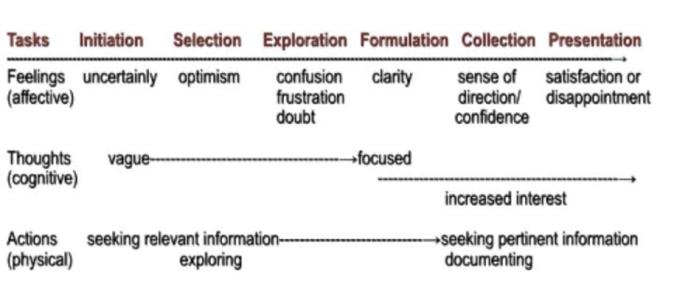
Figure 3: Kuhlthau’s Diagram of Information Search Process (ISP)
(Source : https://www.researchgate.net/publication/366440290/figure/fig1/AS: 11431281115157131@1674778943944/Kuhlthaus-Information-Search-Process-Model.png
6.4. Dervin’s Sense-Making Model
Dervin’s Sense-Making Model was developed by Brenda Dervin in the 1970s and 1980s. It is primarily used in information science to understand how people seek, interpret, and use information. Unlike models that focus only on information systems or the availability of information, Dervin’s model emphasizes the human experience, uncertainty, and the cognitive processes people go through when they encounter gaps in their knowledge.
The central idea is that people construct meaning (make sense) in response to a perceived gap or situation, and information is a tool to help them bridge that gap. This makes the model highly user-centered.
Core Components of the Model
The model revolves around three main concepts: Situation → Gap → Use. Dervin visualized this in what she called the “Situation–Gap–Bridge” framework.

Situation
- Every individual is situated in a particular context.
- A situation is where a person has some experience, knowledge, or need, and it is dynamic and subjective.
- Example: A student trying to understand climate change for a research project is in a situation where they lack some knowledge to complete the task.
Gap
- A gap represents a lack of knowledge, understanding, or clarity that the person wants to address.
- It is subjective, meaning what constitutes a gap varies from person to person.
- The gap is often not just missing information, but a felt difficulty or uncertainty.
- Example: The student may not understand the difference between climate change and global warming.

Bridge (or Use)
- The bridge is the method, strategy, or information resource used to cross the gap.
- It is how people sense-make, i.e., create meaning or understanding from the situation.
- People actively select and interpret information to fit their context.
- Example: The student reads scientific articles, consults a teacher, or watches educational videos to clarify the confusion.
The Sense-Making Process
Dervin described sense-making as a process, not a linear model. It can be visualized as:
- Situation identification: Recognizing where one is and what they are experiencing.
- Gap recognition: Identifying what is missing or unclear.
- Bridge selection: Choosing strategies or resources to fill the gap.
- Sense-making: Applying information and understanding to resolve uncertainty.
- Outcome: The gap is partially or fully bridged; the person gains new knowledge or perspective.
It’s important to note that this process is iterative. If the first bridge fails, the individual may try another method.
Key Principles of the Model
- User-centered: Focuses on the human experience rather than the information itself.
- Contextual: Information needs depend on the person’s situation, environment, and prior knowledge.
- Subjective: Gaps are personal; the same situation may produce different gaps for different people.
- Constructive: Knowledge is actively constructed by the user, not passively received.
- Dynamic: Situations and gaps change over time; sense-making is ongoing.
Applications of the Model
The Sense-Making Model is widely used in library and information science, education, communication studies, and human-computer interaction. Some applications include:
- Information behavior research: Understanding why people search for information.
- Designing information systems: Creating systems that respond to contextual and subjective needs.
- Education: Helping teachers design materials that bridge students’ knowledge gaps.
- Communication studies: Analyzing how people interpret messages based on their experiences.
Diagram of Dervin’s Sense-Making Model The model is often visualized as:
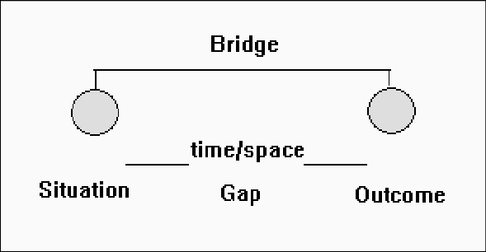
Figure 4: Diagram of Dervin’s Sense making Model
(Source : https://www.researchgate.net/publication/374587924/figure/fig3/ AS:11431281197473639@1697004950907/Dervins-sense-making-model-metaphor.png [SITUATION] → experiences/gaps → [GAP] → bridged using → [BRIDGE] → outcome/understanding
- Situation: Where the person starts.
- Gap: The knowledge or understanding missing.
- Bridge: The means to fill the gap (information, interaction, reflection).
- Outcome: The sense made from the experience.
Limitations
- It Can be difficult to measure objectively because it’s highly subjective.
- Requires careful contextual understanding, which may not be feasible in large-scale studies.
- Doesn’t prescribe specific methods for bridging gaps; it’s more conceptual than prescriptive.
6.5. Bates’ Berry picking Model
The Berry picking model was proposed by Marcia J. Bates in 1989 as an alternative to the traditional linear models of information retrieval (IR), such as the "match between query and document" models used in databases and early search engines. Bates argued that information seeking is not a single, linear query process, but rather a dynamic, iterative, and evolving process.
- Traditional IR Models: Assume a user submits a single, precise query to a database, retrieves a set of documents, and then stops.
- Berrypicking Model: Suggests that users gather information in bits and pieces over time, refining their queries and goals as they learn.
- The model is named "Berrypicking" because information is collected like picking berries from different bushes, rather than harvesting all at once.

Principles
- Information Needs Evolve
  - Users often start with a vague idea of what they want.
  - As they explore sources, their understanding and questions change.
  - Example: A student researching “climate change” may start broadly but later focus on “impact on polar bear populations.”
- Queries Change Continuously
  - Each search or document read can lead to new insights.
  - Users reformulate queries based on what they find.
- Multiple Sources
  - Information is rarely found in a single document.
  - Users gather fragments from books, articles, web pages, interviews, or databases.
- Partial Retrieval
  - Retrieval is incremental, not exhaustive.
  - Each search gives partial information, which accumulates over time.
- Serendipity and Browsing
  - Users often find useful information by chance, not by exact searching.
  - Browsing is an integral part of the search process.

How Berry picking Works
Initial Query:
  - User begins with a broad question or topic.
Document Retrieval:
  - Some documents are found; each document may provide new keywords, concepts, or references.
Query Reformulation:
  - User modifies the query based on new insights.
  - Each document or source can lead to a new search path.
Fragmented Information Gathering:
  - Users collect information in small pieces rather than entire documents.
  - These pieces may include: citations, quotes, ideas, statistics, or concepts.
Iterative Process:
  - Steps 2–4 repeat, with the search branching out in multiple directions.
  - This is unlike linear search models, which assume one query → one result.

Final Understanding:
  - The user synthesizes the fragmented information into a coherent understanding or report.

Table 1: Comparison with Traditional Models
Feature | Traditional IR | Berry picking Model
Search Process | Linear, one query | Iterative, evolving
User Goal | Fixed and specific | Flexible, changing
Information Gathering | Retrieve all relevant docs at once | Gather fragments gradually
Query Formulation | One-time | Continuous refinement
Serendipity | Limited | Integral to discovery
Examples | Library catalog search, Boolean search | Web browsing, citation chasing, Google search with follow-up clicks

Advantages of Berry Picking Model
- Reflects real-world search behavior more accurately.
- Supports exploratory searches where users may not know exactly what they want.
- Accounts for learning and evolving knowledge during the search process.
- Encourages serendipitous discovery and interdisciplinary insights.

Limitations
- Can be time-consuming due to iterative searching.
- Requires active cognitive involvement from the user.
- Difficult to implement in traditional search systems that expect fixed queries.
- Fragmented retrieval may be overwhelming without good organization tools.

Applications
- Library and Information Science
  - Helps understand how people actually search for academic sources.
- Web Search Engines
  - Modern search engines support query refinement, suggestions, and related searches, aligning with berrypicking.
- Knowledge Management
  - Useful in research environments where information evolves with discovery.
- Learning and Education
  - Encourages exploratory learning rather than rote retrieval of facts.

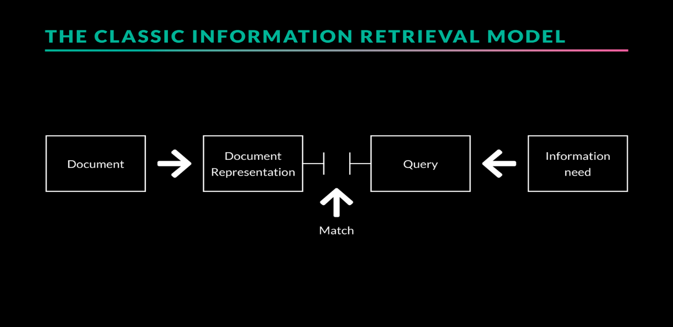
Figure 5: Diagram of Bates’ Berry picking Model of Information Retrieval
(Source : https://ixd.prattsi.org/2018/11/berrypicking-a-discussion-based-on-batess-the-design-of-browsing-1989/)

6.6. Taylor’s Model of Information Need
Taylor’s Model of Information Need was proposed by Robert S. Taylor in 1968. It is one of the foundational models in information science and library science that attempts to explain why people seek information and how their needs can be classified.
Taylor’s model is behavioral and conceptual. It focuses on understanding the types of information needs users have and the complexity of expressing these needs. Taylor emphasized that not all information needs are explicit; sometimes, they are implicit or unrecognized by the user.

Concepts
Taylor’s model is built around the idea that information need is a dynamic and evolving process. He argued that people do not always know what information they require, and there is a gap between the real need and what they can articulate.
He categorized information needs into four levels:

Visibly Expressed Need (Level 1)
- This is the most explicit level.
- The user knows exactly what they want and can clearly express it.
- Example: A student asks, “I need books on quantum physics for my research project.”
- Characteristics:
  - Easily identifiable by librarians or information professionals.
  - Requires minimal interpretation.
Conscious Need (Level 2)
- The user is aware of a gap in knowledge but may not be able to articulate it in precise terms.
- The need is recognized but vaguely defined.
- Example: A researcher knows they need “more background on renewable energy” but cannot specify which aspect (technical, policy, or economic).
- Librarians or information systems may need to ask clarifying questions to define the exact need.

Unconscious or Latent Need (Level 3)
- The user does not realize they need information, or they cannot articulate their need.
- The need exists in the mind but is latent.
- Example: A manager doesn’t know that reading about recent AI regulations could help with strategic planning.
- Information professionals may identify and suggest relevant information to the user.
Normative Need (Level 4)
- Proposed in later interpretations, this is when the need is defined externally, often by an expert or authority, not by the user themselves.
- Example: A librarian or information scientist anticipates the user’s need based on experience or standards and provides information proactively.

Features of Taylor’s Model
- User-centered: Focuses on the needs of the user rather than the information system.
- Hierarchy of needs: Ranges from clearly articulated to unconscious.
- Dynamic process: Information need may evolve as the user interacts with resources.
- Facilitates library services: Helps librarians understand that users may need guidance to articulate and satisfy their information needs.
Significance
- Helps in designing library and information retrieval systems that account for different levels of need.
- Encourages reference librarianship to adopt a proactive approach.
- Forms the theoretical basis for user-centered information services.
- Useful in understanding information-seeking behavior, as it highlights that not all needs are immediately apparent.

Criticisms
- Some argue it is too theoretical and not always easy to apply in modern digital information retrieval systems.
- Does not provide a clear method for identifying latent needs.
- Assumes that needs can always be categorized hierarchically, which may not hold true for all users.
Taylor’s Model (Conceptual) : simple representation:
Explicit Need (Level 1) → Clearly expressed
Conscious Need (Level 2) → Vaguely known
Latent/Unconscious Need (Level 3) → Not realized
Normative Need (Level 4) → Defined externally

Taylor’s model provides a structured way to understand information needs from clearly expressed too latent. It emphasizes that users often need help to articulate their needs, and information professionals play a crucial role in bridging the gap between information availability and user understanding.

6.7. Belkin’s Anomalous State of Knowledge (ASK) Model
The ASK model was proposed by Nicholas J. Belkin in the 1980s as part of his work on Information Retrieval (IR). Unlike traditional models that focused on matching queries to documents, Belkin focused on user needs and cognitive states.
Concept: Anomalous State of Knowledge (ASK)
The Anomalous State of Knowledge is the perceived gap or uncertainty a user experiences when they seek information.
- It is subjective: Each person’s perception of what they don’t know is unique.
- It drives information-seeking behavior: People only search if they feel there’s something missing or anomalous in their knowledge.
Components of the ASK Model
Belkin’s model can be broken down into several components:
- User’s Knowledge State (K):
  - What the user already knows about a topic.
- Anomaly (A):
  - What the user feels they don’t know; the “gap” in their knowledge.
- Problem Situation (P):
  - The context or goal prompting the search.
  - Example: “I need to solve this homework problem” or “I want to write a report.”
- Information Need (IN):
  - The information required to resolve the anomaly.
  - It’s a function of the ASK: IN = f(ASK, Problem Context).

Steps in the ASK Model Process
- Recognition of the anomaly:
The user realizes that they lack knowledge in a particular area.
- Formulation of information need:
They try to articulate what they need to know to fix the gap.
  - This is often imperfect, as users may not know exactly what they are missing.
- Query formulation:
They translate the ASK into a search query or request for information.
- Information retrieval and evaluation:
Retrieved documents are assessed to see if they resolve the anomaly.
- Knowledge update:
If the retrieved information satisfies the user, their knowledge state is updated, and the anomaly is reduced or eliminated.
Implications of the ASK Model
The model influenced IR and information science in several ways:
- User-centered design:
  - IR systems should understand user intentions, not just match keywords.
- Query as a symptom:
  - A user’s search query is not the need itself, but a reflection of the underlying ASK.
- Dynamic knowledge state:
  - Information retrieval is not static; it’s a process of knowledge evolution.
- Supports exploratory search:
  - ASK model is particularly suited for searches where users don’t know exactly what they need, such as learning, research, or complex problem-solving.
Strengths of the ASK Model
- Emphasizes the psychology of information-seeking.
- Focuses on user intent rather than just keywords.
- Can explain why people reformulate queries or abandon searches.
- Provides a theoretical basis for adaptive and interactive IR systems.
Limitations of the ASK Model
- Abstract and hard to operationalize:
  - The ASK is subjective; difficult for a machine to detect automatically.
- No formal retrieval mechanism:
  - Unlike Boolean or vector-space models, ASK doesn’t tell the system how to rank documents.
- Depends on user self-awareness:
  - Users must recognize their knowledge gaps, which is not always possible.
Applications
- Educational technology:
  - Adaptive learning systems can assess a student’s ASK and provide personalized learning resources.
- Interactive search engines:
  - Systems that suggest query refinements based on user feedback.
- Research support tools:
  - Helping scholars explore literature when they only vaguely know what they are missing.
Table 2: Comparison of Different Models
Model Name | Approach | Components | Applicability
Wilson’s Model 1981, 1996 | Holistic & Behavioral | Information need, seeking behavior, intervening variables (psychological, social, environmental), information use | Widely used foundational model; suitable for studying information behavior in social sciences, libraries, and everyday contexts
Ellis’s Model (1989) | Behavioral & process-oriented | Activities such as starting, chaining, browsing, differentiating, monitoring, extracting | Useful for studying researchers’ and academics’ information-seeking patterns
Kuhlthau’s Information Search Process (ISP) Model (1991) | Cognitive & affective | Six stages: initiation, selection, exploration, formulation, collection, presentation; emotions, thoughts, actions | Highly applicable in education, library instruction, and student research behavior
Dervin’s Sense-Making Model (1983) | Cognitive & constructivist | Situation, gap, bridge, outcome; focus on meaning-making | Effective for user-centered research, communication studies, and understanding individual perspectives
Bates’ Berry picking Model (1989) | Dynamic & nonlinear | Evolving queries, multiple sources, incremental information gathering | Useful for understanding modern web searching and exploratory search behavior
Taylor’s Model of Information Need (1968) | Cognitive & user-centered | Four levels of information need: 1) Visceral need, 2) Conscious need, 3) Formalized need, 4) Compromised need | Useful for reference services, understanding user–librarian interaction, and query formulation
Belkin’s Anomalous State of Knowledge (ASK) Model (1980) | Cognitive & problem-oriented | Information need arises from an anomaly or gap in knowledge; users cannot fully express needs as queries | Applied in information retrieval (IR) system design and interactive search systems
Collectively, these models demonstrate that information seeking is a complex, iterative, and cognitively driven process rather than a simple search activity. While Wilson and Ellis explain behavioral patterns, Kuhlthau and Dervin emphasize cognitive and emotional aspects. Bates highlights the dynamic nature of searching, whereas Taylor and Belkin focus on the articulation and underlying causes of information needs. Together, these models provide a comprehensive framework for understanding information-seeking behavior across academic, professional, and everyday contexts.
- Verification of Objectives of the Study
- To identify and analyze major models of information seeking behavior proposed by leading researchers.
Various models have been discussed under heading 6.1 to 6.7 which gives developmental and evolutional study of some of the important models.
- To compare different information seeking behavior models based on their approaches, components, and applicability.
Same is discussed under 6.1 to 6.7.
- To evaluate the relevance of classical information seeking behavior models in contemporary digital information environments.
Classical and modern models of information seeking are discussed under table 1.
- To explore recent trends and developments in information seeking behavior research.
Classical and modern models of information seeking are discussed under table 1. Further, table 2 presents development of various models.
- To highlight the implications of information seeking behavior models for information system design and library services.
These are discussed below in heading 8.
- To examine the concept of information seeking behavior and its significance in Library and Information Science.
These are discussed below in heading 8.
- To suggest an integrated approach for understanding user information seeking behavior in modern information environments.
On the basis of table 2, it can be concluded that various models are in vogue but Belkin’s Anomalous State of Knowledge (ASK) Model (1980) seems to be better in present days environment.
8. Concept of Information Seeking Behavior and Its Significance in LIS
Information seeking behavior refers to the purposive actions undertaken by individuals to acquire information in response to a perceived information need. It includes activities such as searching, browsing, consulting sources, and interacting with information systems. Information seeking behavior is closely related to, but distinct from, broader concepts such as information behavior and information use.
- Information behavior encompasses all human behavior related to information.
- Information seeking behavior focuses specifically on active information pursuit.
- Information searching behavior refers to interactions with information retrieval systems.
Information seeking behavior is significant in LIS for several reasons:
- User-Centered System Design: Understanding user behavior helps librarians and system designers create more effective information systems.
- Collection Development: Knowledge of user needs guides resource selection.
- Reference and Information Services: Enhances the effectiveness of reference interactions.
- Information Literacy Programs: Supports the design of user education initiatives.
- Digital Library Development: Informs interface design and usability improvements.
Thus, ISB serves as a theoretical and practical foundation for LIS research and practice.
9. Scope and Limitations of the Study
The scope of the study is limited to well-established and widely cited models of information seeking behavior, including those proposed by Wilson, Kuhlthau, Ellis, Dervin, Bates, and others. The study focuses on understanding these models in relation to academic and digital information environments.
As the study is based on secondary sources, it does not include empirical data collected from users. Therefore, the findings are dependent on the availability and interpretation of existing literature. Despite this limitation, the study provides valuable theoretical insights into information seeking behavior.
10. Conclusion
Information seeking behavior is a complex, multidimensional phenomenon that cannot be fully captured by any single theoretical framework. The analysis of prominent models—Wilson’s Model, Kuhlthau’s Information Search Process, Ellis’s Behavioral Model, Dervin’s Sense-Making Model, and Bates’ Berrypicking Model—demonstrates that each offers valuable insights into different aspects of how individuals interact with information. While some models emphasize cognitive processes, others highlight emotional, social, or contextual influences, reflecting the intricate interplay of factors that shape information behavior. In contemporary digital environments, where information is abundant, dynamic, and often unstructured, these models remain relevant, but their application requires adaptation to the unique characteristics of digital information systems.
The study underscores the necessity of an integrated, holistic approach that synthesizes multiple models, enabling researchers, librarians, and information system designers to better understand and anticipate user behavior. By combining theoretical perspectives, stakeholders can create more responsive, user-centered digital environments that support effective information discovery, decision-making, and knowledge creation.
Bibliography / References
  - Wilson, T. D. (1999) Models in information behavior research. Journal of Documentation. 55(3), pp. 249-270.
  - Foster, A.E, (2004). A Nonlinear Model of Information Seeking Behavior. Journal of the American Society for Information Science and Technology. 55 (3), 228-237.
  - Sarkhel, Juran Krishna and Khan, Md. Milan (2014). Information Needs and Information Seeking Behavior of Faculty Members of Agricultural Universities in Bangladesh: A Study. The International Journal of Social Sciences, 24(1), 23-36.
  - Chinnasamy, K. (2016). Information need and information seeking behavior of engineering college students in Madurai: A case study. Qualitative and Quantitative Methods in Libraries,5(1), 131–140.
  - Leckie, G J, Pettigrew, K E & Sylvain, C. (1996). Modeling the information seeking of professionals: a general model derived from research on engineers, health care professionals and lawyers. Library Quarterly, 66(2), 161-193.
  - Prasad, H.N.(2012). Information needs and users: second revised and enlarges edition.in BR Publishing. Delhi,
  - Dhiman, A.K. (2003). Basics of Information Technology for Librarians and Information Scientists. 2 Vols. New Delhi: Ess Ess Publications.
  - Niedwiedzka, B. (2003). A proposed general model of information behaviour. Information Research, 9(1). Available: http://informationr.net/ir/9- 1/paper164.html
  - Cheuk Wai-Yi, B. (1998). An information seeking and using process model in the work place : a constructivist approach. Asian Libraries, 7(12), 375-390.
  - Ellis, D. (1989). A behavioural approach to information retrieval design. Journal of Documentation, 45(3), 171-212.
  - Prabha, K. (2013, June). Information seeking behaviour of different types of users in selected libraries of Delhi. Journal of Library & Information Science.
  - Belkin, N.J., et al. (1995). Cases, scripts and information seeking strategies: on the design of interactive information retrieval systems. Expert Systems with Applications, 9, 379- 395.
  - Bhattacharjee, Sudip, Bhattacharjee, Sucheta and Sinha, Manoj Kumar. (2013). Information seeking behaviour: Concept, models, case study. Germany: LAP LAMBERT Academic Publishing.
  - Drsang, E.T. (2005). The information seeking behavior of youths in the digital environment. Library Trend, 54(2); 178-196.
  - Sahu, Harish Kumar (2018). Information Seeking Behavior of students of library and information science department, Pt. Ravishankar Shukla University, Raipur Chhattisgarh: A Study, Granthalya Vigyan, Vol.49; 19-27.
  - Holeyannavar,Atmanand G. and Bankapur, Vinayak M.(2017). Information seeking behaviour of students of physiotherapy college libraries in Karnataka: A study on E-Resources, Indian Journal of Library and information Science, Vol.11(3); 333-340.
  - Davis, G.B., & Olson, M.H. (1985). Management information systems. New York: McGraw Hill.
  - Zhang, W. (1998). Analyzing faculty and staff’s information needs and use of electronic technologies: A liberal arts college’s experience. Journal of Education Media and Library Sciences 35(3): 218-241.
  - Pandey, Chander Prakash and Dhiman, Anil Kumar (2020). A Study of Information Seeking Behaviour of Library Users of Dev Sanskrti Vishwavidyalya, Haridwar. Granthalaya Vigyan Vol.51: 136-149.
  - Dhiman, A.K. and Rani, Yashoda. (2013). Major Models of Information Seeking Behaviour (Hindi). Granthalaya Vigyan, 44: 113-120.

