ANALYSIS OF HOUSEHOLD PATTERN OF DAILY DIETARY DIVERSITY OF PDS BENEFICIARIES, ROHTAK, HARYANA
Ms. Pragya
Student of Department of Geography, Panjab University, Chandigarh

Email : 01pragyagupta@gmail.com
ABSTRACT
The present study aims to understand the consumption of different food groups by the beneficiary households of Public Distribution System (PDS) in Rohtak, Haryana. The results revealed that cereals, pulses, vegetables and dairy products were consumed by households regularly, whereas food groups like fruits, eggs, nuts and animal source foods such as meat and fish were consumed by less than 20% of households. This is the classic case of ‘full but unfed’ which implies that the calories are met but the other vital nutrients are not being provided, leading to several nutritional problems like malnutrition, anaemia and stunted growth. Therefore, in addition to the food security, there is an immediate need for the government to reform PDS and introduce more diverse and nutrient-rich foods to the system to provide a balanced diet for the vulnerable sections of the society.
Keywords: Public Distribution System (PDS), Dietary Diversity, Food Security, Nutrition security, Malnutrition

- INTRODUCTION
Dietary diversity, recognized as a key indicator of nutritional security and food security, measures the availability, access, and affordability of diverse, nutrient-rich foods essential for a balanced diet (FAO, 2013). In relation to Public Distribution System (PDS) reforms, a critical aspect to consider is how the system can better support and promote dietary diversity to ensure improved nutritional outcomes. PDS, which primarily distributes staple grains such as rice and wheat, has a vital role in enhancing nutritional access among vulnerable populations (Khera, 2011). A more diversified diet, including pulses, dairy, fruits, vegetables, and protein sources, can play a crucial role in addressing micronutrient deficiencies and overall malnutrition. Yet, the present PDS structure limits dietary diversity reasons; budgetary constraints, logistical challenges, and a focus on calorie sufficiency over overall nutrition. By including more varieties of food groups of regional preferences and environmental sustainability, PDS can play a pivotal role in enhancing food security by making diverse, nutritious foods more accessible to low-income households. Strengthening dietary diversity through PDS reforms not only aligns with global food security goals but also contributes to long-term health improvements and reduces the burden of diet-related diseases (WHO, 2020).
- LITERATURE REVIEW
Gokhale and Rao (2022) examine the relevance of Socio-demographic and Socio-economic factors affecting Diet Diversity among Rural Pregnant Women in India. The study emphasizes the need of targeted interventions and programs to enhance and preserve the diversity of food groups, while also considering maternal age, education level, occupation, family structure, family income, and ownership of a house. The research highlights the importance of fixing these determinants in order to improve the health outcomes and nutritional intake of pregnant women in rural areas.
Narayanan et al (2023) study in Akole Block, Maharashtra compared dietary diversity and nutritional status of students in upland and lowland regions. The findings reveal socio-economic impact and market access, with upland students showing higher dietary diversity scores. However, upland students had a higher prevalence of malnutrition, indicating a need for interventions. Improved irrigation, livestock ownership, and better market access are key areas to increase dietary diversity in the region. Nutritional gaps in traditional recipes should be addressed, and better nutrition communication and interventions are recommended for tribal communities.
Mushipe et al. (2023) emphasize the interconnectedness of food insecurity, pandemics, and HIV/AIDS, calling for multi-faceted strategies that address the specific vulnerabilities of affected populations. The study underscores the significance of socio-economic factors in shaping food preferences and dietary diversity among people living with HIV/AIDS. It suggests that targeted interventions to improve household income, coupled with the integration of nutritional support into HIV/AIDS programs, can enhance dietary diversity, particularly in households where caregivers have lower educational attainment. Recognizing regional variations and household dynamics is deemed crucial for effective food security initiatives, aligning interventions with the diverse needs and preferences of people living with HIV/AIDS.
Sharma et al (2024) underscores the critical role of maternal dietary diversity in enhancing birth and child health in Rajasthan. The study reveals socio-economic factors and Social and Behavioural Change Communication (SBCC) interventions as key determinants of minimum dietary diversity (MDD) among pregnant women. Despite the largely vegetarian diet, better diversity is associated with higher SBCC intervention exposure, highlighting the need for customized and sustained efforts to overcome socio-economic inequalities in dietary practices during pregnancy
- STUDY AREA:
District Rohtak is one of 22 districts of Haryana which is the focus of the present study. The district is traditionally named after Raja Rohtash in whose day’s it is said that the city was built. It is also said that town is named after Roherra (Tacoma undulate) tree which is called Rohitaka in Sanskrit. It is located about 70 kilometres (43 miles) north of Delhi, and is surrounded by the districts of Jind, Sonipat, Jhajjar, Hisar and Bhiwani, in the north, south, east and west side respectively. The latitude of Rohtak, Haryana, India is 28.89 and the longitude is 76.60 and the average elevation is 217 metres (712 feet) above sea level. District has the area of 1668.47 square kilometres. It has a population of around 400,000 people, and is one of the 10 most populated cities of the state. As per 2011 census of India the sex ratio of the city is 947 females for every 1,000 males, and it is well known as a centre of healthcare services.
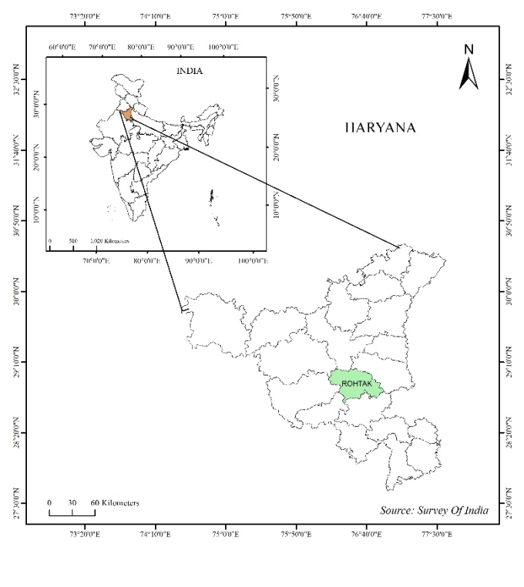
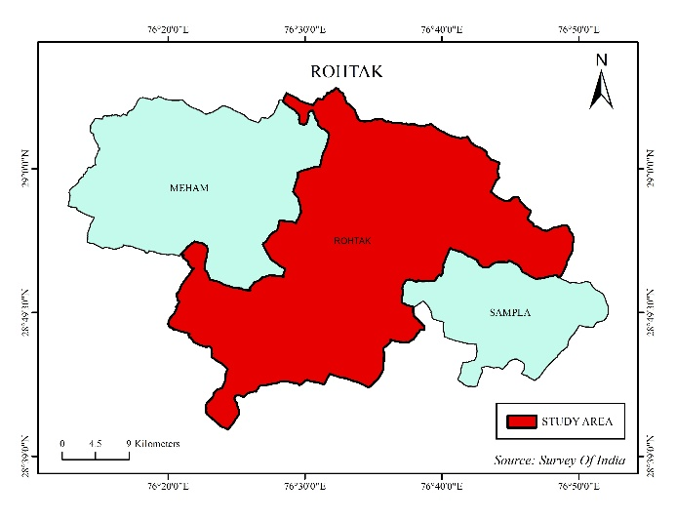

- DATA SOURCES AND METHODOLOGY
4.1 Primary Data : The study is based mainly on primary data to observe the food diversity pattern of the Public Distribution System (PDS). Simple random sampling is done to collect unbiased information on 10 ration shops of the study area so that the results come out to be true representative of the system. To further understand the experiences and the problems faced by beneficiaries, survey of 90 respondents was conducted by selecting the respondents which were ration card holders who avail the PDS services. The Food and Agriculture Organization (FAO) food diversity questionnaire is slightly modified, which groups the food items into nine broad categories according to the environment, people’s preference, and affordability so that the dietary diversity suggested is more in line with the food habits of the region as well as prices without compromising on nutritional requirements. Nine categories also help in suggesting the type of food items a person must have access to like cereals, pulses, milk and dairy products, meat and fish, eggs, vegetables, fruits, oils and fats, and sugar-based food items.
4.2 Secondary data: Apart from primary data, the current study also utilizes secondary data available from various reliable government departments and official websites. This information provides evidence about the performance, availability, and effectiveness of ration shops and nutritional outcomes of PDS. These sources provide valuable insights into the nutritional impact of the PDS on beneficiaries, as well as the availability, accessibility, and operational efficiency of ration outlets. Data was obtained from the following government portals and organizations:
- Food Corporation of India (FCI)
- Ministry of Consumer Affairs, Food & Public Distribution
- NITI Aayog
- AePDS Haryana (Automated e-Public Distribution System, Haryana)
- National Food Security Portal (NFSA)
By integrating local dietary behaviours and economic feasibility into food security assessments, this research aims to bridge the gap between food availability and effective nutritional intake, ultimately contributing to a more sustainable and inclusive food system

FOOD ITEM NAME | YES | NO
1.Cereals & Pulses | 90 | 0
2.Vegetables | 90 | 0
3.Fruits | 10 | 80
3.Meat | 0 | 90
5.Eggs | 6 | 83
6.Fish | 0 | 90
7.Nuts & Seeds | 7 | 83
8.Milk products | 90 | 0
9.Others | 78 | 12
5 RESULTS AND DISCUSSIONS

Figure 1: Intake of different foods items in last 24 HOURS

Dietary diversity achieved by the households availing of the PDS benefits reflects the essential food groups to which they are gaining access. It is also observed that the consumption pattern is biased in the form of high consumption of staples and low consumption of some nutrient-dense food items. The consumption of different categories of food by PDS beneficiaries is presented in the following subsections Intake of Cereal & Pulses
Food prepared at home from cereal grains (rice, wheat, millets) and pulses (lentil, beans etc.) are the mainstay of a household's diet. Cereal grains and pulses are the important sources of carbohydrates,

proteins and micronutrients. Cereal grains and pulses are being consumed by 100% of PDS beneficiaries in Rohtak (90 households).
5.1 Intake of Vegetables
Vegetables are a vital source of vitamins, minerals, and fibre. They contribute to overall health and well-being. Among PDS beneficiaries, all 90 households reported consuming vegetables, indicating their availability and inclusion in meals.
  - Intake of Fruits
Fruits are a good source of vitamins, antioxidants, and dietary fibre. Out of the 90 households only 10 households consume fruits (11.1%), and 80 (88.9%) do not consume fruits. This points out that either fruits are not affordable or not available to the PDS beneficiaries.
5.3 Intake of Meat
This group consists of Meat (beef, pork, poultry, lamb, game meats etc.) Meat is a good source of quality protein, iron, and many vitamins. Consumption of this commodity in PDS households is ZERO (0 families consume it) which suggests that it is either unaffordable or people are not habitual to having meat in their daily diet or both.
5.4 Intake of Eggs
Eggs are a rich source of protein, vitamins, and healthy fats. However, their consumption is relatively low, with only 6 households (6.7%) consuming eggs, while 83 households (93.3%) do not include them in their diet.
  - Intake of Fish
Fish is a great source of omega-3 fatty acids and lean protein. No surveyed households eat fish (0 households), perhaps due to accessibility, cost, or local dietary habits.
5.6 Intake of Nuts & Seeds
Nuts and seeds are a good source of fat, proteins, and micronutrients. Out of all PDS beneficiaries, 7 (7.8%) households eat nuts and seeds while 83 (92.2%) households do not eat nuts and seeds showing that nuts and seeds are likely not accessible or affordable to everyone.
5.7 Intake of Milk & Milk Products
Dairy products contain calcium, protein and vitamins that are necessary for bone health. All (100%) 90 households mentioned drinking milk and eating dairy products. Milk and dairy products are widely available, rich sources of calcium, vitamin D and protein, which are required for bone health, muscle function and maintenance and overall child and adolescent nutrition.
5.8 Intake of Other Food Items
In addition to the main food groups, the households are also involved in the consumption of complementary foods such as edible oil, sugar and processed foods. As per the survey findings, 78 (86.7%) of the households responded that they do consume such additional foods while 12 (13.3%) households responded no. This indicates that the majority of the population relies on these sources to fulfil their nutritional needs.
Government's Public Distribution System (PDS) is another major source of food consumption in the country. The PDS works through a network of ration shops that provide a number of subsidized essential commodities to the consumer. The PDS in Rohtak is one of the effective tools which helps in providing food security to the poor households. This system of providing food through a number of ration shops selling essential food items like rice, wheat, sugar, millets, mustard oil, and kerosene at a very low subsidized price has helped the various vulnerable households to secure a bare minimum level of food consumption. The PDS is the primary tool of GOI to ensure food availability and a minimum level of calories to its people. The main key point here is this system succeed only in providing a quantitative food security but it does not ensure nutrition security by providing a balanced diet, which is the important element of Food Security. The PDS system majorly focuses on cereal grains, particularly wheat and rice, has led to a diet that is nutritionally imbalanced. The PDS may distribute staple food items but not nutrient-dense foods, leading to a situation where people are consuming enough calories but not getting a well-rounded, healthy diet.
The food consumption data in terms of the DDS as done in Rohtak is eye opening. PDS beneficiaries for some of the most essential food groups like cereals, pulses, vegetables and dairy products, which are either given under PDS or are easily affordable, had 100% consumption as per the survey. However, on consumption of fruits, the percentage was low at 11%, and for meat and fish, the survey registered 0% consumption. Similarly, eggs and nuts were consumed by only 6.7% and 7.8% of the households. This gap in consumption is highly serious in nature as cereals, which are the primary source of carbohydrates, are not being combined with protein and micronutrients from other sources as well as healthy fats for good physical and mental development, especially in children and pregnant women.
This limited variety of diet comes with severe consequences. The low number of food items eaten regularly results in acute and chronic micronutrient deficiencies amongst PDS beneficiaries. The combination of inadequate consumption of iron, calcium, vitamin A, and folic acid, for instance, results in a high prevalence of anaemia, stunted growth, weak immunity, and chronic fatigue. Children and the elderly population are most vulnerable to diet-related disorders and illnesses, such as wasting, stunting, and delayed development. Malnutrition continues to plague PDS beneficiaries despite the system's ability to achieve food security, revealing a critical failing of the scheme: food security, even when realised through PDS, does not equate to nutrition security.
- CONCLUSION AND RECOMMENDATIONS
PDS in Rohtak has been a vital tool for ensuring food security among the most vulnerable sections of society, particularly low-income households. By providing access to cereals, pulses, and milk at subsidized rates, the PDS acts as a safety net, shielding families from acute hunger . However, the research also points to remaining nutritional gaps in beneficiaries’ diets which is heavily relied on the staple grains and facing lack of protein-rich foods, fruits, vegetables, and healthy fats. This narrow dietary scope not only curtails the consumption of essential vitamins and minerals but also hampers the intake of vital micronutrients necessary for better physical and mental health. The main focus of PDS is on calorie provision, while it falls short of addressing the multifaceted aspects of nutrition security. This deficiency caused several groups including children, pregnant women, and the elderly, vulnerable to long-term health complications, undermining their overall well-being and impeding sustainable development.
To overcome these issues, the PDS must shift from being a calorie-focused program to a nutrition-sensitive model by diversifying the food basket to include edible oils, and regionally available fruits and vegetables. Implementing fortification measures for rice, wheat, and edible oils distributed through PDS can be an effective strategy to combat micronutrient deficiencies, including anaemia and calcium deficiency. Also Integrating the PDS with other nutritional programmes such as ICDS, Poshan Abhiyan, and the school mid-day meal scheme can create a more holistic and comprehensive nutrition delivery system. Raising awareness among beneficiaries about the importance of a balanced diet and providing community-level nutrition education will be critical to improving dietary practices. Strengthening the digital monitoring mechanism through AePDS will enhance transparency, accountability, and distribution efficiency. Special provisions like nutritional kits for children, pregnant women, and older adults can be introduced to cater to the specific nutritional needs of these vulnerable groups. Or DBT can also be implemented so that people can include nutritional food in their diets.
REFRENCES
- Food and Agriculture Organization. (1996). Rome Declaration on World Food Security and World Food Summit Plan of Action. Rome: FAO.​

- Government of India. (2013). National Food Security Act. Ministry of Law and Justice.​American Economic Association+1KPMG Assets+1

- Kaushal, N., & Muchomba, F. M. (2015). How consumer price subsidies affect nutrition. World Development, 74, 25–42.​

- Krishnamurthy, P., Pathania, V., & Tandon, S. (2017). Food price subsidies and nutrition: Evidence from state reforms to India's Public Distribution System. Economic Development and Cultural Change, 66(1), 55–90.​

- Dev, S. M. (2004). "Poverty and Inequality in India." Economic and Political Weekly, 39(30), 3337-3345.

- Guhan, S. (2010). "Social Security in India: Issues and Perspectives." The Economic and Political Weekly, 45(35), 68-76.

- Jha, R., & Khera, R. (2009). "Public Distribution System in India: A Study of Ration Shops." Indian Journal of Human Development, 3(2), 49-66.

- Khera, R. (2011). "Reviving the Public Distribution System: Policy and Performance." Economic and Political Weekly, 46(43), 41-49.

- Ministry of Consumer Affairs, Food and Public Distribution. (n.d.). Pradhan Mantri Garib Kalyan Anna Yojana. Retrieved from https://dfpd.gov.in/newsdetail.htm?264&#8203;:contentReference[oaicite:11]{index=11}

- Rahman, A. (2016). Universal food security programme and nutritional intake: Evidence from the hunger prone KBK districts in Odisha. Food Policy, 63, 73–86.​

- Shrinivas, A., Baylis, K., & Crost, B. (2023). Food transfers and child nutrition: Evidence from India's Public Distribution System. American Economic Journal: Applied Economics, 15(1), 1–30.​

- Tarozzi, A. (2005). The Indian Public Distribution System as provider of food security: Evidence from child nutrition in Andhra Pradesh. European Economic Review, 49(5), 1305–1330.​

- Kumar, P., & Ayyappan, S. (2014). Food Security and Nutritional Intake in India: Role of Public Distribution System. Economic and Political Weekly, 49(45-46), 49–55.​

- Mishra, A., & Ray, R. (2011). Dietary Diversity, Food Security and Undernourishment: The Indian Experience. Munich Personal RePEc Archive.​

- Radhakrishna, R., & Subbarao, K. (1997). India's Public Distribution System: A National and International Perspective. World Bank Discussion Paper No. 380.​

- Saxena, N. C. (2012). Hunger, Under-Nutrition and Food Security in India. Chronic Poverty Research Centre Working Paper No. 44.​

